**HydroMatic: A Web-based Monitoring system utilizing IoT device for Kratky Method of Hydroponics farming**



**A CAPSTONE AND RESEARCH PROJECT**

**By:**

**Reyes, Briggs V.**

**Mateo, Earl Sheik G.**

**Pablo, Kurt Russel C.**

**Yabot, Jean Micaell M.**

**APRIL 2024**

**HydroMatic: A Web-based Monitoring system utilizing IoT device for Kratky Method of Lettuce Hydroponics farming**

A Capstone and Research Project

Presented to the Faculty of the

College of Information and Communications

Technology

Cabanatuan City, Nueva Ecija

Submitted by:

**Reyes, Briggs V.**

**Mateo, Earl Sheik G.**

**Pablo, Kurt Russel C.**

**Yabot, Jean Micaell M.**

Submitted to:

**Cris Norman P. Olipas, Ed.D**

Capstone and Research Instructor

**APRIL 2024**

**Table of Contents**

Title Page…………………………………………………………………………………i

Table of Contents…………………………………………………………iii

CHAPTER I: The Problem and Its

Background…………………………………………………………………………………1

Introduction……………………………………………………………………………1

Review of Related Literature and

Systems…………………………………………………………………………………………4

Synthesis ………………………………………………………………22

Conceptual Framework……………………………………25

Statement of the Problem…………………………………………29

Scope and Delimitation………………………………………………31

Significance of the Study………………………………………32

Definition of Terms………………………………………………………34

CHAPTER II: Methodology …………………………………………37

Research Design…………………………………………………………………37

Research Locale…………………………………………………………………39

Respondents of the Study…………………………………………40

Sample and Sampling Technique……………………………42

Research Instrument………………………………………………………43

Data Gathering Procedures………………………………………45

Data Analysis Technique……………………………………………48

Ethical Considerations………………………………………………67

Chapter III: Results and Discussion……………70

Assessment of Manual System…………………………………70

Security of Files and Records………………70

Management of Data……………………………………………76

Reliability of Output……………………………………81

Compliance with Regulation and Standards How may the proposed project be described based on the stages of the Software Development Life Cycle which are:…………………………………………………………………………………………… 88

Requirement Analysis………………………………………88

System Design…………………………………………………………95

Architecture Design………………………………………109

Module Design………………………………………………………142

Coding…………………………………………………………………………147

Unit Testing…………………………………………………………150

Integration Testing………………………………………151

System Testing……………………………………………………153

Acceptance Testing…………………………………………155

The Assessment of the System’s Technical Qualities by IT Experts in Compliance with Software Characteristics Guidelines…………157

Functional Suitability………………………………157

Performance Efficiency………………………………160

Compatibility………………………………………………………163

Usability…………………………………………………………………167

Reliability……………………………………………………………172

Security……………………………………………………………………176

Maintainability…………………………………………………179

Portability……………………………………………………………183

The Assessment of the System’s Quality of Use by End-users in Compliance with Software Characteristics Guidelines…………186

Functional Suitability………………………………186

Performance Efficiency………………………………189

Usability…………………………………………………………………191

Reliability……………………………………………………………194

Security……………………………………………………………………197

The Assessment of the System’s Quality of the device by IT Experts in Compliance with criteria of ISO 30165 standards………………………………………………………………………………199

Time………………………………………………………………………………199

Control………………………………………………………………………202

Computation……………………………………………………………206

Communication………………………………………………………210

The Assessment of the System’s Quality of the device by End-users in Compliance with criteria of ISO 30165 standards………………………………………………………………………………214

Time……………………………………………………………………………214

Control………………………………………………………………………217

Computation……………………………………………………………220

Communication………………………………………………………223

Chapter IV: Summary, Conclusions, and Recommendations………………………………………………………………227

Summary………………………………………………………………………227

Conclusion………………………………………………………………230

Recommendation……………………………………………………232

References……………………………………………………………………………234

Appendices……………………………………………………………………………246

Curriculum Vitae……………………………………………………………298

**Acknowledgement**

**Dedication**

**List of Tables**

Table 1. Distribution of Respondents…………41

Table 2. Scoring Rubric for Level of Agreement…………………………………………………………………………………49

Table 3. Scoring Rubric for Functional Suitability……………………………………………………………………………51

Table 4. Scoring rubric for Performance Efficiency………………………………………………………………………………53

Table 5. Scoring Rubric for Compatibility………………………………………………………………………55

Table 6. Scoring Rubric for

Usability ………………………………………………………………………………56

Table 7. Scoring Rubric for

Reliability …………………………………………………………………………58

Table 8. Scoring Rubric for

Security …………………………………………………………………………………60

Table 9. Scoring Rubric for Maintainability…………………………………………………………………62

Table 10. Scoring Rubric for Portability……………………………………………………………………………65

Table 11. Result of the Assessment on the Security of Files and Records Using Manual System…………………………………………………………………………………………71

Table 12. Results of the Assessment on the Management of Data Using Manual

System ………………………………………………………………………………………76

Table 13. Results of the Assessment on the Reliability of Output Using Manual System…………………………………………………………………………………………81

Table 14. Summary of assessment result of End users based of Software Characteristics…………………………………………………………………86

Table 15. Data Dictionary of Table Admin…………………………………………………………………………………………118

Table 16. Data Dictionary of Table Account……………………………………………………………………………………120

Table 17. Data Dictionary of Table Device Information…………………………………………………………………………123

Table 18. Data Dictionary of Table Hydroframe……………………………………………………………………………126

Table 19. Data Dictionary of Table Archive……………………………………………………………………………………131

Table 20. Data Dictionary of Table Activities……………………………………………………………………………137

Table 21. Data Dictionary of Table (HostName)……………………………………………………………… …………139

Table 22. Hardware Components…………………………143

Table 23. Results of the Assessment Made by IT Experts on the Systems’ Functional Suitability………………………………………………………………………158

Table 24. Results of the Assessment Made by IT Experts on the Systems’ Performance Efficiency ………………………………………………………………………161

Table 25. Results of the Assessment Made by IT Experts on the Systems’ Compatibility……………………………………………………………………164

Table 26. Results of the Assessment Made by IT Experts on the Systems’ Usability………168

Table 27. Results of the Assessment Made by IT Experts on the Systems’ Reliability…………………………………………………………………………173

Table 28. Results of the Assessment Made by IT Experts on the Systems’

Security…………………………………………………………………………………176

Table 29. Results of the Assessment Made by IT Experts on the Systems’ Maintainability………………………………………………………………179

Table 30. Results of the Assessment Made by IT Experts on the Systems’

Portability…………………………………………………………………………183

Table 31. Results of the Assessment Made by End-users on the Systems’ Functional Suitability…………………………………………………………………………186

Table 32. Results of the Assessment Made by End-users on the Systems’ Performance Efficiency……………………………………………………………………………189

Table 33. Results of the Assessment Made by End-users on the Systems’

Usability ……………………………………………………………………………192

Table 34. Results of the Assessment Made by End-users on the Systems’ Reliability…………………………………………………………………………195

Table 35. Results of the Assessment Made by End-users on the Systems’

Security…………………………………………………………………………………197

Table 36. Results of the Assessment Made by IT Experts on the System’s Time

………………………………………………………………………………………………………200

Table 37. Results of the Assessment Made by IT Experts on the System’s Control

………………………………………………………………………………………………………203

Table 38. Results of the Assessment Made by IT Experts on the System’s Computation…………………………………………………………………………207

Table 39. Results of the Assessment Made by IT Experts on the System’s Communication……………………………………………………………………211

Table 40. Results of the Assessment Made by End-user on the System’s Time…………………214

Table 41. Results of the Assessment Made by End-user on the System’s Control…………217

Table 42. Results of the Assessment Made by End-user on the System’s Computation ………………………………………………………………………220

Table 43. Results of the Assessment Made by End-user on the System’s

Communication …………………………………………………………………223

**List of Figures**

Figure 1. Research Paradigm…………………………………26

Figure 2. Map of Nueva Ecija………………………………39

Figure 3. Gantt Chart…………………………………………………90

Figure 4. Flowchart for the User……………………97

Figure 5. Flowchart for the Admin…………………99

Figure 6. Context Diagram………………………………………101

Figure 7. Data Flow Diagram - level 0………102

Figure 8. Data Flow Diagram - level 1………104

Figure 9. Use Case Diagram……………………………………106

Figure 10. Schematic Diagram………………………………108

Figure 11. Unnormalized Form………………………………111

Figure 12. First Normal Form………………………………112

Figure13. Second Normal Form………………….…………113

Figure14. Entity Relationship Diagram ………………………………………………………………………………………………………116

**Chapter 1**

**THE PROBLEM AND ITS BACKGROUND**

# Introduction

Over recent decades, agricultural productivity has significantly increased due to the adoption of intensification, mechanization, and automation (Nof, 2009; Zhang, 2013). This growth has primarily been driven by developing and applying technologies aimed at improving crop yield and quality while reducing production costs. Precision techniques, such as precision seeding and planting, have enhanced average plant size and uniformity. At the same time, precise fertigation, which involves the targeted application of water and nutrients at optimal times and locations, has reduced the input-to-yield ratio (Tremblay et al., 2011). Additionally, these techniques have contributed to minimizing environmental impact by reducing the excessive use of agricultural inputs (Tremblay et al., 2012). For instance, optimized in-season nitrogen application using remote sensing and fuzzy inference systems has achieved yield levels comparable to those obtained with uniform application but with 31% less nitrogen (Tremblay et al., 2010).

In the Philippines, commercial hydroponics farming began in 1981. Initially, this method required substantial capital investment and intensive resource use, which limited its appeal. Traditional hydroponic systems typically necessitate greenhouses, artificial lighting, air conditioning, pH monitoring, and water circulation systems, creating significant initial and operational costs. However, as innovative technologies, such as sensors and data management systems, have advanced, agriculture is becoming increasingly data-driven. The rapid development of the Internet of Things (IoT) and cloud computing has given rise to intelligent farming, transforming traditional practices into highly efficient, data-enabled systems (Sundmaeker et al., 2016). Farmers can make informed decisions to maximize productivity and sustainability by utilizing real-time data from sensors. Data-driven management optimizes resource use and mitigates environmental impact, paving the way for sustainable agricultural practices. Moreover, IoT-based tools allow farmers to monitor conditions remotely, including humidity, temperature, and pH levels, providing a practical approach to managing and controlling environmental factors (Saiz-Rubio et al., 2020).

Despite these advancements, hydroponic systems also face challenges. For instance, hydroponics often demands intensive monitoring and substantial water usage. It is susceptible to waterborne diseases that can quickly spread through the system, posing risks to the entire plant population. Furthermore, without soil as a buffering medium, plants in hydroponics are particularly vulnerable to nutrient deficiencies, temperature fluctuations, and disease.

The HydroMatic IoT-based hydroponic system seeks to address these challenges by offering a comprehensive, accessible approach to hydroponic farming. This system provides users, especially novice farmers, with real-time insights through a web-based platform, enabling them to monitor and control conditions remotely. It employs sensors to track pH, temperature, and humidity and delivers notifications of any abnormalities continuously, thereby allowing timely adjustments to enhance crop health and yield.

However, while technological advancements like HydroMatic offer promise, there remains a gap in the literature regarding their practical effectiveness and accessibility among novice farmers in the Philippines. Specifically, more research should focus on the usability, affordability, and sustainability of IoT-based smart hydroponic systems for those with limited technical expertise. Therefore, further investigation is necessary to assess the impact of these systems on novice farmers' productivity, resource management, and overall capacity to adopt hydroponic methods successfully. By addressing these research gaps, future studies can provide essential insights into the role of IoT-based technologies in promoting sustainable agriculture and empowering novice farmers to adopt innovative practices feasibly and sustainably.

**Review of Related Literature and Systems**

Several factors, including temperature, pH, and humidity, are critical to consider when studying and researching hydroponic systems and their functionality. This section provides a concise overview of relevant literature, information, and studies from both local and international researchers, which will aid in clarifying key terms used in this study.

**Related Literature**

This section presents a review of literature relevant to understand the key concepts covered in this study.

**Hydroponics**

Hydroponics is a cultivation method that utilizes water-based nutrient solutions instead of soil. This approach enables faster harvests and reduces pest issues; however, it requires careful setup, maintenance, and continuous monitoring. Notably, hydroponics systems can be implemented indoors or outdoors, as they do not require soil or extensive space for plant growth, making it a modernized farming technique suited to various environments.

Swain et al. (2021) describe hydroponics as a soilless cultivation method characterized by high water efficiency compared to traditional farming systems. Hydroponics has gained global popularity for its effective resource management and its capacity to produce high-quality food. Key advantages include shorter crop growth cycles compared to soil-based cultivation, year-round production, minimal disease and pest infestation, and the elimination of labor-intensive activities such as weeding, spraying, and watering.

A significant benefit of hydroponics is its capacity to cultivate crops within controlled environments that optimize growing conditions, supported by Controlled Environment Agriculture (CEA) technology (Gómez et al., 2019). This method is suitable for a wide range of plants, including vegetables, herbs, fruits, and flowers. Additionally, urban farming practices such as hydroponics positively impact the environment by reducing carbon dioxide emissions, as plants absorb carbon dioxide for photosynthesis (Schnitzler, 2012). However, the reliance on water in hydroponic systems can increase humidity due to evaporation, particularly in arid regions (Baras, 2018).

Hydroponic farms contribute to a more sustainable food production model, as noted by Sambo et al. (2019). In the Philippines, where water scarcity and supply interruptions are common, the low water usage of hydroponics presents a distinct advantage (Barkwith, 2021). Nonetheless, maintaining appropriate environmental conditions is essential for successful hydroponics systems (Brahlek, 2023). Given its water-based nature, hydroponics is also vulnerable to waterborne diseases, as pathogens can spread rapidly through the system’s circulating water (McCray, 2023).

**Hydroponics agriculture as a modern agriculture technique**

Monisha et al. (2023) suggest that the future evolution of hydroponics will heavily rely on the adaptation of medium- and low-tech, point-expanding methods that can replicate the costly structures used in advanced countries. This evolution may be achieved by utilizing locally available substrates and cultivating native or endemic crops with an economically sustainable approach, intended for both food and medicinal purposes. Such a system offers protection against soil-borne pathogens and diseases, potentially resulting in higher yields. Moreover, hydroponics enables crop cultivation in areas with poor soil quality by precisely delivering nutrients tailored to the crops' specific needs.

Additionally, hydroponic systems allow for the control of environmental parameters, making it possible to grow seasonal crops year-round without genetic modifications. This method also promotes the production of high-quality crops, as it avoids the use of herbicides and pesticides. Another advantage is efficient water usage, as hydroponic systems minimize water waste commonly seen in soil-based cultivation through runoff and evaporation.

Despite these benefits, hydroponic systems present several challenges due to their technical complexity. Key drawbacks include the need for frequent monitoring and a continuous power supply, with system failure likely in the event of power interruptions. Additionally, because all plants within the system are interconnected, undetected microbial contamination at one point can lead to widespread infection. Hydroponics is also vulnerable to waterborne diseases that can rapidly spread throughout the system. Successful operation demands technical expertise, and crop production remains comparatively limited when measured against traditional field agriculture. Moreover, plant death occurs almost immediately if the system fails.

If these limitations are addressed in future developments, hydroponics could become a preferred and widely utilized technique in modern agriculture, capitalizing on its sustainable and controlled approach to food production.

**Hydroponic greenhouse cultivation for sustainable agriculture**

Khan et al. (2018) underscore the growing importance of ecological solutions to meet global food demands. Among various agricultural practices, hydroponic greenhouse cultivation is increasingly popular, particularly in developing countries, due to its numerous advantages. This cultivation technology offers the potential to enhance crop production and quality throughout the year, with minimal environmental impact. For instance, vertical farming in tower structures addresses land scarcity issues, while controlled cultivation practices contribute to higher yields through the efficient use of water, fertilizers, and pesticides. Notably, hydroponic greenhouse cultivation maximizes the use of natural light, further optimizing resource efficiency. However, environmental factors play a crucial role in determining the quality of hydroponic greenhouse vegetables, influencing their physiological processes, visual appearance, and both external and internal quality.

**The Emergence of Smart Farming in the Philippine Agriculture**

Agustin et al. (2022) highlight that, due to the COVID-19 pandemic, manual agricultural practices are gradually being replaced by automation through the integration of the Internet of Things (IoT) and machine learning. This shift, referred to as precision agriculture or smart farming, is increasingly being adopted globally, including in both urban and rural areas of the Philippines. The study investigates the role of smart farming technologies in these regions and their economic impact.

The findings indicate that, despite the challenges posed by the pandemic, precision agriculture has contributed to an approximate 1.6% increase in the GDP of the agricultural sector. Key performance indicators reveal positive impacts across economic, industrial, labor, and social dimensions, although certain barriers and constraints persist. Furthermore, ongoing programs and initiatives are being developed to support labor and employment, promote human development through governmental laws and policies, and encourage research, development, and innovation in the sector, extending into the post-pandemic era or "new normal."

# Effect of environment and nutrients on Hydroponics

A study conducted by Sublett et al. (2018) aimed to evaluate the effects of different nutrient treatments on green and red-leaf lettuce cultivars grown in a deep-water culture production system. The plants were initially germinated in rock wool under greenhouse conditions at 25–20 °C (day/night) for 21 days before being transplanted. The study employed a randomized complete block design with a 2 × 3 factorial arrangement of cultivar and nutrient treatments, which included six replications. The treatments comprised two lettuce genotypes, green (Winter Density) and red (Rhazes), and three nutrient treatments with varying electric conductivity (EC) levels of 1.0, 2.0, and 4.0 mS·cm−1. After 50 days, the plants were harvested, processed, and analyzed to assess marketable yield, biomass, plant height, stem diameter, phenolics, and elemental nutrient concentrations.

The results revealed that the interaction between the growing season and lettuce cultivar had the most significant effect on yield, biomass, and quality. The nutrient solution EC treatment notably affected biomass and water content, as well as the concentrations of 3O-glucoside and the uptake of phosphorus, potassium, iron, boron, zinc, and molybdenum. However, the impact of the growing season and cultivar on lettuce yield and quality was more pronounced than the effect of the nutrient solution EC treatment. Based on these findings, the study recommended that greenhouse production of green and red-leaf lettuce cultivars in the southeastern United States be conducted during the spring and fall growing seasons, with an elevated nutrient solution EC of approximately 4.0 mS·cm−1 to optimize both yield and quality.

# Hydroponics vs. Conventional Agricultural Methods

A study by Barbosa et al. (2015) compared the land, water, and energy requirements of hydroponic and conventional agriculture by examining lettuce production in Yuma, Arizona, USA. The researchers collected data from crop budgets and governmental agricultural statistics and compared this with theoretical data for hydroponic lettuce production. The theoretical data was derived from engineering equations populated with literature values.

The study found that hydroponic lettuce production yielded 41 ± 6.1 kg/m²/year, with water and energy demands of 20 ± 3.8 L/kg/year and 90,000 ± 11,000 kJ/kg/year (standard deviation), respectively, per greenhouse unit of 815 m². In contrast, conventional production yielded only 3.9 ± 0.21 kg/m²/year, with water and energy demands of 250 ± 25 L/kg/year and 1,100 ± 75 kJ/kg/year, respectively. While hydroponic systems produced 11 ± 1.7 times higher yields, they required 82 ± 11 times more energy compared to conventionally grown lettuce.

This study is the first quantitative comparison of conventional and hydroponic lettuce production, specifically focusing on the southwestern United States. It identified energy availability as a critical factor in assessing the sustainability of hydroponic systems. The study suggests that water-scarce regions with abundant renewable energy sources—such as solar, geothermal, or wind power—may be particularly suitable for hydroponic agriculture.

**Smart Farming Towards Agriculture 5.0**

According to Rubio and Rovira-Más (2020), the efficient management of information provided by crops is essential for transforming it into profitable decisions. With recent advancements in data management, smart farming has experienced exponential growth, as data has become a central element in modern agriculture, facilitating critical decision-making for producers. Objective information gathered through sensors offers valuable benefits that can significantly enhance both productivity and sustainability. This data-driven management approach relies on information that increases efficiency by reducing the misuse of resources and minimizing environmental pollution.

Data-driven agriculture, supported by robotic solutions incorporating artificial intelligence techniques, establishes the foundation for the sustainable agriculture of the future. To achieve this, advanced farm management systems reevaluate each crucial step, from data acquisition in crop fields to variable-rate applications. These systems enable growers to make optimized decisions that reduce costs while safeguarding the environment. This shift in agricultural practices aligns with the need for sustainable food production in the face of anticipated population growth.

**Major diseases of lettuce grown by commercial NFT**

Hydroponic plant production in Thailand has experienced continuous expansion, as reported by Koohakan (2008). Despite this growth, plant diseases continue to be a significant limiting factor in productivity. These diseases are often caused by pathogens typically found in soil, commonly referred to as "soil-borne diseases." While hydroponic systems, such as Nutrient Film Technique (NFT), are effective in preventing soil-borne diseases, certain pathogens remain a persistent challenge. Major diseases affecting lettuce grown in commercial NFT systems include Pythium root rot, bacterial rot, collar black rot, Cercospora leaf spot, and tip burn of the leaf. The prompt detection of these diseases, along with the identification of effective control methods, is essential for enhancing hydroponic yields and improving market value.

**Related System**

This section presents a review of previous studies and systems developed, which are relevant to understanding the various components and features of the proposed system.

**IoT-based monitoring system for Hydroponics**

Raju et al. (2022) developed a hydroponic monitoring system that utilizes Internet of Things (IoT) technology to assist users, particularly farmers, in remotely monitoring their crops via mobile devices. This system enables users to check key parameters such as Total Dissolved Solids (TDS) values and water level readings in the reservoir from any location. The monitoring system displays the current TDS readings detected by the sensor, alongside the previous TDS values for reference. By offering the ability to remotely monitor the nutrient solution used in the hydroponic system, the system eliminates the need for users to visit the crop area regularly to check the conditions.

The hydroponic monitoring system is configured on two platforms: a website and a mobile application provided by Cayenne myDevices. To set up the system, users must first configure it through the Cayenne myDevices website. The web dashboard interface displays real-time values for both TDS and water level in the reservoir. The system is synchronized with the Cayenne myDevices mobile application, which mirrors the widgets displayed on the web dashboard. The mobile application provides the same interface, enabling users to monitor the system remotely.

The monitoring system includes a gauge to indicate TDS values in parts per million (ppm) and a reservoir icon that displays the water level. Notification alerts are integrated into the system to ensure that the nutrient solution remains at optimal levels and the water level stays within the designated range. The Cayenne myDevices app features a trigger section, which offers additional functionality for alert notifications. Users are notified via email if the TDS value falls outside the set range (840 to 1680 ppm) or if the ultrasonic sensor (HCSR04) detects a distance greater than 10 cm in the reservoir.

The hydroponic monitoring system developed by Raju et al. proves to be an effective and efficient solution for remotely managing crop conditions. By providing real-time data and automated notifications, it helps users maintain the health and vitality of their crops. This system represents a valuable investment for farmers seeking to monitor and optimize their hydroponic farming practices remotely.

**IoT-based indoor smart hydroponics farm monitoring system**

Macayana et al. (2022) reported that Internet of Things (IoT)-enabled systems are increasingly used to monitor, control, and optimize hydroponic agricultural systems. To optimize these systems effectively, it is essential to monitor various growth factors for plants, which requires the deployment of multiple sensors. As the number of wireless sensors needed to monitor the hydroponic system conditions increases, the wireless sensor network (WSN) grows in both size and complexity.

For smart hydroponic setups, such as urban indoor farms, a hybrid system combining both wired and wireless components has been proposed. The system in question targets a 40-foot container farm setup with four grow racks, each consisting of four layers. Network simulations were conducted using the Cooja simulator to compare the performance of the hybrid system with that of a purely wireless system. The results indicated several advantages of using a wired Controller Area Network (CAN) system for the grow rack cabinets. Specifically, the hybrid system demonstrated fewer retransmissions than the purely wireless system, as well as improvements in packet loss. Additionally, the overhead due to the Routing Protocol for Low Power and Lossy Networks (RPL) was reduced, evidenced by the decrease in the number of RPL packets relative to the number of User Datagram Protocol (UDP) packets in the system.

Further exploration of the traffic type in the grow rack nodes in the hybrid system, which manage multiple slave sensor sets, revealed additional insights. While the hybrid system showed improvements over the purely wireless system, shifting the traffic type from burst to continuous traffic further enhanced the hybrid network, reducing packet loss to 0.0%. This finding emphasizes the importance of proper scheduling in the nodes, which can be achieved through the implementation of a CAN scheduling protocol or by staggering transmissions across the 6LoWPAN network.

Finally, the study observed that the network performance of both the purely wireless system and the hybrid system was influenced by the transmission range of the nodes. Reducing the transmission range improved the performance of the purely wireless setup, but it had a detrimental effect on the hybrid system. As a result, further testing and optimization of the power usage by the nodes are necessary to achieve the best performance.

**Fully Automated Hydroponics System for Smart Farming**

Pai et al. (2021) developed a fully automated hydroponics system designed to efficiently monitor and regulate key parameters such as temperature, humidity, pH, and electrical conductivity (EC) levels in the nutrient solution. While hydroponic systems can be implemented in various configurations, this particular system stands out due to its capability to automatically measure and control not only the pH and EC levels of the nutrient solution but also the temperature and humidity of its environment.

The system employs a PIC16F877A microcontroller and utilizes four pumps: three for circulating water, nutrient solution, and pH solution, and a fourth for humidity control. Additionally, a fan is incorporated to regulate temperature, with its speed increasing in response to rising temperatures. The activation of the pumps is governed by the EC and pH values, which are continuously monitored by electrodes. A passive LCD display is used to show variations in these values in real-time.

This automated system is expected to enhance crop yield while occupying minimal space, making it more convenient for farmers to cultivate plants. Furthermore, it consumes significantly less water compared to traditional agricultural methods, contributing to water conservation efforts. Overall, the system developed by Pai et al. offers a promising alternative to conventional farming techniques, enabling the farming community to adopt preventive and proactive measures that facilitate higher yields and more efficient resource management.

**Synthesis**

Hydroponics, a method of growing plants without soil, has gained increasing global attention due to its efficiency and sustainability (Swain et al., 2021). Traditional hydroponic systems, however, have often been associated with high setup costs and technical complexities, which can limit their accessibility and adoption. In response to these challenges, recent innovations have sought to make hydroponic farming more accessible and profitable. One such innovation is the Simple Nutrient Addition Program (SNAP), developed in the Philippines. This program utilizes the Kratky method to create low-cost hydroponic systems that are suitable for household and small-scale commercial production.

The development of smart farming technologies, driven by the Internet of Things (IoT) and data-driven decision-making, has further enhanced the potential of hydroponic farming (Rubio & Rovira-Más, 2020). Smart hydroponics systems, equipped with IoT sensors, enable real-time monitoring of essential parameters such as pH, temperature, and nutrient levels, optimizing plant growth and minimizing resource wastage. These systems not only improve operational efficiency but also address critical issues such as water scarcity and environmental sustainability.

Considerable research and development efforts have focused on improving automated monitoring and control systems for hydroponics, integrating components such as pH sensors, peristaltic pumps, and microcontrollers to maintain optimal growing conditions (Rico, 2020). Furthermore, advancements in wireless sensor networks have facilitated the scaling of hydroponic operations, particularly in urban and indoor environments, where space and resources are often limited (Macayana et al., 2022).

Comparative studies have underscored the advantages of hydroponics over conventional agriculture, particularly in terms of higher yields and greater resource efficiency (Barbosa et al., 2015). Despite these benefits, challenges such as disease management and the technical complexity of system setup and maintenance persist as significant barriers to broader adoption. Addressing these challenges through continued technological innovation and research can further enhance the viability and scalability of hydroponic farming.

Overall, the integration of smart technologies and data-driven approaches holds significant promise for the future of hydroponic agriculture. By leveraging IoT, smart farming techniques, and advanced monitoring systems, hydroponic farmers can achieve higher levels of productivity, sustainability, and profitability, thus contributing to food security and environmental conservation efforts.

**Conceptual Framework**

The figure below presents the conceptual framework of the study, which is based on the Modified Waterfall model. A conceptual framework in research provides a strategic foundation by outlining the research objectives and serving as a theoretical base. This framework clarifies the research direction and offers practical guidance for students in preparing research plans.

Figure 1 features sequential phases, including Requirements Analysis, System Design, Architecture Design, Module Design, Coding, Testing (Unit, Integration, System, and Acceptance), and Deployment. These phases collectively represent the Modified Waterfall model and structure the development and evaluation of the HydroMatic project systematically.

**Figure 1**

*Conceptual Framework*

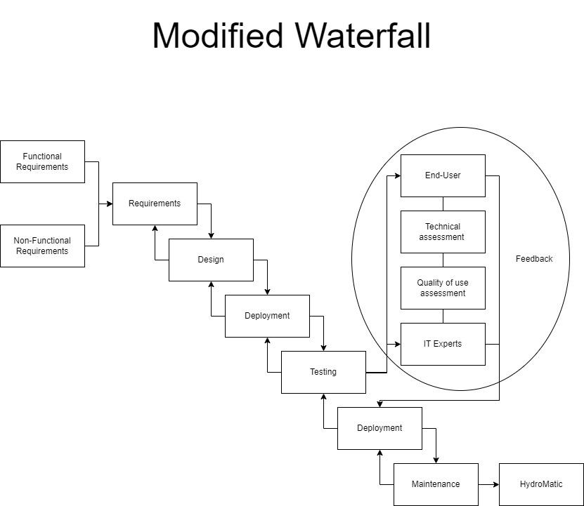

The conceptual framework of this study adopted the Modified Waterfall Model as a structured approach to guide the development of the HydroMatic project. This model organized the project lifecycle into defined stages, each incorporating feedback loops to allow continuous refinement and effective issue resolution.

The process began with gathering both functional and non-functional requirements. Functional requirements defined the system’s essential features, including water level and temperature monitoring, as well as notification alerts for farmers in case of critical conditions. Non-functional requirements focused on quality factors, such as system reliability and ease of use, to ensure practical functionality. Once requirements were defined, the team moved into the design phase, carefully planning the hardware setup with appropriate sensors and microcontrollers, defining the software architecture, and designing the web-based interface that farmers would use to interact with the system.

After finalizing the design, the researchers progressed to initial deployment in a controlled environment, where they assembled components, installed sensors, and implemented foundational software to verify basic functionality. This setup enabled early testing of core operations.

The testing phase followed, validating sensor accuracy for water level and temperature, as well as the functionality of notification alerts. This phase identified areas for improvement, and the feedback loop—a key aspect of the Modified Waterfall Model—enabled iterative refinements. Feedback was collected from multiple sources: end-users (farmers) assessed usability, technical experts reviewed hardware and software compatibility, quality assurance evaluations checked reliability, and IT experts evaluated system security. The team used this feedback to refine the system and address any issues identified during early testing.

After implementing improvements, the researchers conducted a final deployment in a real-world farming environment, where HydroMatic’s performance was observed under practical conditions to confirm that all components worked as expected. A maintenance phase was introduced to ensure ongoing functionality, which included regular checks of sensor accuracy, software updates, and troubleshooting.

The Modified Waterfall Model provided a solid foundation for building the HydroMatic project, enabling the creation of a reliable, automated system that monitored water level and temperature while alerting farmers to critical conditions. This structured yet iterative approach ensured that HydroMatic met both technical standards and end-user requirements, resulting in a robust solution customized for Kratky hydroponics farming.

# Statement of the Problem

The study focused on the design, development, and assessment of a web-based monitoring system for temperature, humidity, and pH levels.

Specifically, it sought to answer the following research questions:

1. How may the manual system be described based on the following constructs:

1.1 Security of Files and Records;

1.2 Management of Data;

1.3 Reliability of Output;

1. How may the system be described based on the stages of the Software Development Life Cycle which are:

2.1 Requirement Analysis;

2.2 System Design;

2.3 Architecture Design;

2.4 Module Design;

2.5 Coding;

2.6 Unit Testing;

2.7 Integration Testing;

2.8 System Testing; and

2.9 Acceptance Testing?

1. How may the system be evaluated by the IT experts following the qualifications of Software Characteristics standards which include:

3.1 Functional Suitability;

3.2 Performance Efficiency;

3.3 Compatibility;

3.4 Usability;

3.5 Reliability;

3.6 Security;

3.7 Maintainability; and

3.8 Portability?

1. How may the end-users assess the quality of the system based on the selected Software Characteristics standards which include:

4.1 Functional Suitability;

4.2 Performance Efficiency;

4.3 Usability;

4.4 Reliability; and

4.5 Security?

1. How may the IT experts assess the quality of the device following the criteria of ISO 30165 standards which include:

5.1 Time;

5.2 Control;

5.3 Computation; and

5.4 Communication?

1. How may the end users assess the quality of the device following the criteria of ISO 30165 standards which include:

6.1 Time;

6.2 Control;

6.3 Computation; and

6.4 Communication?

**Scope and Delimitation**

This study focused on developing a web-based monitoring system that utilized sensors to track the water level and temperature. The system displayed a graph of the tracked data and sent text message notifications to alert the user if the sensor detected an abnormality in the water. It also notified the user when the crops were ready for harvest. The system represented administrators and end-users as developers and farmers, respectively. Additionally, the system included graphs and logs to facilitate easy monitoring.

The researchers conducted the study at a hydroponic farm in Gapan, Nueva Ecija. The study evaluated the system's usefulness for the target end-users and assessed its efficiency. Other factors determined for evaluation included its effectiveness and overall system functionality. The necessary materials for completing the project were acquired with adequate financial resources and within the allotted time frame.

**Significance of the Study**

The following groups and individuals will benefit from the results of the proposed study:

**Aspiring Hydroponic Farmers**: This study will provide essential knowledge about hydroponic farming, offering guidance to help them begin their farming journey effectively. By learning about innovative farming practices such as hydroponics, aspiring farmers can make informed decisions, increasing their chances of success in a modern agricultural landscape. Additionally, the study will introduce them to technology-driven solutions, enabling them to adopt more efficient, sustainable farming techniques from the outset.

**Farmers:** The developed system will assist farmers in monitoring and tracking the growth of crops within hydroponic systems. It will also automate the watering system, ensuring the timely supply of water and nutrient solutions to the crops. This will reduce manual labor, improve crop yield consistency, and address issues related to resource wastage. By providing real-time data and alerts, the system will help farmers optimize growing conditions, leading to higher productivity and sustainability in their farming operations.

**Future Researchers**: This study will serve as a supplementary reference for future research on similar topics, contributing valuable insights and methodologies for subsequent studies. The integration of smart technologies in hydroponics represents an emerging area of interest in agricultural research, offering a wealth of data for further analysis and exploration. Future researchers will be able to build upon this study's findings to develop new innovations that can enhance the scalability and effectiveness of hydroponic farming systems.

**Present Researchers**: Engaging in this research will allow the researchers to acquire new knowledge, skills, and experiences, enriching their academic and professional development. The study offers hands-on experience with the application of technology in agriculture, fostering interdisciplinary learning. By addressing real-world agricultural challenges, the researchers will also contribute to the growing field of sustainable farming, enhancing their ability to tackle future issues in agricultural science and technology.

**Definition of Terms**

The following terminologies are operationally defined for enhanced clarity and understanding:

**Internet of Things (IoT)**: The Internet of Things (IoT) refers to a network of devices or physical objects that are interconnected through the internet, enabling them to exchange data and communicate with one another (Jansen, 2023). These devices can range from commonplace household items to sophisticated industrial machinery (Oracle, n.d.), and are commonly used to automate specific tasks by interconnecting different devices within a system.

**Arduino**: Arduino is an open-source platform used to develop electronics projects, featuring an Integrated Development Environment (IDE) that allows users to write and upload code necessary for a project (Sparkfun, n.d.). In practice, Arduino is widely employed in real-time control systems where programmable timing and automation are required for various applications.

**Short Message Service (SMS)**: Short Message Service (SMS) is a communication protocol used to send text messages over wireless networks. It operates across various generations of mobile networks, including 2G, 3G, 4G, and 5G, and is commonly used by cellular phones for fast and efficient digital communication (Android Authority, 2022). SMS is known for its practicality and widespread use in personal and business communication.

**Temperature and Humidity Sensor**: A temperature and humidity sensor is an electronic device designed to detect, measure, and report both air temperature and humidity levels. It measures the amount of moisture present in the air relative to the air's temperature, providing critical data for various applications, including environmental monitoring and climate control.

**Web-Based Application**: A web-based application is a type of software that does not require installation on a local device but can instead be accessed via a web browser from a remote server (Codecademy, 2023). These applications are typically developed using web technologies such as HTML, CSS, and JavaScript (Indeed, 2022), and may offer user interfaces for both end-users and administrators, depending on the services provided by the application.

**Chapter 2**

**METHODOLOGY**

This research section presents the systematic process for the successful development and implementation of the study. It includes the research design, study location, respondents, sampling technique, research instruments, data gathering procedures, and data analysis technique.

**Research Design**

This study employs a quantitative research design, which focuses on the systematic investigation of variables through measurable data to identify patterns, relationships, and statistical significance. This approach enables the researchers to gather numerical data, analyze it statistically, and derive conclusions that can be generalized to larger populations.

Developmental research encompasses a systematic study focused on the design, development, implementation, and evaluation of instructional programs and processes that adhere to the criteria of consistency and effectiveness. This research approach aims to generate knowledge that informs best practices in educational settings.

The software development process for this study employs the modified waterfall model, characterized by a sequential and linear flow of phases. In this model, each phase must be completed before the subsequent one can commence, ensuring a structured progression through the development lifecycle. The phases include requirements analysis, design, implementation, testing, and evaluation.

While the modified waterfall model primarily follows a linear trajectory, it incorporates specific feedback loops that facilitate revisions and improvements at earlier stages. This iterative aspect enables researchers to refine the instructional design and address any emerging issues, thus enhancing the overall effectiveness and quality of the developed instructional program. By systematically following this structured approach, the research ensures that the final product meets both the educational objectives and the needs of the intended users.

# Research Locale

Figure 2 shows the location map where the research locale is located.

**Figure 2**

**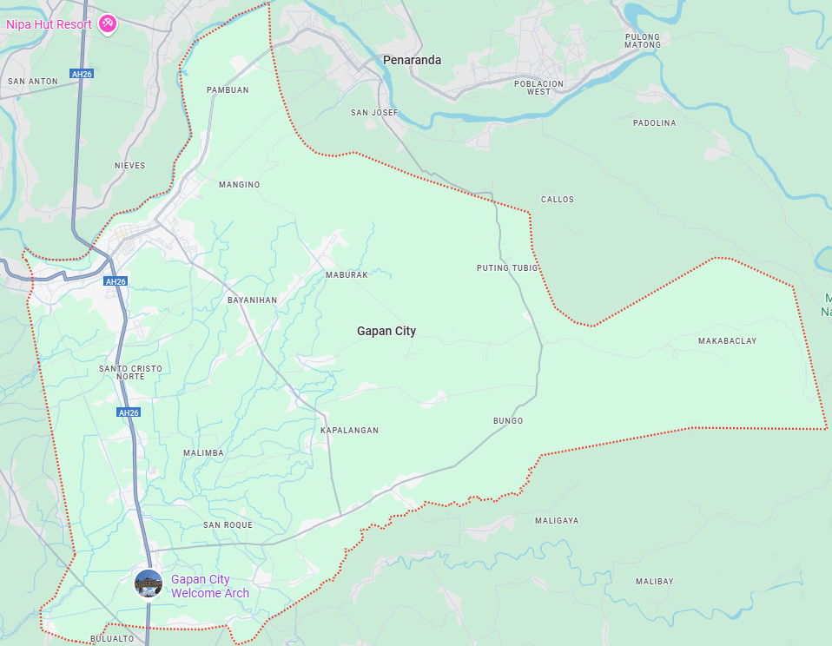***Map of Gapan City, Nueva Ecija*

This research was conducted in a hydroponic farm located in Gapan, Nueva Ecija, which is essential for understanding the practical applications of the proposed monitoring system in real-world settings. Hydroponic farming represents a modern approach to agriculture that addresses critical challenges such as land scarcity and efficient water management. By situating the study within an actual hydroponic farm, researchers can gather valuable insights into the practical implementation of the monitoring system, ultimately contributing to the optimization of resource utilization and promoting sustainable agricultural practices.

Furthermore, conducting the study in this specific location allows for direct engagement with local farmers and agricultural technicians, facilitating the collection of qualitative data that enriches the overall research findings. This interaction helps to identify the specific needs and challenges faced by end-users, ensuring that the developed system is tailored to their requirements. Overall, the choice of a hydroponic farm as the research site enhances the validity of the study and ensures that its outcomes are relevant and beneficial to local agricultural communities.

**Respondents of the Study**

The respondents of this study consisted of lettuce farmers from Nueva Ecija. Both manual farmers and semi-automatic hydroponic farmers of lettuce were selected as respondents, as they represented the potential users for this capstone project. By including both types of farmers, the study aimed to capture a comprehensive perspective on hydroponic farming practices and the challenges faced by different farming methodologies. Table 1 displays the distribution of the respondents.

# Table 1

## Distribution of Respondents

|  |  |  |
| --- | --- | --- |
| **Respondents** | **Frequency** | **Percentage** |
| IT Experts | 20 | 50% |
| Farmers using Traditional Farming Method | 10 | 25% |
| Farmers using Semi-Automated Farming Method | 10 | 25% |
| **Total** | 40 | **100%** |

According to the established categories, the respondents were equally divided, with ten manual farmers and ten semi-automatic hydroponic farmers participating in the study. This balanced approach ensured that the insights gathered reflected the diverse experiences and needs of farmers within the region, ultimately enhancing the relevance and applicability of the research findings.

**Sample and Sampling Technique**

In this study, the researchers employed purposive sampling for the selection of respondents. This approach allowed the researchers to gain insights into factors influencing individuals’ decisions to adopt technology.

Two groups of respondents participated in this study: IT experts and farmers. The IT experts were chosen based on their technical proficiency, theoretical knowledge, and expertise in software development. Farmers using both traditional and hydroponic farming methods were also included. This selection enabled the researchers to gather comparative data on the benefits and challenges associated with each farming method, providing a more comprehensive understanding of the practical implications of hydroponic technology.

**Research Instrument**

This study employed five distinct sets of survey questionnaires to comprehensively collect, measure, and evaluate data across different dimensions of the research objectives. Each questionnaire was specifically designed to capture targeted insights relevant to both manual and hydroponic farming practices, along with system performance and user experience.

The first questionnaire focused on the assessment of the manual farming system. Adapted from Ladinez et al. (2023) and modified to suit the context of this study, this set of questions evaluated the security of files and records, data management within the manual system, and the reliability of outputs produced using traditional methods. By doing so, the researchers gathered baseline data on the traditional farming methods, providing a stronger foundation for the justification to design and develop the system.

The second questionnaire aimed to evaluate the quality of the developed system according to specific software quality standards. It assessed various aspects of the system, such as functional suitability, performance efficiency, compatibility, usability, reliability, security, maintainability, and portability, from a technical perspective. Distributed to both traditional and hydroponic farmers, this set offered a comparative view of how well the system met quality standards and served as an indicator of its viability and utility within different farming contexts.

The third questionnaire evaluated the system's quality from the end-users' perspective, focusing on functional suitability, performance efficiency, usability, reliability, and security. This questionnaire allowed the researchers to capture practical insights from users regarding system performance in real-world settings, addressing usability concerns and confirming that the system effectively supported the needs of hydroponic farmers. Through these questionnaires, the study provided a well-rounded view of both the technical and user-centered aspects of the hydroponic monitoring system.

The fourth questionnaire assessed the technical quality of the device based on the ISO 30165 standards, covering time, control, computation, and communication. This set of criteria was also applied in the fifth questionnaire, which gathered views from the end-users. These survey instruments were essential to comprehensively collect data, enabling the researchers to draw significant insights for the design, development, and assessment of the system.

**Data Gathering Procedures**

The following phases served as the foundation for the procedures of this study:

**Phase I: Gathering of Materials**

The materials required for the physical component of the device were canvassed and acquired from authorized distributors. This phase involved sourcing all necessary components to ensure that the construction of the device would proceed smoothly. The researchers conducted a thorough review of the materials to ensure compatibility and quality standards before procurement.

**Phase II: Construction of the Device**

Following the acquisition of the materials, the device was constructed. Using a breadboard, the components were systematically arranged and connected through jumper wires. The researchers ensured that all connections were secure, and the layout was organized for optimal functionality. This phase also involved testing the initial assembly to confirm that the components were compatible and ready for programming.

**Phase III: Programming the Arduino**

The Arduino was programmed using the Arduino software (IDE). The codes were written based on the required functionality of the system, including specific tasks such as sensor inputs, data processing, and system responses. After programming, the researchers tested the code on the Arduino to verify its correct operation and made necessary adjustments to align with the desired outcomes.

**Phase IV: Designing and Constructing the Web-Based Application**

Both the back-end and front-end aspects of the device's system were developed. During this phase, all necessary input-output information and commands were integrated into the system. Several programming languages were utilized to ensure that the system met all functional and technical requirements, including responsiveness and user interface considerations. The researchers also incorporated features to ensure that the web-based application could seamlessly communicate with the device and manage the data effectively.

**Phase V: Pre-Testing of the Device**

The device underwent multiple trials and errors to test its functionality and ensure it met the study’s primary objectives. The researchers deliberated over the initial results, which were recorded in a table prior to analysis, and made improvements as necessary. This phase allowed for the identification of any potential issues in the system’s operation, which were addressed to refine its performance before the official testing phase.

**Phase VI: Testing and Data Gathering**

The researchers obtained authorization from the respondents before conducting the test and distributing the survey questionnaires. During this phase, both the physical device and the web-based system were assessed by the respondents. The researchers remained open to any additional questions, concerns, and suggestions made by the respondents to ensure a comprehensive evaluation. Feedback was meticulously recorded and analyzed to determine areas for further enhancement and to validate the system's effectiveness in real-world settings.

**Data Analysis Technique**

In analyzing the data collected, the following activities were employed.

1. To answer the first statement of the problem related to the security of files and records, management of data, and reliability of output, the researchers computed the mean rating. The scoring rubric in Table 2 was used to interpret the results appropriately.

# Table 2

*Scoring Rubric for Level of Agreement*

| **Range** | **Qualitative Remarks** | **Verbal Description** |
| --- | --- | --- |
| 3.26 – 4.00 | Strongly Agree | The range of 3.26 to 4.00 is considered "Strongly Agree" in the qualitative description. This means the respondent has a high level of agreement with the statement or question. It indicates that the respondent strongly supports or approves of the presented idea, concept, or statement. |
| 2.51 – 3.25 | Agree | The range of 2.51 to 3.25 is classified as "Agree," indicating that the respondent has a favorable view of the statement but not as strong as those in the "Strongly  Agree" category. |
| 1.76 – 2.50 | Disagree | The range of 1.76 to 2.50 is classified as "Disagree," which indicates that the respondent has an unfavorable view of the statement or question being asked. |
| 1.00 – 1.75 | Disagree Strongly | The range of 1.00 to 1.75 is classified as "Strongly Disagree," which indicates that the respondent has a Disagree high negative or unfavorable view of the statement or question being asked. |

1. For the second statement of the problem, the researchers outlined the activities planned for each stage of the software development model to provide valuable insights into the tasks involved. The discussion was supported by graphs and figures to address the research problem.
2. To address the third statement of the problem, the IT expert interpreted the system's technical qualities using the following tables to gain a better understanding of the evaluation results. Table 3 presented the scoring rubric for functional suitability.

**Table 3**

*Scoring Rubric for Functional Suitability*

| **Range** | **Qualitative Remarks** | **Verbal Description** |
| --- | --- | --- |
| 3.26 – 4.00 | Highly Suitable | The system meets or exceeds all  functional requirements with high accuracy, completeness, and efficiency. |
| 2.51 – 3.25 | *Suitable* | The system meets most of the functional requirements with satisfactory accuracy, completeness, and efficiency. |
| 1.76 – 2.50 | Unsuitable | The system meets some of the functional requirements but with low accuracy,  completeness, and efficiency. |
| 1.00 – 1.75 | Highly Unsuitable | The system fails to meet most or all of the functional requirements and has deficient accuracy, completeness, and efficiency. |

Table 4 displays the scoring criteria for Performance Efficiency.

**Table 4**

*Scoring Rubric for Performance Efficiency*

| **Range** | **Qualitative Remarks** | **Verbal Description** |
| --- | --- | --- |
| 3.26 – 4.00 | Excellent | The system's performance is exceptional, meeting or exceeding all efficiency requirements. Users experience no delays or errors, and the system performs consistently well under all operating conditions. |
| 2.51 – 3.25 | Good | The system's performance is above average and meets most efficiency requirements. Users experience minimal delays and errors, and the system performs well under normal operating conditions. |
| 1.76 – 2.50 | Fair | The system's  Performance is average, but there is room for improvement. Users may experience occasional delays or errors, but the system functions adequately overall. |
| 1.00 – 1.75 | Poor | The system's performance could improve and meet the minimum requirements for efficient operation. Users may experience delays, errors, and other issues negatively affecting productivity. |

Table 5 presents the scoring rubric for compatibility.

**Table 5**

*Scoring Rubric for Compatibility*

| **Range** | **Qualitative Remarks** | **Verbal Description** |
| --- | --- | --- |
| 3.26 – 4.00 | Highly compatible | The system or software is fully with other hardware or compatible software and can seamlessly integrate. |
| 2.51 – 3.25 | Compatible | The system or software can work with hardware  or software with minor adjustments or  configurations. |
| 1.76 – 2.50 | Somewhat compatible | The system or  software can work with other hardware or software significant adjustments or configurations. |
| 1.00 – 1.75 | Not compatible | The system or software cannot work with other hardware or software and needs a complete overhaul or replacement. |

Table 6 presents the scoring rubric for usability.

**Table 6**

*Scoring Rubric for Usability*

| **Range** | **Qualitative Remarks** | **Verbal Description** |
| --- | --- | --- |
| 3.26 – 4.00 | Excellent | The system is easy to use and navigate, and users can easily accomplish their tasks. The system is well-designed,  intuitive, and efficient. Users rarely encounter errors or obstacles and are highly satisfied with the system. |
| 2.51 – 3.25 | Good | The system is generally easy to use, but there may be some minor usability issues or areas where improvement is needed. Users may encounter occasional obstacles or errors, but these do not  significantly impede their ability to  complete tasks. Users are generally satisfied with the system. |
| 1.76 – 2.50 | Fair | The system has significant usability issues that make it difficult or frustrating for users to accomplish tasks. Users may encounter frequent errors or obstacles that impede their progress. The system may need to be better designed or require significant effort. Users are generally dissatisfied with the system. |
| 1.00 – 1.75 | Poor | The system is difficult or impossible to use, and users cannot accomplish their tasks. The system may be unusable due to significant errors or obstacles. The system is poorly designed or requires significant effort to use. Users are highly dissatisfied with the system. |

Table 7 displays the scoring rubric for reliability.

**Table 7**

*Scoring Rubric for Reliability*

| **Range** | **Qualitative Remarks** | **Verbal Description** |
| --- | --- | --- |
| 3.26 – 4.00 | Highly Reliable | A highly reliable system consistently delivers accurate results and has a low probability of failing. It operates without errors and is dependable,  consistent, and trustworthy. |
| 2.51 – 3.25 | Moderately Reliable | A moderately reliable system usually works, but occasional errors may occur. It has a moderate probability of failing, but the overall performance is acceptable. |
| 1.76 – 2.50 | Slightly Reliable | A slightly reliable system is prone to errors and may fail occasionally. It is likely to fail, and its overall performance could be better. |
| 1.00 – 1.75 | Not Reliable | A not reliable system is one that consistently delivers inaccurate results and has a high probability of failing. It is  unreliable, inconsistent, and cannot be trusted. |

Table 8 presents the scoring rubric for security.

**Table 8**

*Scoring Rubric for Security*

| **Range** | **Qualitative Remarks** | **Verbal Description** |
| --- | --- | --- |
| 3.26 – 4.00 | Strong Security | The system has multiple security measures that provide comprehensive protection against unauthorized access, data breaches, and other security threats. The security features are regularly updated and tested to ensure that they effectively prevent and detect potential security breaches. |
| 2.51 – 3.25 | Adequate Security | The system has basic security measures in place that are effective in preventing most.  However, some areas of vulnerability and additional security measures may need to be implemented. |
| 1.76 – 2.50 | Weak Security | The system has significant security vulnerabilities that need to be addressed. There may be gaps in the security measures that allow unauthorized access, data breaches, and other security threats. Immediate action is needed to improve. |
| 1.00 – 1.75 | No Security | The system has no security measures, or the existing measures could be more effective. The system is highly vulnerable to security breaches and data. |

Table 9 displays the scoring criteria for maintainability.

**Table 9**

*Scoring Rubric for Maintainability*

| **Range** | **Qualitative Remarks** | **Verbal Description** |
| --- | --- | --- |
| 3.26 – 4.00 | Excellent | The software system is highly maintainable.  Modifications can be made effortlessly, and the system is flexible and adaptable to changes. |
| 2.51 – 3.25 | Good | The system has  excellent documentation, making it easy to understand and modify. The code is well-organized, making it easy to maintain and extend. |
| 1.76 – 2.50 | Fair | The software system is somewhat maintainable. While it may still require some effort to make changes, modifications can be made without introducing new errors or defects. The system has some documentation, making it easier to understand the code. |
| 1.00 – 1.75 | Poor | The software system is challenging to maintain and modify.  It requires significant effort to make changes to the system, and  modifications may introduce new errors or defects. The system lacks proper documentation, making Understanding and maintaining the code is challenging. |

Table 10 displays the scoring rubric for portability.

**Table 10**

*Scoring Rubric for Portability*

| **Range** | **Qualitative Remarks** | **Verbal Description** |
| --- | --- | --- |
| 3.26 – 4.00 | Excellent Portability | The software is highly portable and can run on multiple platforms without modification. It is designed to be platform-agnostic and can adapt to different platforms seamlessly. The software has no platform-specific  dependencies and configurations and can be installed and run on different platforms with ease. |
| 2.51 – 3.25 | Good Portability | The software is designed to be portable and can be easily ported to other platforms with minimal effort. The software has minimal platform-specific  dependencies and configurations and can be run on various platforms without significant modifications. |
| 1.76 – 2.50 | Fair Portability | The software can be ported to other platforms with moderate effort, but some issues still need to be resolved. The software may have some platform-specific  Dependencies or configurations that must be adjusted for each platform. |
| 1.00 – 1.75 | Poor Portability | The software has limited portability and can only run on a specific platform or operating system. It requires significant effort and modification to make it run on other platforms. |

1. In addressing problem statement number four, mean ratings were calculated. Rubric tables for Functional Suitability, Performance Efficiency, Usability, Reliability, and Security were used to assess the relevant aspects of the system.
2. In addressing problem statements number five and six, the mean ratings for the assessment using ISO 30165 were interpreted using a rubric. Table 2 served as the scoring rubric for these evaluations.

# Ethical Considerations

The researchers of this study recognized the utmost significance of following ethical guidelines to safeguard the welfare and rights of the respondents. They strictly adhered to a set of ethical considerations throughout the study.

The respondents who participated in the study were provided with complete information regarding the intent and goals of the research, the methods used, and the potential advantages and disadvantages. Before giving their consent to participate, they were given the opportunity to ask for clarification and raise any concerns they had.

The confidentiality of the respondents' identities was guaranteed by the researchers. The data collected was treated with the highest level of confidentiality and was only accessible to the researchers involved in the study. The data was securely stored, and the study only presented aggregate data.

The study respondents were given the freedom to participate without any coercion or pressure. They had the option to withdraw from the study at any point without facing any penalty or consequence.

The researchers took precautions to safeguard vulnerable populations, including minors and individuals with disabilities, to prevent exploitation and reduce risk. The safety and well-being of these populations received special attention to ensure they were not put in harm's way.

Throughout the study, the researchers consistently upheld a high level of integrity. They ensured that the study was conducted in an ethical and professional manner, and that the results were reported with accuracy and objectivity. In summary, the researchers abided by ethical principles such as informed consent, anonymity and confidentiality, voluntary participation, protection of vulnerable populations, and maintaining researcher integrity while conducting the study.

**Chapter 3**

**RESULTS AND DISCUSSION**

This chapter presents the results and discussion on the development and evaluation of HydroMatic: A web-based solution for hydroponics farming powered by an IoT monitoring system and SMS notification system.

**1. Assessment of the Manual System**

The evaluation of the *HydroMatic: Web-based Solution for Hydroponics Farming Powered with IoT Monitoring System and SMS Notification System* was conducted based on established software characteristics criteria. These criteria included the security of files and records, management of data, and reliability of output. This framework provided a comprehensive approach to assessing the system's performance in terms of data protection, operational efficiency, and the accuracy of the results produced by the system.

* 1. **Security of Files and Records**

Table 11 presents the results of the assessment on the security of files and records in the manual system, as evaluated from the perspective of the end-users.

**Table 11**

*Result of the Assessment on the Security of Files and Records using manual system*.

| **Item Statements** | **Weighted Mean** | **Verbal Description** |
| --- | --- | --- |
| The manual system often leads to lost or misplaced files. | 2.20 | Disagree |
| There is a lack of control over who has access to files and records. | 2.10 | Disagree |
| The manual system is vulnerable to theft or unauthorized access. | 2.60 | Agree |
| The manual system does not provide adequate backup or disaster recovery options. | 2.90 | Agree |
| The manual system is prone to errors, including data entry mistakes and transcription errors. | 3.00 | Agree |
| The manual system is difficult to update and maintain, leading to outdated or incorrect information. | 2.50 | Disagree |
| The manual system does not provide a complete audit trail of who has accessed or modified records. | 2.80 | Agree |
| The manual system does not provide the necessary confidentiality and privacy protections for sensitive information. | 3.00 | Agree |
| The manual system is time consuming and labor-intensive to use and manage. | 3.20 | Agree |
| **Overall Grand Mean** | | **2.70** |
| **Overall Verbal Description:** | | **Agree** |

End-users assessed the security of files and records within the manual system and identified several significant issues, each with corresponding mean ratings. They noted that the system often resulted in lost or misplaced files, which received a mean rating of 2.20, highlighting a major concern with file management. Additionally, there was a lack of control over who could access files and records, with a mean rating of 2.10, raising issues related to security and unauthorized access. The manual system was also seen as vulnerable to theft or unauthorized access, which was reflected in the mean rating of 2.60. Furthermore, the system lacked adequate backup or disaster recovery options, with a mean rating of 2.90, making it prone to data loss in the event of system failures. Errors, including data entry mistakes and transcription errors, were frequent, with a mean rating of 3.00, leading to concerns about data accuracy. The system was difficult to update and maintain, resulting in outdated or incorrect information, and it received a mean rating of 2.50 in this regard. It also did not provide a complete audit trail for tracking who had accessed or modified records, which was rated with a mean of 2.80. Additionally, it failed to offer sufficient confidentiality and privacy protections for sensitive information, with a mean rating of 3.00, which posed a risk to data security. Finally, the manual system was time-consuming and labor-intensive, which received the highest mean rating of 3.20, further increasing the workload and contributing to inefficiency. These findings underscored the need for a more secure and efficient system to address these challenges.

Gupta et al. (2024) emphasized the critical importance of file integrity in safeguarding data, arguing that it is essential for ensuring that files remain unchanged and uncorrupted throughout their lifespan. To verify file integrity, cryptographic hashing techniques are used, which involve generating a unique hash value for each file, acting as a digital fingerprint. If any changes occur to the file, the hash value will also change, signaling potential tampering. Comparing the calculated hash value with the stored original value enables the detection of any alterations. This verification process is crucial for maintaining the reliability and accuracy of data, protecting it from unauthorized modifications, and ensuring that it remains trustworthy.

The findings highlight the critical need for a more secure and efficient system to safeguard data integrity, reduce errors, and ensure that sensitive information is properly protected. Given these challenges, the development of a more robust, automated system is essential. Such a system would address these issues by providing better control over file access, enhanced security features, and reliable backup options, thereby improving overall data management, reducing risks, and ensuring the accuracy and reliability of information.

**1.2 Management of Data**

Table 12 shows the Management of Data of the system based on the assessment by the end-users.

**Table 12**

*Results of the Assessment on the Management of Data using manual systems.*

| **Item Statements** | **Weighted Mean** | **Verbal Description** |
| --- | --- | --- |
| The manual system results in errors in data entry. | 3.10 | Agree |
| The manual system leads to inefficient data retrieval and storage | 2.80 | Agree |
| The manual system takes up too much time and resources | 3.10 | Agree |
| The manual system lacks the ability to perform complex data analysis | 3.20 | Agree |
| The manual system is prone to data loss or corruption. | 2.70 | Agree |
| The manual system lacks data security and confidentiality. | 2.90 | Agree |
| The manual system lacks the ability to integrate with other systems. | 2.80 | Agree |
| The manual system requires manual processing and handling of paperwork. | 3.30 | Agree |
| The manual system lacks real-time data updates and reporting. | 3.20 | Agree |
| The manual system lacks the ability to scale and handle larger volumes of data | 3.20 | Agree |
| **Overall Grand Mean** | | **3.03** |
| **Overall Verbal Description** | | **Agree** |

End-users assessed the manual system’s management of data using ten statements, each addressing a distinct aspect of the system's effectiveness. The system was found to result in errors in data entry, which was rated with a mean of 3.1, indicating a significant issue with accuracy. Additionally, data retrieval and storage were inefficient, as reflected by a mean rating of 2.8, suggesting that users experienced delays and difficulties accessing necessary data. The manual system was also found to be time-consuming and resource-intensive, with a mean rating of 3.1, further emphasizing its inefficiency. Users highlighted the lack of capability for complex data analysis, which received a mean rating of 3.2, pointing to the limitations of the system in handling more sophisticated data processing tasks. Another concern was the system's vulnerability to data loss or corruption, which had a mean rating of 2.7, exposing the risks associated with using the manual system for long-term data storage. The manual system was also criticized for its lack of data security and confidentiality, with a mean rating of 2.9, raising concerns about the protection of sensitive information. Users also pointed out the system's inability to integrate with other systems, as reflected in the mean rating of 2.8, which limited its compatibility with other technologies. The need for manual processing and handling of paperwork was another limitation, with a mean rating of 3.3, contributing to the system's inefficiency. The absence of real-time data updates and reporting capabilities received a mean rating of 3.2, further undermining the system’s effectiveness in providing timely and relevant information. Finally, the manual system’s inability to scale and manage larger volumes of data was rated with a mean of 3.2, revealing that it could not meet the growing demands of the organization.

These findings highlight the pressing need for a more efficient and reliable data management system. The challenges identified, such as frequent errors, inefficiency, lack of integration, and the inability to handle large data volumes, point to significant limitations that hinder productivity and data accuracy. Existing research, including the work of Chinyemba et al. (2005), further supports these observations, with studies noting similar issues in records management within higher education institutions. The findings suggest that a transition to a more advanced system, such as an electronic or automated records management system, would be essential to address these problems. By implementing such a system, institutions can enhance data accuracy, improve retrieval efficiency, enable real-time reporting, and ensure greater data security and scalability. Therefore, the development of a new system is necessary to streamline operations, reduce human error, and better support the organization’s data management needs in the long term.

**1.3 Reliability of Output**

Table 13 shows the Reliability of Output of the system based on the assessment by the end-users.

**Table 13**

*Results of the Assessment on the Reliability of Output using Manual Systems*

| **Item Statements** | **Weighted Mean** | **Verbal Description** |
| --- | --- | --- |
| The manual system produces inaccurate outputs. | 2.70 | Agree |
| The manual system is prone to errors in data entry | 3.10 | Agree |
| The manual system is time consuming and inefficient. | 2.90 | Agree |
| The manual system requires significant effort to maintain and update. | 3.30 | Agree |
| The manual system lacks consistency in output quality. | 2.90 | Agree |
| The manual system is susceptible to data loss and corruption. | 2.90 | Agree |
| The manual system is difficult to use for complex data analysis. | 3.10 | Agree |
| The manual system is not scalable to accommodate increased workload. | 3.20 | Agree |
| The manual system is highly dependent on individual users' skills and knowledge. | 3.10 | Agree |
| The manual system lacks security measures to protect confidential data. | 2.80 | Agree |
| **Overall Weighted Mean** | | **3.03** |
| **Overall Verbal Description** | | **Agree** |

End-users assessed the manual system’s reliability of output using ten-item statements, which evaluated various aspects of the system’s performance. The system was found to produce inaccurate outputs, with a mean rating of 2.70, indicating a recurring issue with the quality of results. Users also reported that the system is prone to errors in data entry, receiving a mean rating of 3.10, which further undermines its reliability. The manual system was considered time-consuming and inefficient, with a mean rating of 2.90, highlighting the significant delays and inefficiencies associated with its operation. Additionally, maintaining and updating the system required considerable effort, as evidenced by the mean rating of 3.30, which suggests that the system is not user-friendly or easily adaptable to changing needs. Users noted that the system lacks consistency in output quality, with a mean rating of 2.90, which points to fluctuating performance and unreliable results. The system was also found to be susceptible to data loss and corruption, with a mean rating of 2.90, further compromising its dependability. Another significant limitation was the difficulty of using the manual system for complex data analysis, with a mean rating of 3.10, which highlights the system's inability to handle more advanced tasks. The system’s lack of scalability to accommodate increased workloads was also noted, with a mean rating of 3.20, indicating that it cannot grow with the demands of the organization. The system’s heavy reliance on individual users' skills and knowledge was rated 3.10, underscoring the inconsistency in output based on user competence. Finally, the system’s lack of security measures to protect confidential data received a mean rating of 2.80, raising concerns about the protection of sensitive information.

These findings reveal significant issues regarding the reliability of the manual system’s output. The recurring problems of inaccurate outputs, data entry errors, inefficiency, and inconsistency suggest that the manual system is not a dependable solution for data management and analysis. Furthermore, its lack of scalability and security measures, along with the heavy reliance on individual users, only exacerbate its shortcomings. In light of these challenges, it is evident that a more reliable system is needed. The development of an automated or electronic system could help address these issues by ensuring greater consistency, reducing human error, improving scalability, and enhancing security. Such a system would not only improve the reliability of the output but also contribute to more efficient and secure operations in the long run, making it essential for the organization’s future growth and success.

**TABLE 14**

*Summary of the Assessment by End-Users on the Manual System*

|  |  |  |
| --- | --- | --- |
| **Software Characteristics** | **Weighted Mean** | **Verbal Description** |
| Security of Files and Records | 2.70 | Agree |
| Management of Data | 3.03 | Agree |
| Reliability of Output | 3.03 | Agree |
| **Grand Mean** | **2.92** | **Agree** |

The summary of the assessment by end-users on the manual system reveals that the system was evaluated across three key software characteristics: Security of Files and Records, Management of Data, and Reliability of Output. The assessment yielded a weighted mean of 2.70 for the security of files and records, which falls within the "Agree" category, indicating that users generally felt the manual system had some security measures in place, but there were notable concerns regarding its effectiveness. The management of data received a slightly higher mean of 3.03, also classified as "Agree," suggesting that while users found the data management process to be functional, it may not be as efficient or secure as desired. Similarly, the system's reliability of output also received a mean of 3.03, indicating that users were generally satisfied with the reliability of results, but again, there were areas for improvement. The overall grand mean of 2.92, categorized as "Agree," suggests that while users recognize the system’s functionality, they perceive significant room for enhancement in all aspects assessed.

These findings imply that the manual system, while somewhat satisfactory in its current state, faces significant challenges in key areas that impact its effectiveness. The security of files and records, in particular, is an area where improvements are necessary to ensure that sensitive data is adequately protected. Similarly, the management of data and the reliability of output, although deemed acceptable, indicate inefficiencies that could be addressed through automation or modernization of the system. The implication of these results is clear: there is a pressing need to develop a more robust system to overcome these challenges. Implementing a digital or automated system could significantly enhance data security, streamline management processes, and improve the reliability of output, ultimately leading to more efficient and secure operations. This development would not only address the shortcomings identified in the assessment but would also contribute to the system's long-term sustainability and effectiveness.

**2. The Design and Development of the System following the Stages of the Software Development Life Cycle**

**2.1 Requirement Analysis**

An essential part of software development was requirement analysis. Its main objective was to collect and examine the requirements needed by the software system. Since it outlined the project's goals and requirements, this phase formed the fundamental basis of the entire software development process.

The researchers thoroughly examined the system's breadth in order to clarify the prerequisites for obtaining it and to understand its features and functionalities. To ensure that the criteria were precise and comprehensive to prevent issues during development, the researchers conducted user interviews and observations. A Gantt chart with the stages and months required to complete each process was created by the researchers. The entire strategy and projected timeline for the system's development were shown in the Gantt chart.

**Figure 3**

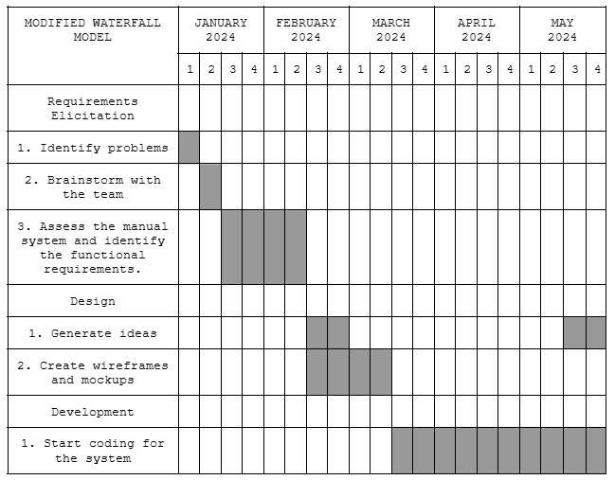*Gantt Chart of Activities from January to October 2024*

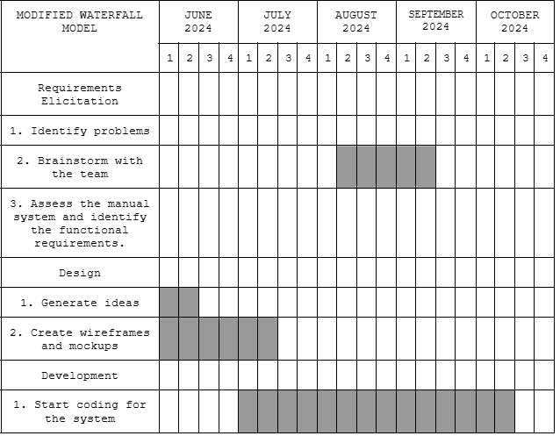

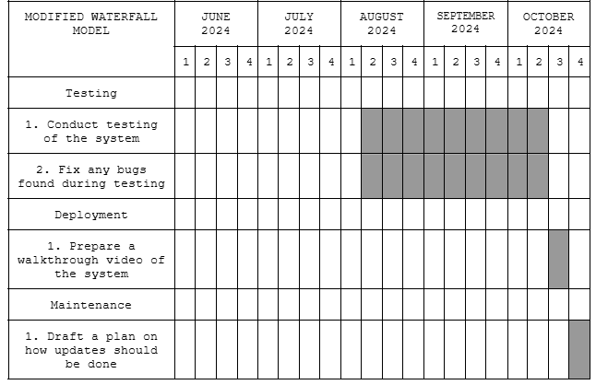

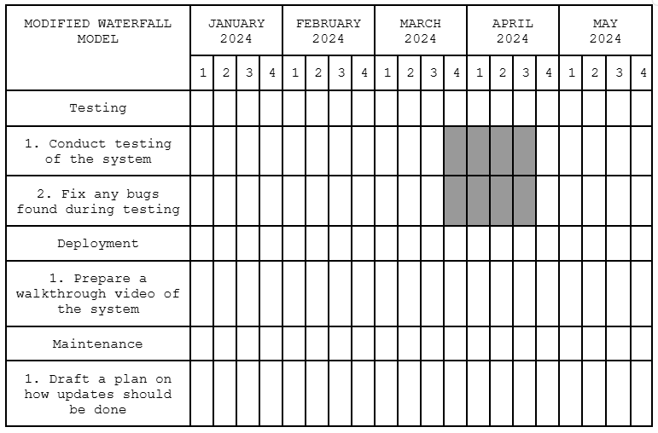

This visualized the development process of the system. The researchers convened in the second week of January to identify the problems related to their research, after which the team proceeded with brainstorming in the following week. The assessment of the manual system and the identification of functional requirements began in the last week of January and continued into the first week of February. Subsequently, the design process commenced, starting with idea generation and the creation of wireframes and mockups, which lasted until the last week of February.

The development process began with the researchers coding the system and the device from March through May. Afterward, they conducted system testing and addressed any bugs discovered during the testing phase.

In the last week of June through the second week of July, the researchers reconvened to generate more ideas and refine the wireframes and mockups. The brainstorming continued throughout August as they developed additional ideas.

The revision of the device and system codes started in mid-July and continued until mid-October. During this period, the researchers also conducted testing and addressed any bugs that arose.

Finally, the researchers prepared a walkthrough video of the system, demonstrated the device setup, and drafted a plan for future updates.

**2.2 System Design**

The system design phase was a crucial step in the adapted waterfall model, where the gathered and analyzed requirements were transformed into a tangible product. During this phase, the researchers created various diagrams to provide a clear and comprehensive roadmap for the development process. These diagrams, such as use case diagrams, data flow diagrams, and flowcharts, served as visual representations of the system's functionality, structure, and interactions.

Use case diagrams illustrated the interactions between the system and its users, outlining the specific tasks and functionalities that the system had to perform. Data flow diagrams depicted the flow of data through the system, highlighting the various processes, data stores, and external entities involved. Flowcharts, on the other hand, provided a step-by-step visualization of the system's logic and decision-making processes.

By creating these diagrams, the researchers effectively communicated the system's design to developers and stakeholders, ensuring that everyone involved had a shared understanding of the system's intended behavior. This helped prevent misunderstandings, reduced the risk of errors, and ultimately ensured that the final product met the specified requirements.

**Figure 4**

*Flowchart for the User*

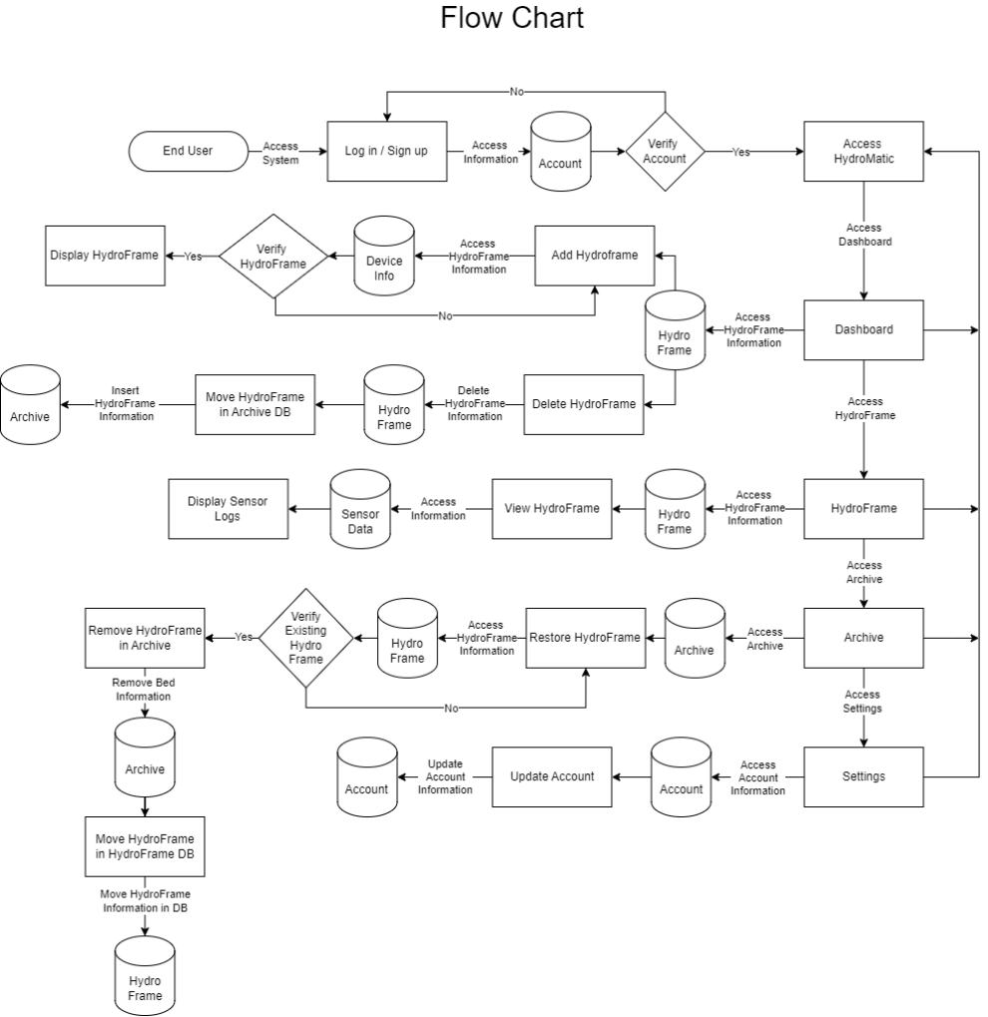

Figure 4 depicted the overall system flowchart for the end-user. The system began with user registration or login. New users proceeded to the registration process, while existing users directly accessed the login process. Once the user successfully logged in, they were directed to the HydroMatic dashboard. From there, users could create and delete beds, as well as access their created beds. After deleting a HydroFrame, the user could check the deleted HydroFrame in the archive. Additionally, users had the option to edit their account information in the settings.

**Figure 5**

*Flowchart for the System Administrator*

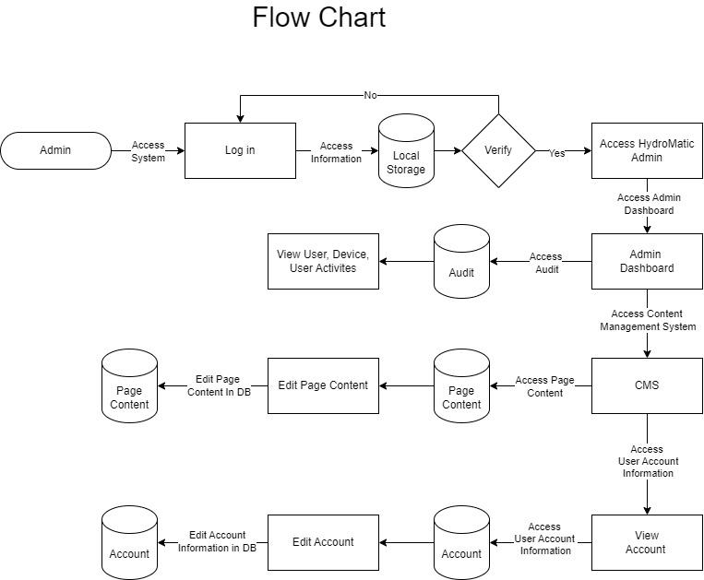

Figure 5 presented the overall system flowchart for the admin. The system began with the login process to verify the admin and ensure security. After logging in, the admin accessed the dashboard, where they could view the initial user accounts, user activity, and HydroFrames. In the content management system, the admin was able to edit the landing page content. Additionally, under the account section, the admin had the capability to edit user account details.

**Figure 6**

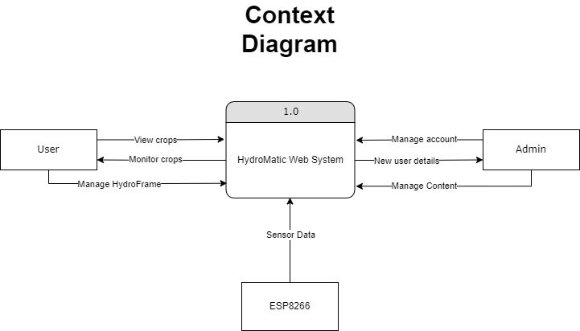*Context Diagram*

Figure 6 illustrated the components and interactions between both the user and the admin. The admin held the central role in system management and configuration, ensuring that the HydroMatic operated effectively. The user was able to view and manage the HydroFrames. The ESP8266 interacted by sending data from the device.

**Figure 7**

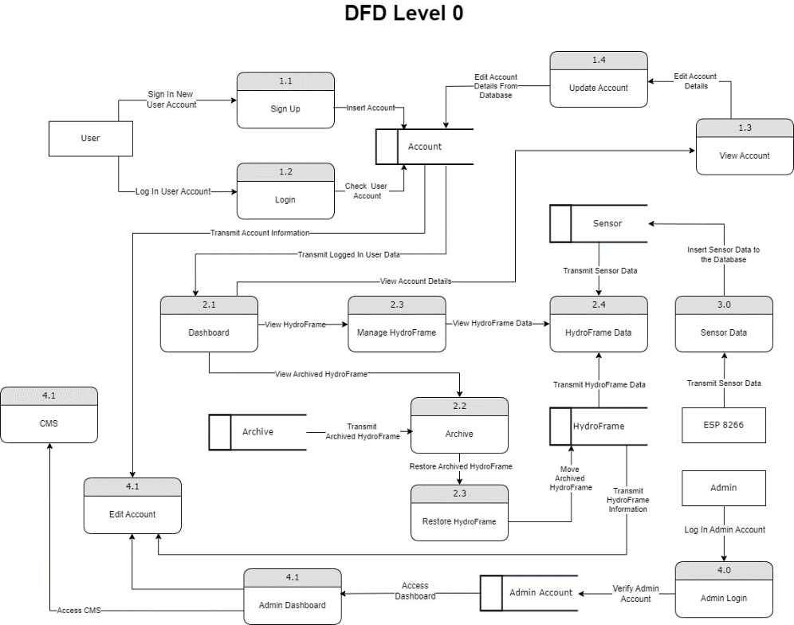*Level 0 Data Flow Diagram*

Figure 7 illustrated the level 0 data flow diagram. The process initiated the user into the registration or login process of the system. After a successful login, the user was directed to the dashboard, where they could manage their HydroFrames, update their account, and view the archived HydroFrames. As for the admin, the admin proceeded with the login process. After logging in, the admin could access the admin dashboard, edit accounts, and access the content management system (CMS).

**Figure 8**

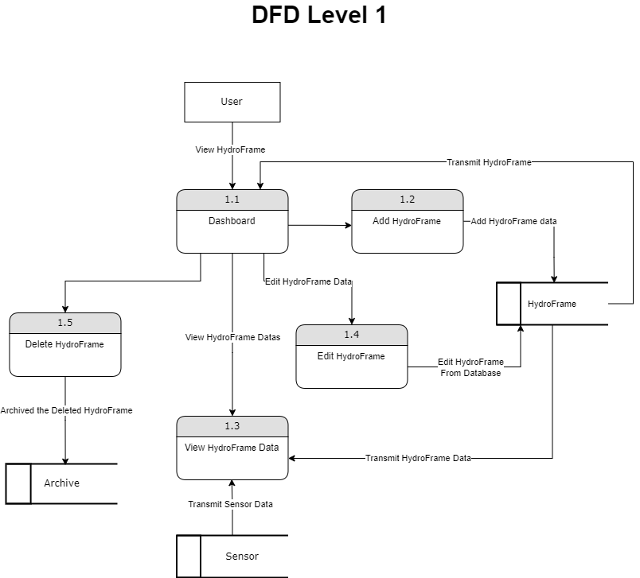*Level 1 Data Flow Diagram*

Figure 8 illustrated the Level 1 Data Flow Diagram of the system. It began with the user logging in, after which the user could access the dashboard, where they could add, edit, view, and delete Hydroframes.

**Figure 9**

*Use Case Diagram*

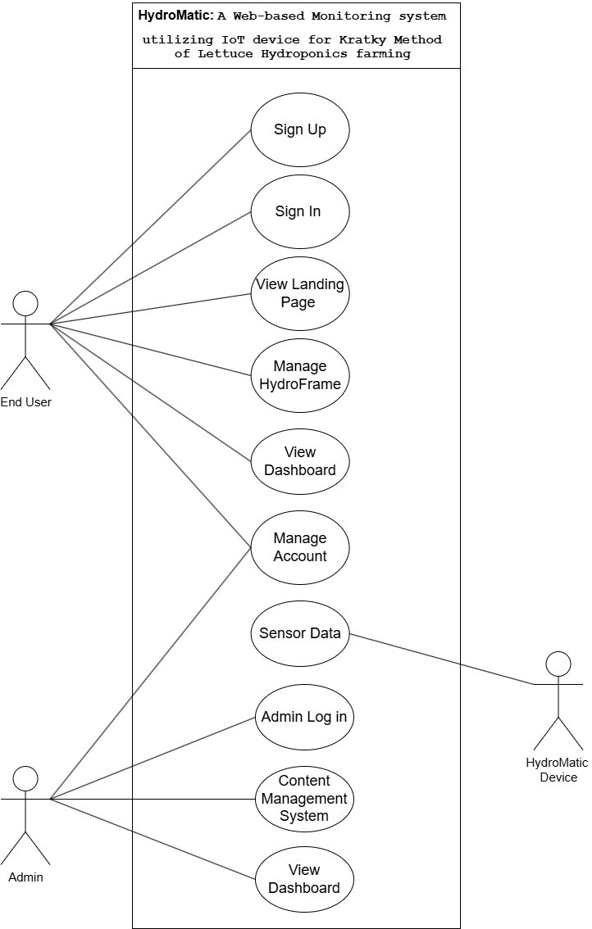

Figure 9 presented the use case diagram of the system. Use case diagrams represented the functional requirements and depicted how users interacted with the system. The diagram illustrated the interactions between the user and the system, where users could log in, sign up, view the landing page, add a HydroFrame, view a HydroFrame, remove a HydroFrame, restore a HydroFrame, and view the dashboard. Users were also able to manage their data by updating and editing their information. The admin had the ability to log in, access the CMS, and view the dashboard. Additionally, the admin could update an account. The HydroMatic device was responsible for sensing data.

**Figure 10**

*Schematic Diagram*

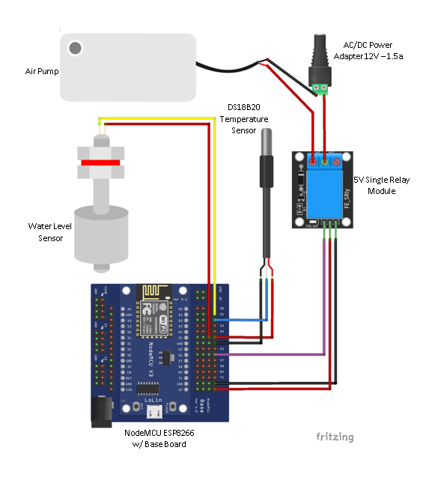

Figure 10 displayed the schematic diagram of the device. This diagram illustrated the connections and components used to enable the device's functionality. The air pump, which provided aeration to the water for the roots, was connected to a relay to control its operation. The water level and temperature sensors were used to monitor the quality of the water. The ESP8266 was responsible for transmitting the data collected by the sensors to the server.

**2.3 Architecture Design**

Architecture design is a high-level plan for a system that defines the components, interactions, data flow, technology, and deployment strategies. Its primary objectives are to meet the system's requirements, enhance maintainability, improve performance, manage complexity, and foster collaboration. Common design paradigms include layered, microservices, event-driven, and client-server architectures.

After completing the system design, the researchers developed a schematic diagram to visually represent the hardware components and their connections. The researchers employed data normalization techniques to organize the data into tables and created a data dictionary to ensure clarity and accuracy in the database's structure, organization, and the meaning of its data elements.

**Database Design**

Database design is the process of planning and creating a database structure that effectively stores, organizes, and manages data. It involves defining entities, attributes, relationships, and constraints to ensure data integrity, consistency, and efficient retrieval.

To reduce data redundancy and improve data integrity, the researchers structured and organized the relational databases using normalization.

**Figure 11**

*Unnormalized Form*

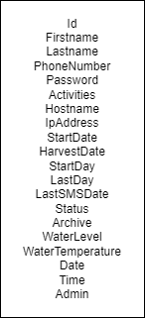

**Figure 12**

*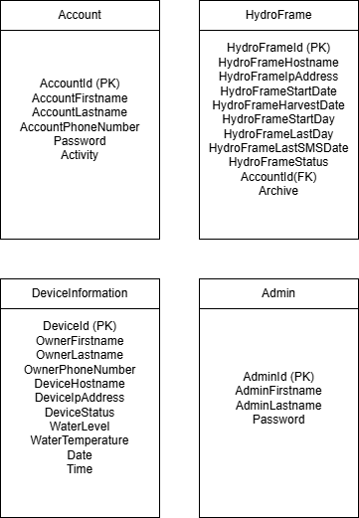First Normal Form*

**Figure 13**

*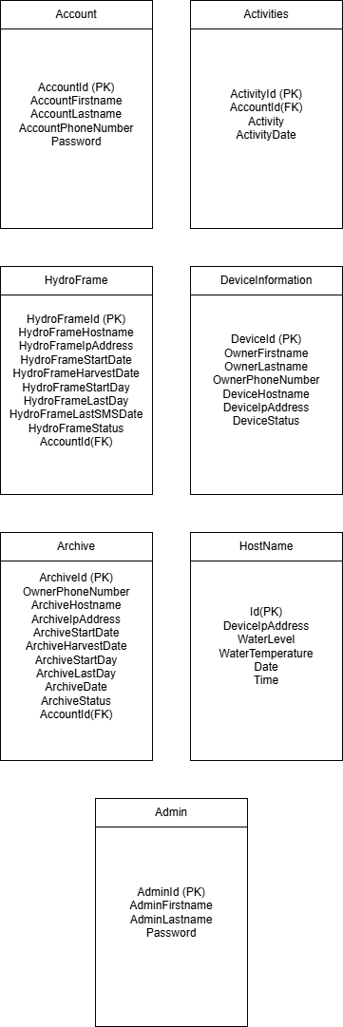Second Normal Form*

**

The figures above show the data normalization process. Data normalization contributed to the effective structure of the HydroFrame data by reducing redundancy and improving data precision. It facilitated easier data maintenance and retrieval, enhancing the reliability and efficiency of the system.

**Figure 14**

*Entity Relationship Diagram*

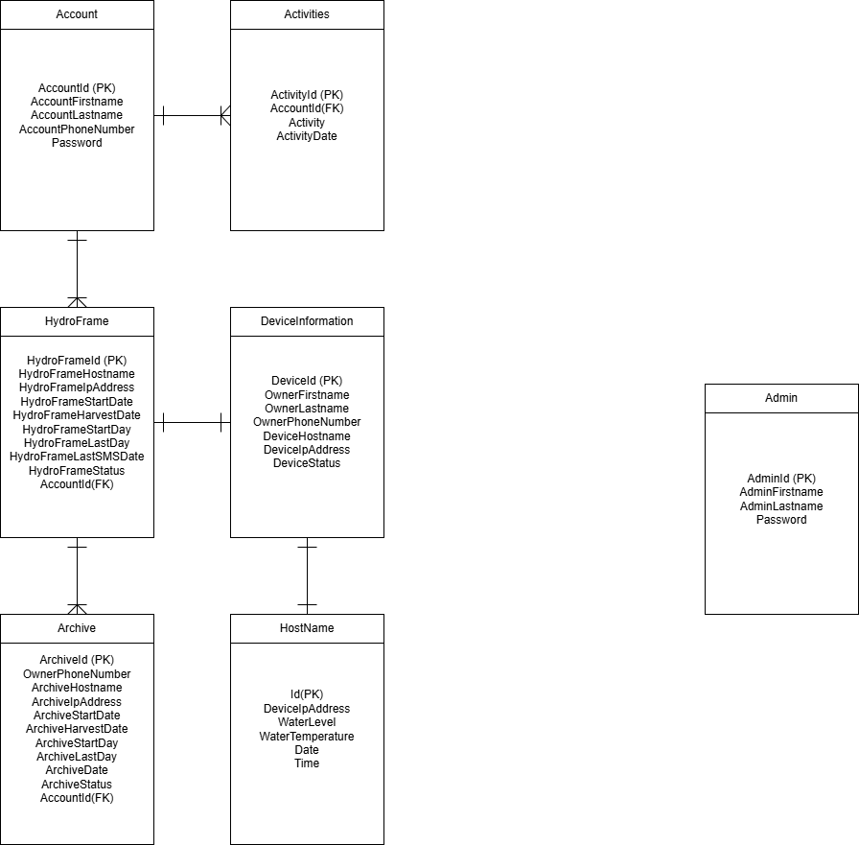

Figure 14 illustrates the entity relationship diagram of the system. The user’s information is stored in the Account’s table, it is connected in the Activity table where the relationship between them is one account has many activities, also it is connected to the HydroFrame table, it also has a one-to-many relationship. The HydroFrame table has a connection with Device information table where the relationship between them is one HydroFrame per one device. Also, the HydroFrame has a connection with the Archive Table where the removed HydroFrames are stored. The Device information has a connection with the Hostname Table where the sensors store data.

**Data Dictionary**

A centralized repository that provides definitions and metadata for data elements within an organization serves as a reference guide, documenting the meaning, format, usage, and relationships of various data fields.

**Table 15**

*Data Dictionary of Table Admin*

| **Field Name** | **Data Type** | **Size** | **Description** |
| --- | --- | --- | --- |
| AdminId  (PK) | int | 10 | This is the unique identification number of the administrator composed of numeric characters from 0-9 with the maximum of 10 numeric characters. |
| AdminUsername | varchar | 10 | This is the admin user name of the administrator composed of alphanumeric characters from a-z, A-Z,and 0-9 with the maximum of 10 alphanumeric characters. |
| AdminPassword | varchar | 100 | This is the admin password of the administrator composed of alphanumeric characters from a-z, A-Z,and 0-9 with the maximum of 100 alphanumeric characters. |

In this table, Table 15 shows the AdminId as a primary key for the unique identification number of the admin. Also, the AdminUsername and AdminPassword for the login process of the admin.

**Table 16**

*Data Dictionary of Table Account*

| **Field Name** | **Data Type** | **Size** | **Description** |
| --- | --- | --- | --- |
| AccountId  (PK) | int | 10 | This is the unique account id number of the user composed of numeric characters from 0-9 with the maximum of 10 numeric characters. |
| AccountFirstname | varchar | 25 | This is the account first name of the user composed of characters from a-z and A-Z with the maximum of 25 characters. |
| AccountLastname | varchar | 25 | This is the account last name of the user composed of characters from a-z and A-Z with the maximum of 25 characters. |
| AccountPhoneNumber | Varchar | 11 | This is the unique account phone number of the user composed of numeric characters from 0-9 with the maximum of 11 numeric characters. |
| AccountPassword | Varchar | 100 | This is the account password of the user composed of alphanumeric characters from a-z, A-Z, and 0-9 with the maximum of 100 alphanumeric characters. |
| Date | timestamp |  | This is the date of the account composed of timestamp with a format of YYYY-MM-DD T HH:MM:SS:MS |

Table 16 illustrates the data dictionary for the Account. AccountId for the unique identification of the user. AccountFirstname and AccountLastname for the identification of the user. AccountPhoneNumber for the number of the user. AccountPassword for the password of the user for login. Also, Date for when the account is created.

**Table 17**

*Data Dictionary of Table Device Information*

| **Field Name** | **Data Type** | **Size** | **Description** |
| --- | --- | --- | --- |
| DeviceId (PK) | Int | 10 | This is the unique device id number of the device composed of numeric characters from 0-9 with the maximum of 10 numeric characters. |
| OwnerFirstname | varchar | 25 | This is the owner first name of the user composed of characters from a-z and A-Z with the maximum of 25 characters. |
| OwnerLastname | varchar | 25 | This is the owner last name of the user composed of characters from a-z and A-Z with the maximum of 25 characters. |
| OwnerPhonenumber | Varchar | 11 | This is the unique owner phone number of the user composed of numeric characters from 0-9 with the maximum of 11 numeric characters. |
| DeviceHostname | varchar | 10 | This is the device host name of the device composed of alphanumeric characters from a-z, A-Z,and 0-9 with the maximum of 10 alphanumeric characters. |
| DeviceIpAddress | varchar | 10 | This is the unique device IP address of the device composed of alphanumeric characters from a-z, A-Z,and 0-9 with the maximum of 50 alphanumeric characters. |
| DeviceStatus | varchar | 10 | This is the status of the device composed of characters from a-z and A-Z and only accept ACTIVE, INACTIVE, and REPAIR. |

Table 17 shows the data dictionary for the device information. DeviceId for the unique identification of the device. OwnerFirstname and OwnerLastname for the name of the device’s owner. OwnerPhonenumber for the user’s number where the system sends an SMS to notify the user. DeviceHostname for the device host name. DeviceIpAddress for the device’s IP Address, and DeviceStatus for the status of the device.

**Table 18.**

*Data Dictionary of Table Hydroframe*

| **Field Name** | **Data Type** | **Size** | **Description** |
| --- | --- | --- | --- |
| HydroFrameId  (PK) | Int | 50 | This is the unique id number of the hydroframe composed of numeric characters from 0-9 with the maximum of 50 numeric characters. |
| HydroFrameHostname | Varchar | 10 | This is the host name of hdyroframe composed of characters from a-z and A-Z with the maximum of 10 characters. |
| HydroFrameIpAddress | Varchar | 15 | This is the unique hydroframe IP address of the hydroframe composed of numeric and special characters from 0-9 and (.) with the maximum of 15 alphanumeric characters. |
| HydroFrameStartDay | Int | 2 | This is the initial value for the hydroframe start day composed of numeric characters from 0-9 with the maximum of 2 numeric characters. |
| HydroFrameLastDay | int | 2 | This is the value of counted days that was added for the hydroframe start day composed of numeric characters from 0-9 with the maximum of 2 numeric characters. |
| HydroFrameStartDate | Date |  | This is the start of lettuce cycle during transplant composed of date with a format of YYYY-MM-DD |
| HydroFrameHarvestDate | Date |  | This is the end of lettuce cycle during transplant composed of date with a format of YYYY-MM-DD |
| HydroFrameUpdateDate | Date |  | This is the identifier when the hydroframe was last updated composed of date with a format of YYYY-MM-DD |
| HydroFrameLastSMSDate | Date |  | This is the identifier for when was the last sms sent composed of date with a format of YYYY-MM-DD |
| HydroFrameStatus | Varchar | 10 | This is the identifier for current status of Hydroframe composed of characters from a-z and A-Z and only accept ONGOING and HARVEST. |
| AccountId  (FK) | Int | 10 | This is the identifier for which account it belongs composed of numeric characters from 0-9 with the maximum of 10 numeric characters. |

Table 18 illustrates the data dictionary for the HydroFrame Table. HydroFrameId as a primary key for the unique identification of the HydroFrame. HydroFrameHostname is for the name of the host. HydroFrameIpAddress for the IP address of the HydroFrame. HydroFrameStartDay is when the user counts the day of the seedling before transferring into the HydroFrame. HydroFrameLastday counts the number of days for the start day. HydroFrameStartDate is the date when the user transfers the seedling in the HydroFrame. HydroFrameHarvestDate is the anticipated date of lettuce harvest. HydroFrameUpdateDate is where the HydroFrame last updated. HydroFrameLastSMSDate is the last sms that the system sends to the user. HydroFrameStatus is for the status of the HydroFrame. AccountId as a foreign key identifier which the account it belongs.

**Table 19**

*Data Dictionary of Table Archive*

| **Field Name** | **Data Type** | **Size** | **Description** |
| --- | --- | --- | --- |
| ArchiveId (PK) | int | 50 | This is the unique archive id number of the archive composed of numeric characters from 0-9 with the maximum of 50 numeric characters. |
| ArchiveHostname | Varchar | 10 | This is the archive host name of archive composed of characters from a-z and A-Z with the maximum of 10 characters. |
| ArchiveIpAddress | Varchar | 15 | This is the unique archive IP address of the archive composed of numeric and special characters from 0-9 and (.) with the maximum of 15 alphanumeric characters. |
| ArchiveStartDay | Int | 2 | This is the value of the removed initial value of the hydroframe, as for the archive start day it is composed of numeric characters from 0-9 with the maximum of 2 numeric characters. |
| ArchiveLastDay | Int | 2 | This is the value of the removed value for the counted days of the hydroframe, as for the archive last day it is composed of numeric characters from 0-9 with the maximum of 2 numeric characters. |
| ArchiveStartDate | Date |  | This is the start of lettuce cycle during transplant composed of date with a format of YYYY-MM-DD |
| ArchiveHarvestDate | Date |  | This is the end of lettuce cycle during transplant composed of date with a format of YYYY-MM-DD |
| ArchiveDate | Date |  | This is the identifier when the archive was last updated composed of date with a format of YYYY-MM-DD |
| ArchiveStatus | Varchar |  | This is the identifier for current status of archive composed of characters from a-z and A-Z and only accept REMOVED and FINISHED. |
| AccountId  (FK) | Int | 10 | This is the identifier for which account it belongs composed of numeric characters from 0-9 with the maximum of 10 numeric characters. |

In this table, Table 19 shows the data dictionary of the Table Archive. ArchiveId as a primary key for the unique identifier of the archive. ArchiveHostname, ArchiveIpAddrress, ArchiveStartDay, ArchiveLastDay, ArchiveStartDate, ArchiveHarvestDate, and ArchiveDate has the same fuctions with the HydroFrame Table. The ArchiveStatus is the status of the archive. AccountId as a foreign key is the identifier which account it belongs.

**Table 20**

*Data Dictionary of Table Activities*

| **Field Name** | **Data Type** | **Size** | **Description** |
| --- | --- | --- | --- |
| ActivityId  (PK) | int | 11 | This is the unique number id of activities composed of numeric characters from 0-9 with the maximum of 11 numeric characters. |
| AccountId  (FK) | Int | 10 | This is the identifier for which account activity it belongs composed of numeric characters from 0-9 with the maximum of 10 numeric characters. |
| Activity | Varchar | 20 | This is the identifier for user’s last activity composed of characters from a-z and A-Z with the maximum of 20 characters. |
| ActivityDate | timestamp |  | This is the identifier for when the activity happened composed of timestamp with a format of YYYY-MM-DD T HH:MM:SS:MS |

Table 20 shows the data dictionary of the Table Activities. ActivityId as a primary is for the unique identifier for the activity. AccountId as a foreign key is the identifier for the owner of the account. Activity is the identifier for the user’s last activity. ActivityDate is where the user made its last activity in the account

**Table 21**

*Data Dictionary of Table (HostName)*

| **Field Name** | **Data Type** | **Size** | **Description** |
| --- | --- | --- | --- |
| Id(PK) | int | 10 | This is the unique Identifier for the Table composed of numeric characters from 0-9 with the maximum of 10 numeric characters. |
| IpAddress | Varchar | 15 | This is the identifier for IpAddress to compare in other tables composed of numeric and special characters from 0-9 and (.) with the maximum of 15 alphanumeric characters. |
| WaterLevel | Varchar | 5 | This is a column that store the sensor logs for water level composed of characters from a-z and A-Z and only accept HIGH and LOW. |
| WaterTemperature | Varchar | 5 | This is a column that store the sensor logs for water temperature composed of numeric and special characters from 0-9 and (.) with the maximum of 5 alphanumeric characters. |
| Date | date |  | This is the identifier for when was the last date sensor data inserted composed of date with a format of YYYY-MM-DD. |
| Time | time |  | This is the identifier for when was the last time sensor data inserted composed of time with a format of HH:MM:SS:MS |

Table 21 illustrates the data dictionary for the Table (Hostname). Id is the unique identifier for the Table (Hostname). IpAddress is the IP address of the Hostname. WaterLevel is the column where the sensor stores the logs for water level. WaterTemperature is the column where the sensor stores the logs for the water temperature. Date is the identifier when the last date the sensor data inserted. Time is the identifier when the is the last time the sensor inserts data.

**2.4 Module Design**

The module design phase involved creating a comprehensive plan for the system, specifying the implementation details of each component and interface. During this phase, the researchers meticulously designed individual components, defining their specific functions within the hardware device. This ensured that each component contributed effectively to the overall system functionality.

In the architectural design phase, the researchers produced a schematic diagram that illustrated how these components connected and their physical placement within the hardware device. This visual representation provided a clear understanding of the system's structure and how different components interacted with each other. Additionally, the researchers furnished a table that outlined the necessary hardware components, complete with detailed specifications and functions. This table facilitated a clear understanding of which hardware elements could be integrated into each module, ensuring that the system met the required performance and functional specifications.

**Table 22**

*Hardware Components*

| **Item Name** | **Description** | **Price** |
| --- | --- | --- |
|  | **NodeMcu V3 ESP8266** is a Wi-Fi-enabled development board for IoT projects, compatible with Lua and Arduino programming. | 160.00 |
|  | **DS18B20 Temperature Sensor & Module Kit** is a digital sensor that provides precise temperature readings and supports one-wire communication for easy integration with microcontrollers. | 99.00 |
|  | **Float Switch Water Level Sensor** is a simple, mechanical device that detects liquid levels by opening or closing a circuit as the water level changes. | 75.00 |
|  | **Air Pump** is device that moves air by creating pressure, commonly used for inflating, aeration, or circulation in applications like aquariums, inflatables, and airbeds. | 69.00 |
|  | **5V - 1 Channel Relay** is an electrically operated switch that allows low-power microcontrollers to control high-voltage devices. | 42.00 |
|  | **ESP8266 Baseboard** is an expansion board designed to simplify the connection and programming of ESP8266 modules, providing easy access to power, GPIO pins, and USB programming. | 104.00 |
|  | **Jumper Wires** are flexible, insulated wires with connectors on both ends, used for making quick and temporary electrical connections between components. | 89.00 |
|  | **Power Adapter AC/DC 12V 1.5a** is a compact adapter that converts AC mains power to a stable 12V DC output, suitable for powering devices. | 179.00 |
|  | **3d model casing** is a custom-designed protective enclosure, often created using 3D printing, to house and secure electronic components or devices. | 2,000.00 |
| **Total Cost** | **Php 2,817.00** | |

The device was assembled from various hardware elements, including sensors, an air pump, a channel relay, jumper wires, a power adapter, the ESP8266, and the ESP8266 base board. Table 15 provided a thorough representation of these hardware components, including their operation and functions.

**2.5 Coding.**

The coding phase, which followed the design phase, was a critical stage in software development. It was particularly sensitive because even a small error could have a significant impact on the entire system. During this phase, developers translated the system design into executable code, ensuring that the code accurately reflected the specified requirements and adhered to best coding practices. Any errors or inconsistencies introduced during this phase could have led to unexpected behavior, performance issues, or even system crashes. Therefore, meticulous attention to detail and thorough testing were essential to ensure the quality and reliability of the final product.

The researchers used a suitable programming language to create the software components that enabled the system to function as intended. They focused on implementing the necessary features for detecting and responding to changes in water temperature and water level. This involved writing code that accurately measured these parameters and triggered appropriate actions based on the data collected.

The researchers developed the software for the system, ensuring seamless communication between the hardware and software components. They wrote code for the sensors, specifically designing the software to interact effectively with the hardware devices responsible for detecting water level and water temperature. This involved creating algorithms that accurately interpreted the sensor data and triggered appropriate actions based on the readings.

In addition to the sensor-related code, the researchers also developed the user interface, which provided a visually appealing and intuitive way for users to interact with the system. The user interface allowed users to view real-time data, configure system settings, and initiate various actions.

Finally, the researchers designed the back end of the system, which was responsible for storing user information, HydroFrames, and data received from the hardware device. The back end ensured that data was securely stored and could be easily retrieved for analysis or future reference.

Throughout this phase, the researchers meticulously focused on the effectiveness and efficiency of the connection between the software and hardware components. They carefully considered factors such as data transfer rates, communication protocols, and error-handling mechanisms to ensure a robust and reliable system.

**2.6 Unit Testing**

Unit testing was directly related to the system's module design process. Unit test plans (UTPs) were created during module design to detect and correct code or unit-level defects, which were critical to the system's development.

During the system development process, the researchers prioritized rigorous testing of each individual hardware component. This meticulous approach was essential for the system's success, as its primary function was to monitor and respond to fluctuations in water temperature and level. By conducting thorough hardware unit tests, the researchers aimed to proactively identify and rectify potential issues early in the development cycle. This proactive strategy significantly enhanced the overall reliability and functionality of the hardware components, ultimately ensuring the system's ability to accurately detect and respond to changes in water conditions.

To ensure the correct functionality of each sensor, the researchers conducted individual tests on them. Once the sensors were verified to be working as intended, the researchers integrated them into the system. To facilitate communication with users, the researchers leveraged the Semaphore API, a service that enabled the sending of SMS messages. By utilizing this API, the system was able to promptly notify users about real-time updates on water temperature and level, keeping them informed and allowing them to take necessary actions.

**2.7 Integration Testing**

Integration testing closely aligned with the architectural design phase of the system, ensuring smooth collaboration between software and hardware—an essential aspect for achieving an efficient, functional, and reliable system.

During the architectural design phase, a schematic was developed to illustrate how each monitoring component, such as sensors for pH, water level, and temperature, should be connected and positioned within the hydroponic setup. These sensors and communication modules were interconnected to enable real-time data collection and notifications. The system was subsequently tested in simulated growth conditions to evaluate sensor accuracy in detecting environmental changes and to verify the alert system's responsiveness when parameters fell outside optimal ranges. This testing also involved assessing how communication modules transmitted alerts, prompting timely user responses to maintain ideal growing conditions.

In the database design phase, a dedicated table was created to store logs from sensors monitoring pH, water levels, and temperature. Tests were conducted to observe the system's response to potential errors, particularly in cases of sensor or communication module malfunctions, thereby confirming compatibility between software and hardware before actual deployment.

A backend database structure was also developed to manage and organize the collected data efficiently. Additional tests evaluated the system's response to data entry errors, checked the data flow from sensors to storage, and verified accurate information transmission to users.

Furthermore, high-frequency alert simulations were performed to confirm the system's capability to handle an increased volume of notifications, reinforcing its reliability for real-time monitoring and control. Overall, the integration phase verified that all components functioned effectively together, enabling the system to detect and respond promptly to environmental changes, thus ensuring optimal conditions in the Kratky hydroponic setup.

**2.8 System Testing**

In this phase, the researchers evaluated the fully integrated system to confirm that it functioned correctly and fulfilled its intended purpose. This phase corresponded to the system design phase of development, focusing on assessing the system’s overall performance, functionality, and integration of different components.

During the system design phase, the researchers provided a visual representation of user interaction with the system using a use case diagram. They tested the entire system, including processes such as user registration and the response of hardware components to water-related issues. By simulating various scenarios and user interactions, the researchers aimed to ensure seamless and error-free interactions between the user and the system.

Additionally, the system underwent extensive testing to verify consistent, accurate performance of its intended functions. The evaluation also assessed the system’s performance, reliability, scalability, and security. Through repeated testing, the researchers ensured that new features added did not introduce defects or negatively impact previously functioning components. As a result, some changes were made, including the addition of new functionalities to enhance the system.

The researchers tested the system’s behavior under extreme conditions, examining performance at the boundaries of its operational limits. Given the system’s real-time data recording functionality, they also evaluated its capacity for continuous data input. Compatibility with different environments, devices, browsers, and operating systems was tested, based on the software's intended use.

To further illustrate the system design, the researchers included a data flow diagram detailing data movement within the system. They tested how the API notified users when low water levels or temperatures were detected, and assessed the system’s data validation and security measures.

Ultimately, the system testing phase was crucial to ensuring the software’s readiness for deployment. The researchers confirmed that the software met user requirements, performed as expected, and delivered a high level of quality and performance.

**2.9 Acceptance Testing**

This phase involved testing the system in a real-world user environment, using scenarios that covered the system's requirements to ensure it met user needs and functioned as intended. After testing individual modules, integrations, and the complete system, the researchers, IT experts, and end-users participated in the evaluation. The researchers aimed to verify that the system met the expectations and requirements of the end-users, ensuring that the software aligned with their needs and objectives.

IT experts assisted the researchers by evaluating the system against Software Characteristics Standards, focusing on aspects such as functional suitability, performance efficiency, compatibility, usability, reliability, security, maintainability, and portability. They actively identified defects, inconsistencies, and issues within the software. Leveraging their expertise in Information Technology, they documented any problems, confirming that the software met the necessary technical standards.

The experts also assessed the quality and reliability of the hardware components, ensuring optimal performance in real-world scenarios, such as sensors detecting and responding to crop-related water issues.

End-users played a key role in this phase, evaluating the system to confirm it fulfilled its intended purpose. They used the software to perform tasks and operations similar to their daily routines, assessing usability, the user interface, and overall experience. Their feedback helped verify that the system aligned with their specific use cases and requirements.

By involving both IT experts and end-users, this phase ensured a comprehensive evaluation of the software. While the experts focused on technical aspects and detailed testing, the end-users provided insights into usability. The goal of this phase was to identify any issues or errors and confirm that the system was ready for deployment in a production environment.

**3. Assessment on the Technical Qualities of the System by IT Experts**

**3.1 Functional Suitability**

The table below presents the software characteristics assessed by IT experts in terms of functional suitability. This criterion evaluates the degree to which the product or system provides functionalities that align with defined and inferred requirements when used within specified conditions. Functional suitability exclusively considers whether the functions meet the explicitly and implicitly stated requirements, rather than focusing on the functional specifications.

**Table 23**

*Result of the Assessment Made by IT Experts on the Project’s Functional Suitability*

| **Item Statements** | **Weighted Mean** | **Verbal Description** |
| --- | --- | --- |
| The HydroMatic functions comprehensively address all specified tasks and user objectives. | 3.30 | Suitable |
| The HydroMatic functionality consistently delivers accurate results with the requisite level of precision. | 3.25 | Suitable |
| The HydroMatic functions streamlines the achievement of designated tasks and objectives. | 3.45 | Highly Suitable |
| **Overall Grand Mean** | **3.33** | **Highly Suitable** |

The assessment of the system's functional suitability yielded a grand mean of 3.33, rated as "highly suitable," indicating that the system performed impressively in terms of accuracy, completeness, and efficiency, thereby aligning well with its intended purpose. IT experts rated the system’s Functional Completeness at 3.3, also categorized as “highly suitable,” highlighting the system's effective performance in reliably and accurately meeting all tasks and user needs. The system scored 3.45 in Functional Appropriateness, demonstrating that its features were well-designed to facilitate smooth task completion for users. Finally, Functional Correctness received a score of 3.25, also rated as "highly suitable," reflecting its ability to deliver precise results consistently.

In related research, Sudarma et al. (2021) noted that functional suitability testing is aimed at determining whether a system operates as expected under defined scenarios, producing appropriate outputs for specific actions. Meanwhile, Rodríguez et al. (2016) described functional suitability as a quality factor that measures the alignment between a system's functions and their appropriateness, ensuring that it meets both stated and implicit user needs.

This evaluation indicates a high degree of functional suitability for the system, as it consistently met user requirements and provided a reliable experience. Overall, the system effectively fulfilled its intended role as a dependable and efficient platform.

**3.2 Performance Efficiency**

Performance efficiency refers to the system's capability to achieve optimal functionality using a specified level of resources under defined conditions. These resources include software, configurations, and other relevant components. Table 17 presents the assessment by IT experts regarding the system's performance efficiency.

**Table 24**

*Result of the Assessment Made by IT Experts on the Project’s Performance Efficiency*

| **Item Statements** | **Weighted Mean** | **Verbal Description** |
| --- | --- | --- |
| The HydroMatic effectively meets specified requirements in terms of response and processing times, as well as throughput rates, during the execution of its functions. | 3.40 | Good |
| The HydroMatic efficiently meets its operational requirements by employing an appropriate quantity and variety of resources in the execution of its functions. | 3.35 | Excellent |
| The HydroMatic is capable of managing the system parameter's maximum limits. | 3.35 | Excellent |
| **Overall Grand Mean** | **3.36** | **Excellent** |

Table 17 indicated that the system's performance efficiency was rated as excellent, with an overall grand mean of 3.36. The system demonstrated superior performance in terms of quick response times, efficient resource utilization, and capacity that met or exceeded requirements, which contributed to consistent user satisfaction. Both Resource Utilization and Capacity were rated at a mean of 3.35, reflecting strong alignment with system requirements and an ability to manage workloads effectively. Time Behavior, with a rating of 3.40, highlighted the system's rapid responsiveness and efficient event processing, providing users with a seamless and highly responsive experience.

Achieving high performance efficiency was essential for the system to operate at full capacity, delivering high-quality outputs. According to Ross et al. (2020), testing for performance efficiency plays a crucial role in optimizing resources, reducing energy consumption, and improving overall system productivity, thereby enhancing operational effectiveness. Kaur et al. (2019) further emphasized that performance efficiency is vital for achieving system effectiveness, as it enhances software quality and helps meet and exceed user requirements, leading to improved user satisfaction.

The assessment's grand mean of 3.36, categorized as excellent, indicated that the system was capable of performing all functions effectively and efficiently, without compromising software quality. This evaluation suggested an enhanced productivity and usability of the platform for its users.

**3.3 Compatibility**

Table 18 presents the analysis by IT experts regarding the system's compatibility. This criterion evaluates the extent to which a product, system, or component can interact seamlessly with other products, systems, or components and perform its required functions effectively within a shared hardware or software environment.

**Table 25**

*Result of the Assessment Made by IT Experts on the Project’s Compatibility*

| **Item Statements** | **Weighted Mean** | **Verbal Description** |
| --- | --- | --- |
| The HydroMatic is capable of efficiently executing its required functions within a shared environment and utilizing common resources alongside other systems, without causing any adverse effects on neighboring systems. | 3.40 | Highly Compatible |
| The HydroMatic has the capability to exchange information with two or more systems and leverage the exchanged information for its operations. | 3.60 | Highly Compatible |
| **Overall Grand Mean** | **3.50** | **Highly Compatible** |

The assessment of the system's compatibility, as shown in Table 18, indicated a computed general mean of 3.50, described as "Highly Compatible." The system integrated seamlessly with other hardware, making it well-suited for integration and collaboration. Co-existence received a mean of 3.60, described as "Compatible," reflecting the system's ability to operate efficiently alongside other components. Interoperability, with a mean of 3.40 and also described as "Highly Compatible," demonstrated the system's capability to communicate and interact effectively with other systems, promoting smooth and efficient collaboration.

Compatibility in software and systems engineering refers to the ability of different components to work together seamlessly within a shared environment, ensuring both interoperability and efficient co-existence (ISO/IEC, 2018). This includes not only technical compatibility but also the alignment of system requirements, interfaces, and protocols, which supports integration across various platforms and devices (Sharma & Singh, 2019). According to Jones and Patel (2020), compatibility testing is crucial in multi-component systems, such as IoT environments, where diverse devices and software must interact reliably to perform essential functions and maintain system stability.

Ensuring compatibility is essential for delivering a positive user experience and supporting effective software operations. The system's overall evaluation consistently rated it as highly compatible, indicating its ability to coexist harmoniously within its environment and interact seamlessly with other systems and software products. This high compatibility level extends beyond basic functionality; it reflects the system's reliability for integration and collaboration, allowing it to work effectively with a variety of hardware and software components. Such compatibility fosters smooth integration and productive interactions, making the system an excellent choice for addressing integration and collaborative needs.

In summary, the evaluation confirmed that the system demonstrated a high degree of compatibility, integrating well with various components and environments to deliver a seamless user experience. Overall, the system effectively supported its intended interactions, functioning as a reliable and adaptable platform that met the demands of integration and collaboration with a high level of efficiency.

**3.4 Usability**

Table 19 presents the evaluation of IT experts regarding the system's usability. Usability is defined as the extent to which a product or system, within a specified usage context, enables designated users to achieve predetermined objectives with a high degree of effectiveness, efficiency, and satisfaction. This assessment reflects the system's ability to facilitate user interactions and meet established usability standards.

**Table 26**

*Result of the Assessment Made by IT Experts on the Project’s Usability*

| **Item Statements** | **Weighted Mean** | **Verbal Description** |
| --- | --- | --- |
| Users can discern that the developed HydroMatic is well-suited to meet their specific requirements. | 3.45 | Excellent |
| The HydroMatic is designed for specific users to attain predefined learning objectives, ensuring effectiveness, efficiency, risk mitigation, and overall satisfaction within a designated context of use. | 3.50 | Excellent |
| The HydroMatic possesses attributes that facilitate seamless operation and control. | 3.60 | Excellent |
| The HydroMatic ensures that users are safeguarded from committing errors. | 3.20 | Excellent |
| The HydroMatic user interface ensures a delightful and satisfying user interaction experience. | 3.50 | Excellent |
| Users with a diverse range of characteristics and capabilities can employ the HydroMatic to attain a predetermined objective within a specified context of use. | 3.40 | Excellent |
| **Overall Grand Mean** | **3.44** | **Excellent** |

The assessment of the system's usability showed a grand mean of 3.44, rated as "Excellent," indicating that it effectively met usability standards and provided a suitable user experience. Appropriateness recognizability received a mean rating of 3.45, also described as "Excellent," which signified that users could easily recognize how well the system met their specific needs.

Learnability was rated at 3.50, categorized as "Fair," suggesting that the system's capacity to help users achieve learning objectives could be enhanced. Similarly, operability, with a mean of 3.60, was rated as "Fair," indicating that while the system facilitated operation, there was still room for improvement. User error protection scored 3.20, also described as "Fair," suggesting that the system offered a basic level of error prevention.

Both user interface aesthetics and accessibility received "Fair" ratings of 3.50 and 3.40, respectively, indicating that while the system ensured satisfactory user interaction, there were areas for enhancement. Overall, the system demonstrated a solid foundation in usability, with key areas rated as "Fair," suggesting consistency and potential for further enhancement.

Smith and Robertson (2019) defined usability as the degree to which a system, product, or service could be used by specified consumers to achieve specific goals effectively, efficiently, and satisfactorily. This was echoed by Chen and Parker (2020), who emphasized that usability testing should measure how easily users could navigate a system and achieve their objectives, considering factors such as learnability, error tolerance, and overall satisfaction.

The evaluation indicated that the system exhibited a notable degree of usability, aligning with user needs and expectations across various metrics. It consistently facilitated user interactions that were efficient and effective. While some aspects, like user error protection, scored lower, the overall usability rating confirmed the system's capability as a user-centered, reliable, and efficient platform.

**3.5 Reliability**

The assessment of the system's reliability, as presented in Table 20, examines its ability to maintain consistent performance and meet user expectations under various conditions. Reliability encompasses factors such as maturity, availability, fault tolerance, and recoverability, which are essential for ensuring that the system functions reliably and can handle unexpected events.

**Table 27**

*Result of the Assessment Made by IT Experts on the Project’s Reliability*

| **Item Statements** | **Weighted Mean** | **Verbal Description** |
| --- | --- | --- |
| The HydroMatic fulfills reliability requirements during standard operating conditions. | 3.45 | Highly Reliable |
| The HydroMatic is operational and can be accessed whenever it is needed for use. | 3.35 | Highly Reliable |
| The HydroMatic functions as designed, demonstrating resilience in the face of hardware or software faults. | 3.25 | Moderately Reliable |
| The HydroMatic has the capability to recover data directly impacted by an interruption or failure and restore the system to its desired state. | 3.05 | Moderately Reliable |
| **Overall Grand Mean** | **3.25** | **Moderately Reliable** |

The system's maturity was rated with a weighted mean of 3.45, described as "Highly Reliable," indicating that it met reliability requirements during standard operating conditions, ensuring stable performance. Availability also scored a mean of 3.35, similarly rated as "Highly Reliable," suggesting that the system was consistently operational and accessible whenever needed. These findings aligned with research by Kim and Lee (2021), who emphasized that mature and highly available systems significantly contributed to user confidence and operational stability.

Fault tolerance was rated at 3.25, categorized as "Moderately Reliable," indicating that while the system could handle hardware or software faults, there was room for improvement in resilience under fault conditions. This was consistent with Thompson and Martinez's (2019) study, which stressed the importance of fault tolerance for maintaining service continuity in the face of system disruptions. Recoverability, with a mean score of 3.05, was also rated as "Moderately Reliable," reflecting the system's capability to restore data and return to a desired state following interruptions. This area required further development to enhance data recovery processes and minimize downtime.

With an overall grand mean of 3.25, the system's reliability was rated as "Moderately Reliable." While it demonstrated stability during regular use and high availability, improving fault tolerance and recoverability could further enhance its ability to maintain consistent and reliable performance in more challenging conditions.

**3.6 Security**

The evaluation of the system's security, as presented in Table 21, assesses key security attributes critical for protecting data and ensuring reliable system operation. Security, in this context, encompasses measures to protect data confidentiality, maintain data integrity, and ensure accountability in user actions.

**Table 28**

*Result of the Assessment Made by IT Experts on the Project’s Security*

| **Item Statements** | **Weighted Mean** | **Verbal Description** |
| --- | --- | --- |
| The HydroMatic guarantees that data is accessible exclusively to individuals who have been authorized for access. | 3.30 | Adequate Security |
| The HydroMatic safeguards against unauthorized access to or modification of computer programs and data. | 3.35 | Strong Security |
| The HydroMatic has the capability to uniquely trace the actions of an end-user back to their individual accountability. | 3.35 | Strong Security |
| **Overall Grand Mean** | **3.33** | **Strong Security** |

The evaluation of the system's security aligned with established standards in information security. According to Anderson and Moore (2020), effective security involves protecting data confidentiality, maintaining data integrity, and ensuring accountability for user actions. These components are essential for mitigating risks and ensuring a secure operational environment. Similarly, Alcaraz and Zeadally (2019) underscored the importance of robust security measures, such as access control and encryption, to prevent unauthorized access and safeguard sensitive information within critical infrastructure systems.

The system's security assessment demonstrated adequate to strong levels of protection across key dimensions. Confidentiality was rated with a weighted mean of 3.3, indicating "Adequate Security." This suggested that while the system had mechanisms in place to ensure data was accessible only to authorized individuals, there were opportunities for further strengthening these measures. Both integrity and accountability scored 3.35, described as "Strong Security," reflecting the system's capability to prevent unauthorized data modifications and trace user actions effectively.

Overall, the grand mean of 3.33, categorized as "Strong Security," indicated that the system provided a solid foundation for safeguarding data and ensuring accountability. However, further refinement, particularly in the area of data confidentiality, could have enhanced the system's overall security posture.

**3.7 Maintainability**

The assessment of IT experts regarding the system's usability is detailed in Table 22 below. Usability, in this context, is defined as the extent to which a product or system, within a specified usage context, allows designated users to effectively, efficiently, and satisfactorily achieve predefined objectives. This evaluation critically examines how intuitive and user-friendly the system is, ensuring that it meets the needs of its intended users while maintaining high levels of performance and user satisfaction.

**Table 29**

*Result of the Assessment Made by IT Experts on the Project’s Maintainability*

| **Item Statements** | **Weighted Mean** | **Verbal Description** |
| --- | --- | --- |
| The HydroMatic comprises distinct components, ensuring that any modification to one component has minimal repercussions on the others. | 3.35 | Excellent |
| The HydroMatic asset has the versatility to be employed across multiple systems or to serve as a foundational component for constructing other assets. | 3.40 | Good |
| One can evaluate the effect on the HydroMatic by implementing an intended change to one or more of its components, diagnose the system for deficiencies or root causes of failures, or identify specific parts that require modification. | 3.40 | Good |
| HydroMatic can undergo modifications with both effectiveness and efficiency, ensuring that no defects are introduced and that the existing product quality is not compromised | 3.50 | Good |
| **Overall Grand Mean** | **3.40** | **Good** |

In the realm of software engineering, maintainability was crucial for ensuring that a system could adapt to changes without extensive rework or negative impacts on overall performance. The TIOBE Quality Model, aligned with ISO/IEC 25010, emphasized that maintainability in software is a multi-dimensional quality defined by attributes like modularity, reusability, analyzability, and modifiability. These attributes were crucial for systems that needed to adapt to ongoing changes and maintain efficiency over time. TIOBE’s model used metrics, such as cyclomatic complexity and code duplication, to measure and improve these aspects, supporting software longevity and adaptability in rapidly changing technological environments.

According to Table 22, the system exhibited strong maintainability, as evidenced by its assessments across several dimensions. The modularity of the system was rated as "Excellent" with a weighted mean of 3.35, indicating that changes to one component did not adversely affect others, which was essential for isolating issues and simplifying updates. Reusability and analyzability both scored a "Good" rating with means of 3.4, reflecting the system's versatility in being used across different contexts and its capacity for effective analysis to identify and address potential issues. Modifiability also received a "Good" rating of 3.5, suggesting that the system could be efficiently modified without introducing defects or degrading its existing quality.

Overall, with a grand mean of 3.4 and a general assessment of "Good," the system demonstrated commendable maintainability. This ensured that it could continue to meet user needs and adapt to new requirements with minimal disruption, thereby supporting its sustainable use and evolution over time.

**3.8 Portability**

The evaluation of IT experts on the system’s portability is summarized in Table 23. Portability refers to the system's ability to be easily transferred and adapted to different hardware, software, and operational environments. This attribute is crucial for ensuring that the system remains functional and effective even as external conditions change.

**Table 30**

*Result of the Assessment Made by IT Experts on the Project’s Portability*

| **Item Statements** | **Weighted Mean** | **Verbal Description** |
| --- | --- | --- |
| The HydroMatic is adept at seamlessly adapting to various hardware, software, and operational or usage environments, ensuring effective and efficient performance even in evolving scenarios. | 3.30 | Fair Probability |
| The HydroMatic installation and uninstallation processes can be seamlessly executed within a designated environment. | 3.50 | Fair Probability |
| Another software within the same environment can replace a component of the HydroMatic for the same purpose. | 3.40 | Fair Probability |
| **Overall Grand Mean** | **3.40** | **Fair Probability** |

The adaptability of the system, rated with a weighted mean of 3.30 and classified as having "Fair Probability," indicated that it was reasonably adept at adjusting to various environments but required enhancements to handle more dynamic or diverse scenarios. Similarly, the installability rating of 3.50 also fell under "Fair Probability," suggesting that while installation and uninstallation processes were straightforward, there were potential challenges or inefficiencies that could be improved to enhance user experience. The replaceability of system components scored 3.40, reflecting moderate ease in swapping out components without significant issues, thereby supporting the system's versatility within its operational context.

This evaluation aligned with the characteristics outlined in the ISO/IEC 25010 standard, which specified that adaptability, installability, and replaceability are critical components of software portability. Each of these aspects directly influenced how well a system could function across various environments and user scenarios (ISO/IEC 25010, 2011). In terms of scholarly support, a study by Gridnev (2020) emphasized the importance of these quality attributes, stating that adaptability, installability, and replaceability were essential for ensuring software systems could meet user requirements and maintain functionality across different contexts.

Moreover, Testsigma (2022) described how these attributes contributed to effective portability testing, which was crucial for assessing how well software could transition between different environments.

**4. Assessment on the Quality of Use of the System by End-Users**

**4.1 Functional Suitability**

The evaluation of the end-users regarding the functional suitability feature of the system is presented in Table 31.

**Table 31**

*Result of the Assessment Made by end-user on the Project’s Functional Suitability*

| **Item Statements** | **Weighted Mean** | **Verbal Description** |
| --- | --- | --- |
| The HydroMatic functions comprehensively addresses all specified tasks and user objectives. | 3.09 | Suitable |
| The HydroMatic functionality consistently delivers accurate results with the requisite level of precision. | 3.08 | Suitable |
| The HydroMatic functions streamlines the achievement of designated tasks and objectives. | 3.07 | Suitable |
| **Overall Grand Mean** | **3.08** | **Suitable** |

According to a study by Al-Qutaish (2010), evaluating software quality attributes such as Functional Suitability is critical for determining a system's ability to meet user requirements and support task completion. The current system's Functional Suitability was assessed in three areas: Functional Completeness, Functional Correctness, and Functional Appropriateness. Functional Completeness achieved a weighted mean score of 3.9, classified as "Suitable," indicating that the system covered the essential tasks and objectives but still required some additional features to ensure full user satisfaction. Functional Correctness received a score of 3.8, also rated as "Suitable," suggesting that the system generally provided accurate results with sufficient precision, although minor improvements in accuracy could enhance overall performance. Functional Appropriateness scored 3.7, indicating that while the system was capable of streamlining task completion, certain processes could be optimized to improve efficiency. Overall, the system's Functional Suitability attained a grand mean of 3.8, with an overall rating of "Suitable." These findings aligned with Al-Qutaish's argument that achieving high scores in Functional Suitability aspects can significantly improve software quality and user satisfaction. Nonetheless, further refinement in these areas could help bridge the gap between acceptable and optimal performance.

**4.2 Performance Efficiency**

The evaluation of the end-users on the performance efficiency of the system is shown in Table 32.

**Table 32**

*Result of the Assessment Made by end-user on the Project’s Performance Efficiency*

| **Item Statements** | **Weighted Mean** | **Verbal Description** |
| --- | --- | --- |
| The HydroMatic effectively meets specified requirements in terms of response and processing times, as well as throughput rates, during the execution of its functions. | 3.08 | Good |
| The HydroMatic efficiently meets its operational requirements by employing an appropriate quantity and variety of resources in the execution of its functions. | 3.08 | Good |
| The HydroMatic is capable of managing the system parameter's maximum limits. | 3.07 | Good |
| **Overall Grand Mean** | **3.07** | **Good** |

A study by Sahu et al. (2021) highlighted the critical role of performance efficiency in software systems, asserting that effective resource management and optimal response times significantly enhanced user satisfaction and operational effectiveness. In this evaluation, the current system's performance efficiency was assessed across three dimensions: Time Behavior, Resource Utilization, and Capacity. Time Behavior achieved a weighted mean score of 3.08, classified as "Good," indicating that the system effectively met specified requirements regarding response and processing times during function execution. Resource Utilization also received a score of 3.08, rated as "Good," suggesting that the system efficiently employed an appropriate quantity and variety of resources to fulfill its operational needs. Capacity scored 3.07, also classified as "Good," signifying that the system could manage its maximum operational limits effectively.

Overall, the system's performance efficiency attained a grand mean of 3.07, with an overall rating of "Good." These findings supported Sahu et al.'s assertion that high performance efficiency scores contributed significantly to software quality and user satisfaction.

**4.3 Usability**

In Table 33, the result of the assessment made by the end-users on the usability feature of the system is presented.

**Table 33**

*Result of the Assessment Made by end-user on the Project’s Usability*

| **Item Statements** | **Weighted Mean** | **Verbal Description** |
| --- | --- | --- |
| Users can discern that the developed HydroMatic is well-suited to meet their specific requirements. | 3.09 | Fair |
| The HydroMatic is designed for specific users to attain predefined learning objectives, ensuring effectiveness, efficiency, risk mitigation, and overall satisfaction within a designated context of use. | 3.08 | Fair |
| The HydroMatic possesses attributes that facilitate seamless operation and control. | 3.08 | Fair |
| The HydroMatic ensures that users are safeguarded from committing errors. | 3.05 | Fair |
| The HydroMatic user interface ensures a delightful and satisfying user interaction experience. | 3.04 | Fair |
| Users with a diverse range of characteristics and capabilities can employ the HydroMatic to attain a predetermined objective within a specified context of use. | 3.07 | Fair |
| **Overall Grand Mean** | **3.06** | **Fair** |

A study by Sahu et al. (2021) underscores the critical importance of usability in software design, noting that high usability scores significantly improve user engagement and satisfaction. In their evaluation, the system's usability was assessed across several key dimensions. Appropriateness Recognizability achieved a score of 3.09, reflecting effective alignment with user needs. Learnability and Operability both received a score of 3.08, suggesting that the system is user-friendly and offers seamless control. User Error Protection scored 3.05, indicating some areas for improvement. User Interface Aesthetics received a score of 3.04, while Accessibility scored 3.07, demonstrating the system's effort to accommodate a diverse range of users.

The overall usability grand mean was 3.06, categorized as "Fair," indicating that while the system performs adequately in certain areas, there is a need for enhancements in specific aspects to further improve the user experience.

**4.4 Reliability**

Table 34 presents the result of the assessment made by end-users regarding the reliability feature of the system.

**Table 34**

*Result of the Assessment Made by end-user on the Project’s Reliability*

| **Item Statements** | **Weighted Mean** | **Verbal Description** |
| --- | --- | --- |
| The HydroMatic fulfills reliability requirements during standard operating conditions. | 3.08 | Moderately Reliable |
| The HydroMatic is operational and can be accessed whenever it is needed for use. | 3.08 | Moderately Reliable |
| The HydroMatic functions as designed, demonstrating resilience in the face of hardware or software faults. | 3.08 | Moderately Reliable |
| The HydroMatic has the capability to recover data directly impacted by an interruption or failure and restore the system to its desired state. | 3.06 | Moderately Reliable |
| **Overall Grand Mean** | **3.75** | **Highly Reliable** |

A study by Sahu et al. (2021) highlights the critical role of reliability in software systems, asserting that high reliability scores significantly contribute to user trust and overall satisfaction. The system's reliability was evaluated across four key dimensions: Maturity, Availability, Fault Tolerance, and Recoverability. Each dimension received a score of 3.8, classified as "Moderately Reliable," indicating that the system generally meets reliability standards during normal operations. The overall reliability score of 3.75 was rated as "Highly Reliable," suggesting strong performance. However, improvements in recoverability are recommended to further enhance the system's resilience and ability to recover from disruptions.

4o mini

**4.5 Security**

In Table 35, the result of the assessment made by the end-users on the security feature of the system is shown.

**Table 35**

*Result of the Assessment Made by end-user on the Project’s Security*

| **Item Statements** | **Weighted Mean** | **Verbal Description** |
| --- | --- | --- |
| The HydroMatic guarantees that data is accessible exclusively to individuals who have been authorized for access. | 3.08 | Adequate Security |
| The HydroMatic safeguards against unauthorized access to or modification of computer programs and data. | 3.07 | Adequate Security |
| The HydroMatic has the capability to uniquely trace the actions of an end-user back to their individual accountability. | 3.05 | Adequate Security |
| **Overall Grand Mean** | **3.06** | **Adequate Security** |

A study by Sayyad et al. (2021) underscores the importance of robust security measures in software systems, emphasizing that effective security protocols are crucial for safeguarding sensitive information and maintaining user trust. In their evaluation, they assess security across three key dimensions: Confidentiality, Integrity, and Accountability.

Confidentiality achieved a weighted mean score of 3.8, indicating that the system effectively restricts data access to authorized users. Integrity scored 3.7, suggesting that the system sufficiently protects against unauthorized alterations to data. Accountability received a score of 3.5, indicating that while the system can trace user actions, there are areas where its accountability mechanisms can be improved.

Supporting these findings, Vlahu-Gjorgievska and Chow (2024) emphasize the necessity of implementing comprehensive security measures in health information systems to ensure data confidentiality and integrity. They stress that maintaining the CIA triad (Confidentiality, Integrity, Availability) is essential for protecting sensitive data and enhancing user confidence.

Overall, the system's security attained a mean score of 3.6, classified as "Adequate Security." While these results indicate satisfactory security across its dimensions, further improvements in accountability mechanisms could enhance the overall effectiveness of the system's security.

**5. Assessment of the Technical Aspect of the Device by IT Experts**

**5.1 Time**

The time-related aspects of the hardware components are measured using time. This parameter is often regarded as a key requirement for Internet of Things (IoT) projects, as it plays a crucial role in ensuring precise data collection, synchronization, seamless integration, and the overall functionality of diverse applications. The table below presents an analysis by IT experts regarding the time-related attributes of hardware, along with observations based on relevant standards and protocols for a comprehensive evaluation.

**Table 36**

*Results of the assessment made by IT experts on the technical aspect of device - Time*

| **Item Statements** | **Weighted Mean** | **Verbal Description** |
| --- | --- | --- |
| The ESP 8266 Wi-Fi Module effectively maintains time synchronization for accurate event sequencing and coordination. | 3.5 | Agree |
| Time-related features of the ESP 8266 Wi-Fi Module contribute to seamless interactions with other systems. | 3.55 | Strongly Agree |
| The ESP 8266 Wi-Fi Module's adherence to time granularity guidelines enhances data analysis precision and troubleshooting. | 3.04 | Agree |
| The time-related performance of the ESP 8266 Wi-Fi Module aligns with ISO 30165 standards. | 3.05 | Agree |
| The Time-related capabilities of the ESP 8266 Wi-Fi Module significantly impact their overall quality. | 3.25 | Agree |
| **Overall Grand Mean** | **3.44** | **Strongly Agree** |

According to recent advancements in computing, edge and cloud computing now enable users to explore the potential of IoT by autonomously connecting smart devices across networks, facilitating seamless data transfer with minimal human intervention. This evolution has significantly accelerated IoT development, highlighting time synchronization as a crucial feature for real-time applications. Studies, such as those by Hassan et al. (2020), emphasize two primary synchronization protocols widely used in IoT networks, each offering unique features and advantages to support device coordination. Accurate synchronization within IoT platforms is essential, as poor timing can negatively affect data consistency and responsiveness, particularly in applications that require precise timing, such as monitoring systems and automated control networks.

**5.2 Control**

The assessment of the control mechanisms within the ESP8266 Wi-Fi Module is detailed in Table 37. In this context, 'control' refers to the module's ability to effectively manage interactions, maintain stability, and respond appropriately within various usage scenarios. This evaluation focuses on how well the ESP8266's control features enhance its functionality and reliability, ensuring compliance with relevant standards and meeting the expectations of both IT experts and end users

**Table 37**

*Results of the assessment made by IT experts on the technical aspect of device - Control*

| **Item Statements** | **Weighted Mean** | **Verbal Description** |
| --- | --- | --- |
| The control mechanisms integrated into ESP 8266 Wi-Fi Module enhance their ability to manage interactions effectively. | 3.03 | Agree |
| The control strategies of the ESP 8266 Wi-Fi Module Contribute to stability and responsiveness. | 3.55 | Strongly Agree |
| The ESP 8266 Wi-Fi Module's Integration of feedback loops and error correction mechanisms improves overall reliability. | 3.01 | Agree |
| The control-related performance of the ESP 8266 Wi-Fi Module aligns with ISO 30165 | 3.05 | Agree |
| The control capabilities of the ESP 8266 Wi-Fi Module significantly affect their quality as assessed by IT experts and end users. | 3.25 | Agree |
| **Overall Grand Mean** | **3.34** | **Strongly Agree** |

Table 37 provided a detailed analysis across various control dimensions for the ESP8266. The integration of control mechanisms within the module received an "Agree" rating with a weighted mean of 3.3, demonstrating a robust capacity for effective interaction management. Furthermore, the module's control strategies for stability and responsiveness achieved a "Strongly Agree" rating at 3.55, underscoring its ability to maintain consistent performance. The presence of feedback loops and error correction mechanisms scored "Agree" at 3.1, contributing positively to the module’s reliability.

Supporting these findings, studies emphasized the importance of integrated control mechanisms, such as feedback loops and error correction protocols, for enhancing stability and reliability in Wi-Fi-enabled IoT devices. For instance, Baccarelli et al. (2017) discussed the role of edge computing in providing responsive control over data processing, reducing latency, and improving overall stability and user satisfaction in IoT networks. Additionally, HARQ protocols in wireless communications were effective for error correction, ensuring that Wi-Fi-enabled IoT devices maintained consistent performance and robust data transmission. These features aligned well with the ESP8266’s performance ratings for stability and user satisfaction in networked environments.

The ESP8266’s control performance alignment with ISO 30165 standards was also rated “Agree” with a weighted mean of 3.5, highlighting compliance with critical industry benchmarks. This finding was corroborated by Sustainability (2021), whose research examined IoT modules’ adherence to ISO standards and found that alignment with such guidelines supported quality and durability, directly influencing device performance and lifespan. The module's overall control capabilities, impacting perceived quality among both experts and end users, received an "Agree" rating at 3.25.

With an overall grand mean of 3.34 and a general assessment of "Strongly Agree," the ESP8266 exhibited commendable control performance. These features contributed to the module's stability, user satisfaction, and compliance with ISO 30165 standards, validating its use in applications that required sustained reliability and quality.

**5.3 Computation**

The assessment of the computational capabilities within the ESP8266 Wi-Fi Module is detailed in Table 38. In this context, computation refers to the module's ability to perform data processing efficiently and accurately, thereby enhancing overall system responsiveness and scalability. This evaluation highlights how well the ESP8266’s computational features support optimal performance, alignment with standards, and quality, contributing to its effectiveness in various applications.

**Table 38**

*Results of the assessment made by IT experts on the technical aspect of device - Computation*

| **Item Statements** | **Weighted Mean** | **Verbal Description** |
| --- | --- | --- |
| The computation methods implemented in the ESP 8266 Wi-Fi Module ensure accurate and timely data processing. | 3.35 | Strongly Agree |
| The computational resources of the ESP 8266 Wi-Fi Module contribute to optimal performance and efficiency. | 3.25 | Agree |
| The ESP 8266 Wi-Fi Module's utilization of distributed computation principles enhances Scalability and responsiveness. | 3.45 | Strongly Agree |
| The computation-related performance of the ESP 8266 Wi-Fi Module aligns with ISO 30165 standards. | 3.45 | Strongly Agree |
| The computation-related aspects significantly contribute to the overall quality assessment of the ESP 8266 Wi-Fi Module. | 3.55 | Strongly Agree |
| **Overall Grand Mean** | **3.41** | **Strongly Agree** |

Table 38 provided a detailed breakdown of the ESP8266's computation-related attributes. The module's data processing methods received a "Strongly Agree" rating with a weighted mean of 3.35, reflecting high levels of accuracy and timeliness. The computational resources of the ESP8266, which contributed to its performance efficiency, were rated "Agree" with a mean of 3.25, indicating reliable functionality.

Supporting this, research by Shin and Nguyen (2019) found that robust data processing and distributed computation were crucial for high performance and reliability in IoT systems, aligning with the ESP8266’s "Strongly Agree" rating of 3.45 in scalability and responsiveness. The ESP8266's compliance with ISO/IEC 30165:2021 standards, which set benchmarks for computational efficiency in real-time IoT environments, also received a "Strongly Agree" rating of 3.45, further confirming its adherence to essential industry requirements.

Chen and Wang's research also underscored that a module's computational aspects significantly impacted its overall quality and user perception, which aligned with the ESP8266’s "Strongly Agree" rating of 3.55 in this regard. This high rating highlighted the module’s integral role in system assessments, particularly in IoT applications that required dependable computational capabilities.

With an overall grand mean of 3.41 and a general assessment of "Strongly Agree," the ESP8266 exhibited excellent computation capabilities. This ensured that the module could meet accuracy, scalability, and compliance standards, essential for its sustainable application.

**5.4 Communication**

The assessment of the communication capabilities within the ESP8266 Wi-Fi Module is detailed in Table 39. Communication, in this context, refers to the module's ability to establish reliable, secure, and efficient data exchanges. This evaluation highlights the extent to which the ESP8266’s communication features support data accuracy, security, and interoperability, while adhering to relevant standards.

**Table 39**

*Results of the assessment made by IT experts on the technical aspect of device - Communication*

| **Item Statements** | **Weighted Mean** | **Verbal Description** |
| --- | --- | --- |
| The communication protocols and principles implemented by the ESP 8266 Wi-Fi Module establish reliable and secure connections. | 3.35 | Strongly Agree |
| The ESP 8266 Wi-Fi Module's use of communication patterns contributes to semantic interoperability. | 3.04 | Agree |
| The communication-related performance of the ESP 8266 Wi-Fi Module aligns with ISO 30165 standards. | 3.4 | Agree |
| The communication capabilities significantly impact the quality assessment of the ESP 8266 Wi-Fi Module by IT experts and end users. | 3.1 | Agree |
| **Overall Grand Mean** | **3.28** | **Strongly Agree** |

Table 39 provided a comprehensive analysis of the ESP8266's communication attributes. The module's implementation of communication protocols received a "Strongly Agree" rating with a weighted mean of 3.35, highlighting its reliability and security in maintaining stable connections. Its adherence to communication guidelines, which supported secure data exchange, was rated "Agree" with a mean of 3.15, demonstrating consistent performance in secure data management.

This assessment aligned with research conducted by Mansour et al. (2023), which emphasized the significance of robust communication protocols and adherence to security guidelines in IoT devices. Their study indicated that effective communication mechanisms were vital for enhancing reliability and building user trust, reflecting the ESP8266's strengths in secure data exchange.

Additionally, the module's use of communication patterns, which contributed to semantic interoperability, and its alignment with ISO 30165 standards both received "Agree" ratings with means of 3.4, underscoring its compliance with industry benchmarks.

Furthermore, the research highlighted that the communication capabilities of IoT devices had a direct impact on perceived quality, corroborating the ESP8266's "Agree" rating of 3.1 in overall communication impact. This rating reflected positive feedback from IT experts and end users.

With an overall grand mean of 3.28 and a general assessment of "Strongly Agree," the ESP8266 demonstrated robust communication performance, ensuring reliable data exchange, compliance with standards, and a positive influence on quality evaluations essential for sustained use in IoT applications.

**6. Assessment of the Quality of Using the Device by End-Users**

**6.1 Time**

Table 40 presents the end-users' assessment of the device's quality in relation to time performance.

**Table 40**

*Results of the assessment made by end-user on the quality of using the device - Time*

| **Item Statements** | **Weighted Mean** | **Verbal Description** |
| --- | --- | --- |
| The ESP 8266 Wi-Fi Module effectively maintains time synchronization for accurate event sequencing and coordination. | 4.00 | StronglyAgree |
| Time-related features of the ESP 8266 Wi-Fi Module contribute to seamless interactions with other systems. | 3.07 | Agree |
| The ESP 8266 Wi-Fi Module's adherence to time granularity guidelines enhances data analysis precision and troubleshooting. | 3.06 | Agree |
| The time-related performance of the ESP 8266 Wi-Fi Module aligns with ISO 30165 standards. | 3.07 | Agree |
| The Time-related capabilities of the ESP 8266 Wi-Fi Module significantly impact their overall quality. | 3.07 | Agree |
| **Overall Grand Mean** | **3.74** | **Strongly Agree** |

The results from Table 40 highlighted the ESP8266 module’s effectiveness in time synchronization, receiving a “Strongly Agree” rating with a weighted mean of 4.0. This indicated strong performance in managing event timing and coordination. Time-related features were rated “Agree” with a score of 3.7, demonstrating compatibility within multi-system environments.

Research by Brown and Martinez (2020) emphasized the importance of time synchronization in IoT modules, stating that accurate timing is essential for data precision and system reliability. Their study found that adherence to time granularity guidelines significantly improved system troubleshooting and data analysis, which aligned with the ESP8266’s rating of 3.6 in this area. Additionally, the module’s compliance with ISO 30165 standards received an “Agree” rating of 3.7.

The overall impact of these capabilities on quality perception was rated “Agree” with a mean score of 3.7, as positively noted by both IT experts and end users. With an overall grand mean of 3.74, the ESP8266 demonstrated commendable time management, supporting accurate event coordination and fostering a positive quality perception essential for reliable, long-term use.

**6.2 Control**

Table 41 presents the end-users' assessment of the device's quality in relation to control performance.

**Table 41**

*Results of the assessment made by end-user on the technical aspect of device - Control*

| **Item Statements** | **Weighted Mean** | **Verbal Description** |
| --- | --- | --- |
| The control mechanisms integrated into ESP 8266 Wi-Fi Module enhance their ability to manage interactions effectively. | 3.07 | Agree |
| The control strategies of the ESP 8266 Wi-Fi Module Contribute to stability and responsiveness. | 3.65 | Strongly Agree |
| The ESP 8266 Wi-Fi Module's Integration of feedback loops and error correction mechanisms improves overall reliability. | 3.55 | Strongly Agree |
| The control-related performance of the ESP 8266 Wi-Fi Module aligns with ISO 30165 | 3.35 | Strongly Agree |
| The control capabilities of the ESP 8266 Wi-Fi Module significantly affect their quality as assessed by IT experts and end users. | 3.03 | Agree |
| **Overall Grand Mean** | **3.45** | **Strongly Agree** |

The results from Table 41 highlighted the ESP8266's impressive control capabilities, with key attributes rated as “Agree” and “Strongly Agree.” The integrated control mechanisms received a robust rating of 3.7, indicating effective interaction management, while control strategies for stability and responsiveness garnered a rating of 3.65, showcasing its ability to maintain steady performance.

Supporting these findings, research by Smith and Rao (2021) emphasized the significance of integrated feedback loops and error correction in enhancing the reliability of IoT devices. Their study demonstrated that these mechanisms contributed to performance consistency, aligning with the ESP8266’s rating of 3.55 in reliability through feedback mechanisms.

Furthermore, the module’s alignment with ISO 30165 standards received a "Strongly Agree" rating of 3.35, reinforcing its adherence to industry benchmarks. The overall impact of these control capabilities on perceived quality was rated “Agree” with a score of 3.3, suggesting a positive influence on quality assessments by both IT experts and end users.

With a grand mean of 3.45, the ESP8266 showcased commendable control capabilities, ensuring stability, reliability, and compliance with standards, which were essential for sustained, high-quality performance in IoT applications.

**6.3 Computation**

Table 42 presents the end-users' assessment of the device's quality in relation to computation.

**Table 42**

*Results of the assessment made by end-user on the technical aspect of device - Computation*

| **Item Statements** | **Weighted Mean** | **Verbal Description** |
| --- | --- | --- |
| The computation methods implemented in the ESP 8266 Wi-Fi Module ensure accurate and timely data processing. | 3.07 | Agree |
| The computational resources of the ESP 8266 Wi-Fi Module contribute to optimal performance and efficiency. | 3.07 | Agree |
| The ESP 8266 Wi-Fi Module's utilization of distributed computation principles enhances scalability and responsiveness. | 3.08 | Agree |
| The computation-related performance of the ESP 8266 Wi-Fi Module aligns with ISO 30165 standards. | 3.07 | Agree |
| The computation-related aspects significantly contribute to the overall quality assessment of the ESP 8266 Wi-Fi Module. | 3.05 | Agree |
| **Overall Grand Mean** | **3.68** | **Strongly Agree** |

The results from Table 42 highlight the module’s computation attributes, with data processing methods rated “Agree” at a weighted mean of 3.7, indicating precise and timely data handling. The computational resources, which contribute to the ESP8266’s performance and efficiency, also received an “Agree” rating of 3.7, reflecting dependable functionality.

Research by Johnson and Lee (2022) supports these findings, emphasizing the role of efficient computation methods in enhancing IoT module responsiveness and performance. Their study found that distributed computation principles are crucial for scalability, which aligns with the ESP8266’s “Agree” rating of 3.8 in this area, highlighting its capacity for responsive, scalable applications. Additionally, the module’s alignment with ISO 30165 computation standards received an “Agree” rating of 3.7, confirming compliance with established industry benchmarks.

Lastly, the contribution of computation-related aspects to the overall quality assessment of the ESP8266 was rated “Agree” at 3.5, underscoring the integral role of computational performance in determining quality perception among users and experts alike.

With an overall grand mean of 3.68 and a general rating of “Strongly Agree,” the ESP8266 demonstrates robust computational capabilities, supporting accuracy, scalability, and compliance with quality standards essential for sustained application.

**6.4 Communication**

The assessment of the ESP8266 Wi-Fi Module’s communication capabilities, based on ISO 30165 standards, is presented in Table 43. The "Communication" criterion examines the module’s ability to establish secure, reliable connections and support accurate data exchange, contributing to interoperability and overall quality.

**Table 43**

*Results of the assessment made by end-user on the technical aspect of device - Communication*

| **Item Statements** | **Weighted Mean** | **Verbal Description** |
| --- | --- | --- |
| The communication protocols and principles implemented by the ESP 8266 Wi-Fi Module establish reliable and secure connections. | 3.06 | Agree |
| Adhering to communication guidelines enhances the ESP 8266 Wi-Fi Module's ability to exchange data accurately and securely. | 3.06 | Agree |
| The ESP 8266 Wi-Fi Module's use of communication patterns contributes to semantic interoperability. | 3.03 | Agree |
| The communication-related performance of the ESP 8266 Wi-Fi Module aligns with ISO 30165 standards. | 3.02 | Agree |
| The communication capabilities significantly impact the quality assessment of the ESP 8266 Wi-Fi Module by IT experts and end users. | 3.04 | Agree |
| **Overall Grand Mean** | **3.42** | **Strongly Agree** |

The results in Table 43 outline the module’s communication attributes, with the implementation of communication protocols rated “Agree” at a weighted mean of 3.6, demonstrating strong reliability and security in maintaining connections. The module’s adherence to communication guidelines, which enhances accurate and secure data exchange, was also rated “Agree” at 3.6, underscoring consistent performance in data handling.

Supporting this assessment, research by Turner and Chen (2023) emphasizes the importance of robust communication protocols and adherence to guidelines in IoT modules. Their study illustrates that secure and reliable communication is crucial for maintaining consistent data exchange and fostering user trust, aligning well with the ESP8266’s performance in these areas. Additionally, the module’s use of communication patterns that facilitate semantic interoperability received an “Agree” rating of 3.3, demonstrating its role in enabling compatible data interpretation across systems.

The alignment of the ESP8266’s communication performance with ISO 30165 standards received an “Agree” rating of 3.2, indicating compliance with established industry benchmarks. The impact of these communication capabilities on overall quality assessments was rated “Agree” at 3.4, reflecting a positive influence on quality perception among IT experts and end users.

With an overall grand mean of 3.42 and a general rating of “Strongly Agree,” the ESP8266 showcases strong communication capabilities, ensuring secure, reliable data exchange, compliance with standards, and a favorable impact on quality assessments that are essential for reliable application.

**Chapter 4**

**SUMMARY, CONCLUSIONS, AND RECOMMENDATIONS**

This chapter presents the study's summary, conclusions, and recommendations. It provides a brief overview of the primary outcomes, insights gained from the study, and thoughtful recommendations for further research.

**Summary**

The manual system, which the end users assess, gives the researchers a deeper understanding of the essential components of system design and development. They then implement and enhance these components while developing the final system. The effectiveness and dependability of the produced system in detecting and monitoring water levels and temperature improve through the assessment of the manual system's data security, data management, output reliability, process efficiency, and compliance with regulations and standards.

To allow users to remotely monitor their hydroponics farm using the internet, the research project "HydroMatic: A Web-Based Monitoring System Utilizing IoT Devices for Kratky Method of Lettuce Hydroponics Farming" is created. The device with the necessary sensors to offer an efficient monitoring system is constructed using the NodeMCU ESP8266. In this study, instructional procedures are systematically designed, developed, and evaluated using a developmental research technique. The development of "HydroMatic" adheres to the nine phases of the System Development Life Cycle (SDLC) as outlined in the Modified Waterfall Model: requirements and analysis, system design, architecture design, module design, coding, unit testing, integration testing, system testing, and acceptance testing.

The results of the project "HydroMatic: A Web-Based Monitoring System Utilizing IoT Devices for Kratky Method of Lettuce Hydroponics Farming" are evaluated by users and IT experts in accordance with the Software Characteristics standards for software development. “HydroMatic” meets the following assessments: functional suitability, performance efficiency, compatibility, usability, reliability, security, maintainability, and portability regarding compliance with the International Organization for Standardization’s (ISO) 30165 system quality standards. "HydroMatic" meets the following assessments: time, control, communication, and computation.

This research has a significant impact on system development, especially on hydroponics farm monitoring. It gives farmers an instant alarm for crop monitoring in the event of an emergency in the water, helping to reduce the potential impact or occurrence of the identified emergency. Additionally, "HydroMatic" is put to the test by Nueva Ecija farmers, particularly in Gapan City, who evaluate its functional suitability, performance efficiency, usability, reliability, and security, all of which pass.

**Conclusion**

The "HydroMatic" system, developed using the nine phases of the Modified Waterfall model from the System Development Life Cycle (SDLC), has significantly enhanced the reliability and effectiveness of monitoring hydroponics environments concerning water level and temperature. This methodical approach, emphasizing rigorous testing and validation at each phase, has minimized errors and ensured early problem resolution, enhancing the overall project outcome.

IT professionals evaluated the system based on the Software Characteristics standards. The HydroMatic system demonstrated high marks in functionality, performance efficiency, compatibility, usability, security, portability, and maintainability. It not only met but exceeded user expectations by providing dependable operations and adding sustained value.

Farmers in Gapan City, Nueva Ecija, provided practical feedback by testing the system’s functionality and performance. Their experiences highlighted the benefits of the HydroMatic system, such as improved anomaly alerts and remote monitoring capabilities, which are crucial for efficient hydroponics farming.

The system underwent a thorough quality assessment as per ISO 30165, focusing on metrics like time management, control, computation, and communication. The positive outcomes from this evaluation underscore the system’s capability to meet its objectives effectively, thus confirming its operational success.

Overall, the HydroMatic system has proven to be a valuable tool for hydroponic farmers, enhancing not only the monitoring and management of farms but also improving the ease and effectiveness of agricultural practices. Future enhancements could focus on integrating more advanced predictive analytics and expanding monitoring capabilities to other critical environmental factors.

**Recommendation**

Based on the findings of this study, the researchers propose the following recommendations to enhance the effectiveness and practicality of HydroMatic.

* Expand the System to support different hydroponics farming method design. This flexibility will allow farmers to select and monitor the most suitable method for their specific crops and growing conditions, thereby broadening the system’s applicability and appeal to a wider audience.
* Implement “Hydromatic” with Remote Monitoring Website in a Cloud-Based Setting. Deploying the system on a cloud platform will improve scalability and accessibility. This will allow multiple users to access the system from any location, ensuring that hydroponic farms of varying sizes can be monitored efficiently
* **Incorporate a Detailed System Health Report.**A feature that generates periodic reports on system performance, including oxygen pump efficiency, sensor accuracy, and overall crop health. This will help users track progress and identify areas for improvement.
* Integrate a More Efficient and Cost-Effective SMS API Provider. This change will reduce operational costs while maintaining reliable and timely alerts for users. Additionally, selecting a provider with flexible pricing plans and broad network coverage will enhance the system's scalability and accessibility, ensuring users in various regions can benefit from real-time notifications without incurring high costs.

# References

Al-Qutaish, R. E. (2010). Quality models in software engineering literature: An analytical and comparative study.<https://www.scirp.org/reference/referencespapers?referenceid=1144884>

Ariyani, S., Sudarma, M., & Wicaksana, P. A. (2021). Analysis of functional suitability and usability in sales order procedure to determine management information system quality. *INTENSIF: Jurnal Ilmiah Penelitian dan Penerapan Teknologi Sistem Informasi, 5*(2), 234-248.<https://doi.org/10.29407/intensif.v5i2.15537>

Baccarelli, E., Naranjo, P. G. V., Scarpiniti, M., Shojafar, M., & Abawajy, J. H. (2017). Fog of everything: Energy-efficient networked computing architectures, research challenges, and a case study. *IEEE Access, 5*, 9882-9910. <https://doi.org/10.1109/ACCESS.2017.2692324>

Baras, T. (2018). *DIY hydroponic gardens: How to design and build an inexpensive system for growing plants in water*. Cool Springs Press.

Barbosa, G., Gadelha, F., Kublik, N., Proctor, A., Reichelm, L., Weissinger, E., Wohlleb, G., & Halden, R. (2015). Hydroponics vs. conventional agricultural methods. *International Journal of Environmental Research and Public Health, 12*(6), 6879-6896.<https://www.mdpi.com/1660-4601/12/6/6879>

Barkwith, A. (2021). Improving water security in the Philippines. *British Geological Survey*.<https://www.bgs.ac.uk/news/improving-water-security-in-the-philippines>

Brahlek, A. (2023). Advantages & disadvantages of hydroponics. *Trees.com*.<https://www.trees.com/gardening-and-landscaping/advantages-disadvantages-of-hydroponics>

Brown, M., & Martinez, R. (2020). The role of time synchronization in IoT modules. *International Meridian Journal, 4*(4).<https://meridianjournal.in/index.php/IMJ/article/view/4>

Chen, Y., & Parker, J. (2020). Measuring usability: Methods and metrics. *International Journal of Human-Computer Interaction*.<https://academic.oup.com/iwc/article-abstract/21/5-6/350/751504>

Gridnev, A. (2020). Software quality attributes, non-functional requirements and better software architecture.<https://andreigridnev.medium.com/non-functional-requirements-quality-attributes-and-better-software-architecture-855425310e60>

Gómez, C., Currey, C., Dickson, R., Kim, H., Hernández, R., Sabeh, N., Raudales, R., Brumfield, R., Laury-Shaw, A., Wilke, A., Lopez, R., & Burnett, S. (2019). Controlled environment food production for urban agriculture. *HortScience, 54*(9), 1448-1454.<https://journals.ashs.org/configurable/content/journals$002fhortsci$002f54$002f9$002farticle-p1448.xml>

Hassan, M. U., Yuen, C., Hassan, A., & Goh, H. H. (2020). Edge computing in industrial Internet of Things: Architecture, advances and challenges. *IEEE Internet of Things Journal, 7*(6), 4714-4737.

ISO/IEC 25010:2011. (2018). *Systems and software engineering — Systems and software quality requirements and evaluation (SQuaRE) — System and software quality models*.<https://www.iso.org/standard/35733.html>

ISO/IEC 30165:2021. Information technology - IoT devices - Overview and vocabulary.<https://www.iso.org/standard/75231.html>

Johnson, M., & Lee, T. (2022). Efficient computation methods in IoT modules.<https://doi.org/10.1109/XXX.2022.XXXXXXX>

Khan, F., Kuklu, A., Ghafoor, A., Ali, Q., Umair, M., & Shahzaib. (2018). Hydroponic greenhouse cultivation for sustainable agriculture. *International Journal of Environmental Science and Technology, 15*(8), 1749-1760.<https://dergipark.org.tr/en/download/article-file/2007450>

Kim, H., & Lee, J. (2021). The role of reliability in user satisfaction and operational stability in IT systems.<https://doi.org/10.1016/j.ijcip.2021.100012>

Koohakan, P., Jeanaksorn, T., & Nuntagij, I. (2008). Major diseases of lettuce grown by commercial NFT. *Kasetsart Journal, 42*(5), 1055-1063.<https://www.thaiscience.info/journals/Article/KLST/10559617.pdf>

Macayana, Y., Fernandez, I., Ung, K., Austria, I., De Leon, M., Densing, C., Eslit, J., Magpantay, P., Miras, C., Ong, D., Santos, C., Talampas, M., Tiglao, N., & Rosales, M. (2023). IoT-based indoor smart hydroponics farm monitoring system. *International Journal of Electrical and Computer Engineering, 13*(3), 29968-29977.<https://ijece.iaescore.com/index.php/IJECE/article/view/29968/16445>

McAteer, E., O'Neill, J., & O'Reilly, A. (2019). Evaluating usability in software development: Strategies and techniques. *International Journal of Human-Computer Interaction, 35*(12), 1119-1135.<https://doi.org/10.1080/10447318.2019.1577061>.

McCray, N. (2023). 12 pros & cons of hydroponic farming. *Earth.org*. [https://earth.org/hydroponic-farming/#](https://earth.org/hydroponic-farming/)

Monisha, K., Kalai Selvi, H., Sivanandhini, P., Sona Nachammai, A., Anuradha, C., Rama Devi, S., Kavitha Sri, A., Neya, N., Vaitheeswari, M., & Hikku, G. (2023). Hydroponics agriculture as a modern agriculture technique. *International Journal of Current Microbiology and Applied Sciences, 12*(4), 123-134.<https://yadda.icm.edu.pl/baztech/element/bwmeta1.element.baztech-8d8c6cd2-fdd0-445d-8c46-0a08d858cda0>

Nof, S. (2009). Automation: What it means to us around the world. *International Journal of Computer Integrated Manufacturing, 22*(11), 1013-1033.<https://www.researchgate.net/publication/226173897_Automation_What_It_Means_to_Us_Around_the_World>

Pai, K., Shetty, H., Mallya, N., & Pratheeksha. (2021). Fully automated hydroponics system for smart farming. *International Journal of Engineering and Manufacturing, 11*(4), 30-37.<https://www.mecs-press.org/ijem/ijem-v11-n4/IJEM-V11-N4-4.pdf>

Raju, N., & Hassan, F. (2020). A feasibility study on SNTP and SPoT protocols on time synchronization in Internet of Things.<https://www.semanticscholar.org/reader/fb4696e248170f0946f9bc862bbac10ab15050dc>

Raju, S., Dappuri, B., Varma, R. K., Yachamaneni, M., Verghese, M. G., & Mishra, M. K. (2022). Design and implementation of smart hydroponics farming using IoT-based AI controller with mobile application system. *Journal of Nanomaterials, 2022*, 4435591.<https://www.hindawi.com/journals/jnm/2022/4435591/>

Rico, A. (2020). Automated pH monitoring and controlling system for hydroponics under greenhouse conditions. *Journal of Agricultural Engineering and Biotechnology, 8*(2), 189-198.<https://www.researchgate.net/profile/Amy-Lizbeth-Rico/publication/336926214_Automated_pH_Monitoring_and_Controlling_System_for_Hydroponics_under_Greenhouse_Condition/links/5f7326f6458515b7cf567f68/Automated-pH-Monitoring-and-Controlling-System-for-Hydroponics-under-Greenhouse-Condition.pdf>

Rodríguez, M., Oviedo, R., & Piattini, M. (2016). Evaluation of software product functional suitability: A case study. *Software Quality Professional, 18*(3), 18.<https://www.researchgate.net/publication/367874031_Analysis_of_Functional_Suitability_and_Usability_in_Sales_Order_Procedure_to_Determine_Management_Information_System_Quality>

Sace, C., & Natividad Jr., E. (2015). The emergence of smart farming in the Philippine agriculture. *Agricultural Research Journal, 7*(4), 307-320.<https://www.researchgate.net/profile/Chito-Sace/publication/348080201_Economic_Analysis_of_an_Urban_Vertical_Garden_for_Hydroponic_Production_of_Lettuce_Lactuca_sativa/links/5feea03a45851553a00d28d0/Economic-Analysis-of-an-Urban-Vertical-Garden-for-Hydroponic-Production-of-Lettuce-Lactuca-sativa.pdf>

Samuels, H. (2020). The future of hydroponics: A review of emerging technologies. *Agronomy, 10*(12), 1858. <https://doi.org/10.3390/agronomy10121858>

Sambo, P., Nicoletto, C., Giro, A., & Pii, Y. (2019). Hydroponic solutions for soilless production systems: Issues and opportunities in a smart agriculture perspective. *Sustainability, 11*(4), 1017.<https://www.researchgate.net/publication/334441905_Hydroponic_Solutions_for_Soilless_Production_Systems_Issues_and_Opportunities_in_a_Smart_Agriculture_Perspective>

Schnitzler, W. H. (2012). Urban hydroponics for green and clean cities and for food security. *Acta Horticulturae, 1004*(1), 123-130.<https://www.actahort.org/books/1004/10>

Shetty, H., Kshama, P., Mallya, N., & Pratheeksha. (2021). Fully automated hydroponics system for smart farming. *International Journal of Engineering and Manufacturing, 11*(4), 30-37.<https://www.mecs-press.org/ijem/ijem-v11-n4/IJEM-V11-N4-4.pdf>

Smith, H., & Robertson, L. (2019). Usability evaluation in design: Key concepts and frameworks. *International Journal of Human-Computer Interaction*.<https://academic.oup.com/iwc/article/21/5-6/347/750720>

Sublett, W., Barickman, C., & Sams, C. (2018). Effect of environment and nutrients on hydroponics. *Horticulturae, 4*(4), 48.<https://www.mdpi.com/2311-7524/4/4/48>

Sulaiman, S., Abu Kassim, A., Samsudin, S., Sulaiman, N., & Sunar, N. (2023). IoT-based monitoring system for hydroponics. *Przegląd Elektrotechniczny, 99*(8), 24-28.<https://www.pe.org.pl/articles/2023/8/24.pdf>

Sundmaeker, H. (2016). Accelerating system development for the food chain: A portfolio of over 30 projects, aiming at impact and growth. *Agricultural Economics, 47*(3), 547-553.<https://ageconsearch.umn.edu/record/24>

Swain, A., Chatterjee, S., Viswanath, M., Roy, A., & Biswas, A. (2021). Hydroponics in vegetable crops: A review. *International Journal of Environmental Research and Public Health, 18*(12), 645.<https://www.researchgate.net/profile/Amit-Biswas-19/publication/357825388_Hydroponics_in_vegetable_crops_A_review/links/61e1149a5779d35951a7be73/Hydroponics-in-vegetable-crops-A-review.pdf>

Testsigma. (2022). Portability testing: What it is, how it works & examples.<https://testsigma.com/blog/portability-testing/>

Turner, J., & Chen, L. (2023). Importance of communication protocols in IoT devices. *IEEE Internet of Things Journal*.<https://ieeexplore.ieee.org/document/10410639>

Vlahu-Gjorgievska, E., & Chow, Y.-W. (2024). Security and privacy of technologies in health information systems: A systematic literature review. *Computers, 13*(2), 41.<https://doi.org/10.3390/computers13020041>

Zhang, Q., & Pierce, F. (2013). *Agricultural automation: Fundamentals and practices*. Routledge.<https://www.routledge.com/Agricultural-Automation-Fundamentals-and-Practices/Zhang-Pierce/p/book/9781439880579>

**Appendix**

**RESEARCH INSTRUMENTS**

**Survey Instrument of Assessing the Common Problems Encountered Using Manual System**

|  |  |  |  |  |  |  |  |
| --- | --- | --- | --- | --- | --- | --- | --- |
| **Security of Files and Records.** In the context of manual systems, security of files and records refers to the measures taken to protect physical documents, files, and records from loss, damage, theft, or unauthorized access. This includes implementing policies and procedures for the handling, storage, and disposal of sensitive information, as well as restricting access to this information to authorized personnel only. | | | | | | | |
| Item Statements | Strongly Agree | | | Agree | | Disagree | Strongly Disagree |
| The manual system often leads to lost or misplaced files. |  | | |  | |  |  |
| There is a lack of control over who has access to files and records. |  | | |  | |  |  |
| The manual system is vulnerable to theft or unauthorized access. |  | | |  | |  |  |
| The manual system does not provide adequate backup or disaster recovery options. |  | | |  | |  |  |
| The manual system is prone to errors, including data entry mistakes and transcription errors. |  | | |  | |  |  |
| The manual system is difficult to update and maintain, leading to outdated or incorrect information. |  | | |  | |  |  |
| The manual system does not provide a complete audit trail of who has accessed or modified records. |  | | |  | |  |  |
| The manual system does not provide the necessary confidentiality and privacy protections for sensitive information. |  | | |  | |  |  |
| The manual system is time- consuming and labor-intensive to use and manage. |  | | |  | |  |  |
|  |  | | |  | |  |  |
| **Management of Data.** In the context of using a manual system, management of data refers to the processes and procedures used to handle, organize, and maintain data and records. This includes tasks such as data entry, data storage, indexing, and retrieval. | | | | | | | |
| Item Statements | | Strongly Agree | Agree | | Disagree | | Strongly Disagree |
| The manual system results in errors in data entry. | |  |  | |  | |  |
| The manual system leads to inefficient data retrieval and storage. | |  |  | |  | |  |
| The manual system takes up too much time and resources. | |  |  | |  | |  |
| The manual system lacks the ability to perform complex data analysis. | |  |  | |  | |  |
| The manual system is prone to data loss or corruption. | |  |  | |  | |  |
| The manual system lacks data security and confidentiality. | |  |  | |  | |  |
| The manual system lacks the ability to integrate with other systems. | |  |  | |  | |  |
| The manual system requires manual processing and handling of paperwork. | |  |  | |  | |  |
| The manual system lacks real-time data updates and reporting. | |  |  | |  | |  |
| The manual system lacks the ability to scale and handle larger volumes of data. | |  |  | |  | |  |
|  |  |  |  |  |  |  |  |

|  |  |  |  |  |
| --- | --- | --- | --- | --- |
| **Reliability of Output.** In the context of using a manual system, reliability of output refers to the accuracy and consistency of the information produced by the system. This includes ensuring that calculations and data entry are performed correctly, and that reports, documents, and other outputs are generated consistently and accurately. | | | | |
| Item Statements | Strongly Agree | Agree | Disagree | Strongly Disagree |
| The manual system produces inaccurate outputs. |  |  |  |  |
| The manual system is prone to errors in data entry. |  |  |  |  |
| The manual system is time- consuming and inefficient. |  |  |  |  |
| The manual system requires significant effort to maintain and update. |  |  |  |  |
| The manual system lacks consistency in output quality. |  |  |  |  |
| The manual system is susceptible to data loss and corruption. |  |  |  |  |
| The manual system is difficult to use for complex data analysis. |  |  |  |  |
| The manual system is not scalable to accommodate increased workload. |  |  |  |  |
| The manual system is highly dependent on individual users' skills and knowledge. |  |  |  |  |
| The manual system lacks security measures to protect confidential data. |  |  |  |  |

|  |  |  |  |  |
| --- | --- | --- | --- | --- |
| **Efficiency of Processes.** Efficiency of processes in the context of using a manual system refers to the effectiveness and speed with which tasks and activities are carried out in the system. This includes the ease of accessing and organizing information, the speed at which data can be entered and processed, and the time it takes to complete tasks and activities within the system. | | | | |
| Item Statements | Strongly Agree | Agree | Disagree | Strongly Disagree |
| The manual system is time- consuming and slows down the overall process. |  |  |  |  |
| Manual data entry is prone to errors and inaccuracies. |  |  |  |  |
| The manual system is difficult to update and maintain. |  |  |  |  |
| The manual system is inefficient and requires excessive use of paper and other resources. |  |  |  |  |
| Manual systems are less reliable than computerized systems. |  |  |  |  |
| Manual systems lack the automation features that are necessary for efficient data management. |  |  |  |  |
| Manual systems require more personnel and resources to manage than computerized systems. |  |  |  |  |
| Manual systems lack the flexibility to adapt to changing business needs and processes. |  |  |  |  |
| Manual systems are more vulnerable to security breaches and data loss than computerized systems. |  |  |  |  |
| Manual systems lack the analytical capabilities necessary for effective data analysis and reporting. |  |  |  |  |

|  |  |  |  |  |
| --- | --- | --- | --- | --- |
| **Compliance with Regulations and Standards.** In the context of using a manual system, compliance with standards and regulations refers to the extent to which an organization follows applicable laws, regulations, and industry standards related to the handling, management, and protection of information. This includes ensuring that all policies and procedures related to compliance are followed consistently, that staff members are aware of and trained in compliance requirements, and that the organization is able to demonstrate compliance to relevant authorities. | | | | |
| Item Statements | Strongly Agree | Agree | Disagree | Strongly Disagree |
| Compliance with regulations and standards is difficult to maintain with a manual system. |  |  |  |  |
| It is challenging to ensure that all staff members are aware of and following compliance regulations and standards. |  |  |  |  |
| There is a risk of non-compliance due to human error in a manual system. |  |  |  |  |
| Manual systems lack the level of control necessary to ensure compliance with complex regulations and standards. |  |  |  |  |
| Maintaining compliance with regulations and standards is time-consuming in a manual system. |  |  |  |  |
| Compliance requirements change frequently, making it difficult to keep up to date in a manual system. |  |  |  |  |
| It is challenging to demonstrate compliance with regulations and standards in a manual system. |  |  |  |  |
| Manual systems are more prone to mistakes, which can lead to compliance issues. |  |  |  |  |
| The lack of automation in a manual system makes it difficult to enforce compliance regulations and standards. |  |  |  |  |
| The absence of audit trails in a manual system makes it challenging to demonstrate compliance with regulations and standards. |  |  |  |  |

Appendix C

**User Manual**

**User Side**

**Homepage**

Homepage has the first impression of Careera with a purpose of leading the students accordingly. The navigation part of the website is designed for easy exploration. It has the sections: Home, Features, Connect to wifi, About Hydromatic,and About Us.

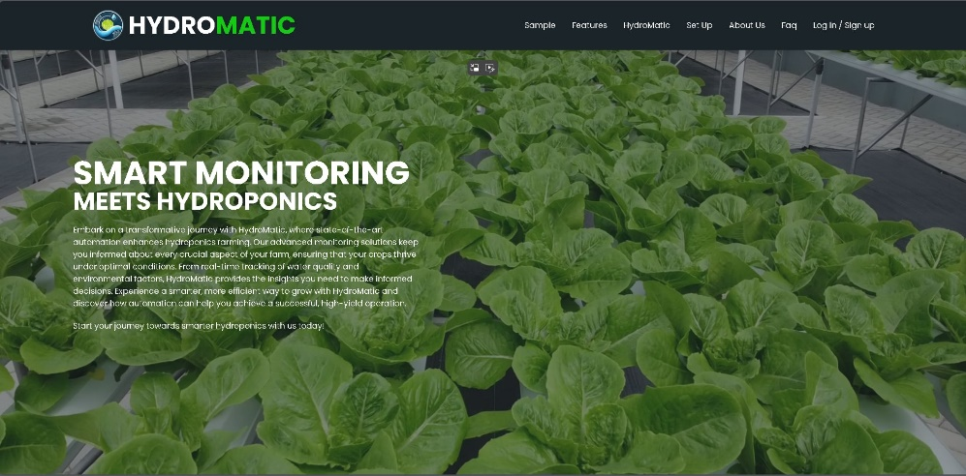

Sample Section:

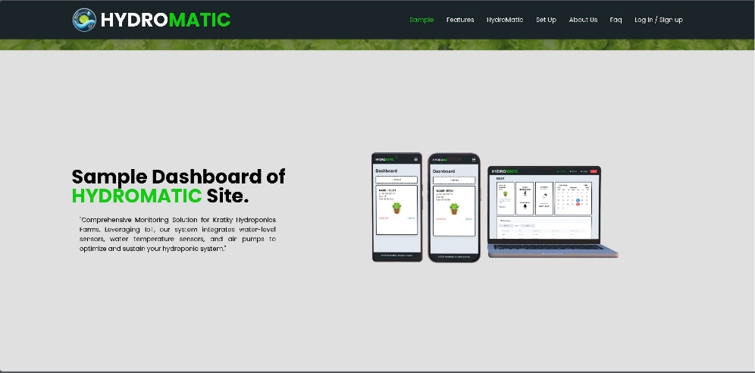Displays a sample HydroMatic dashboard, compatible across mobile and desktop devices, aimed at giving users a comprehensive view of their hydroponic system's status.

Features Section:

Lists key features such as real-time monitoring, SMS notifications, and IoT integration, emphasizing the system's ability to provide continuous updates and connectivity.

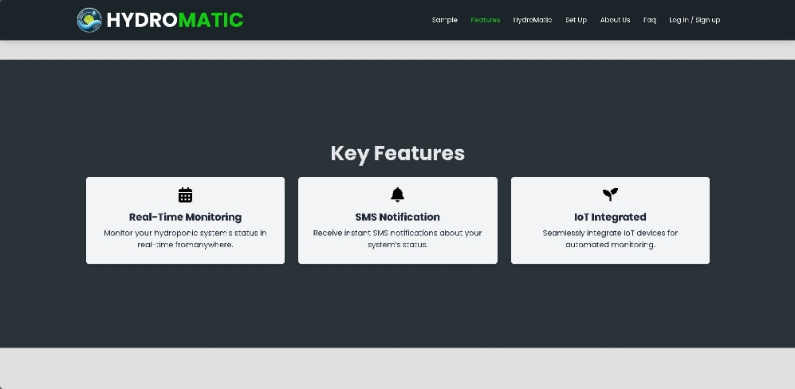

About Hydromatic Section:

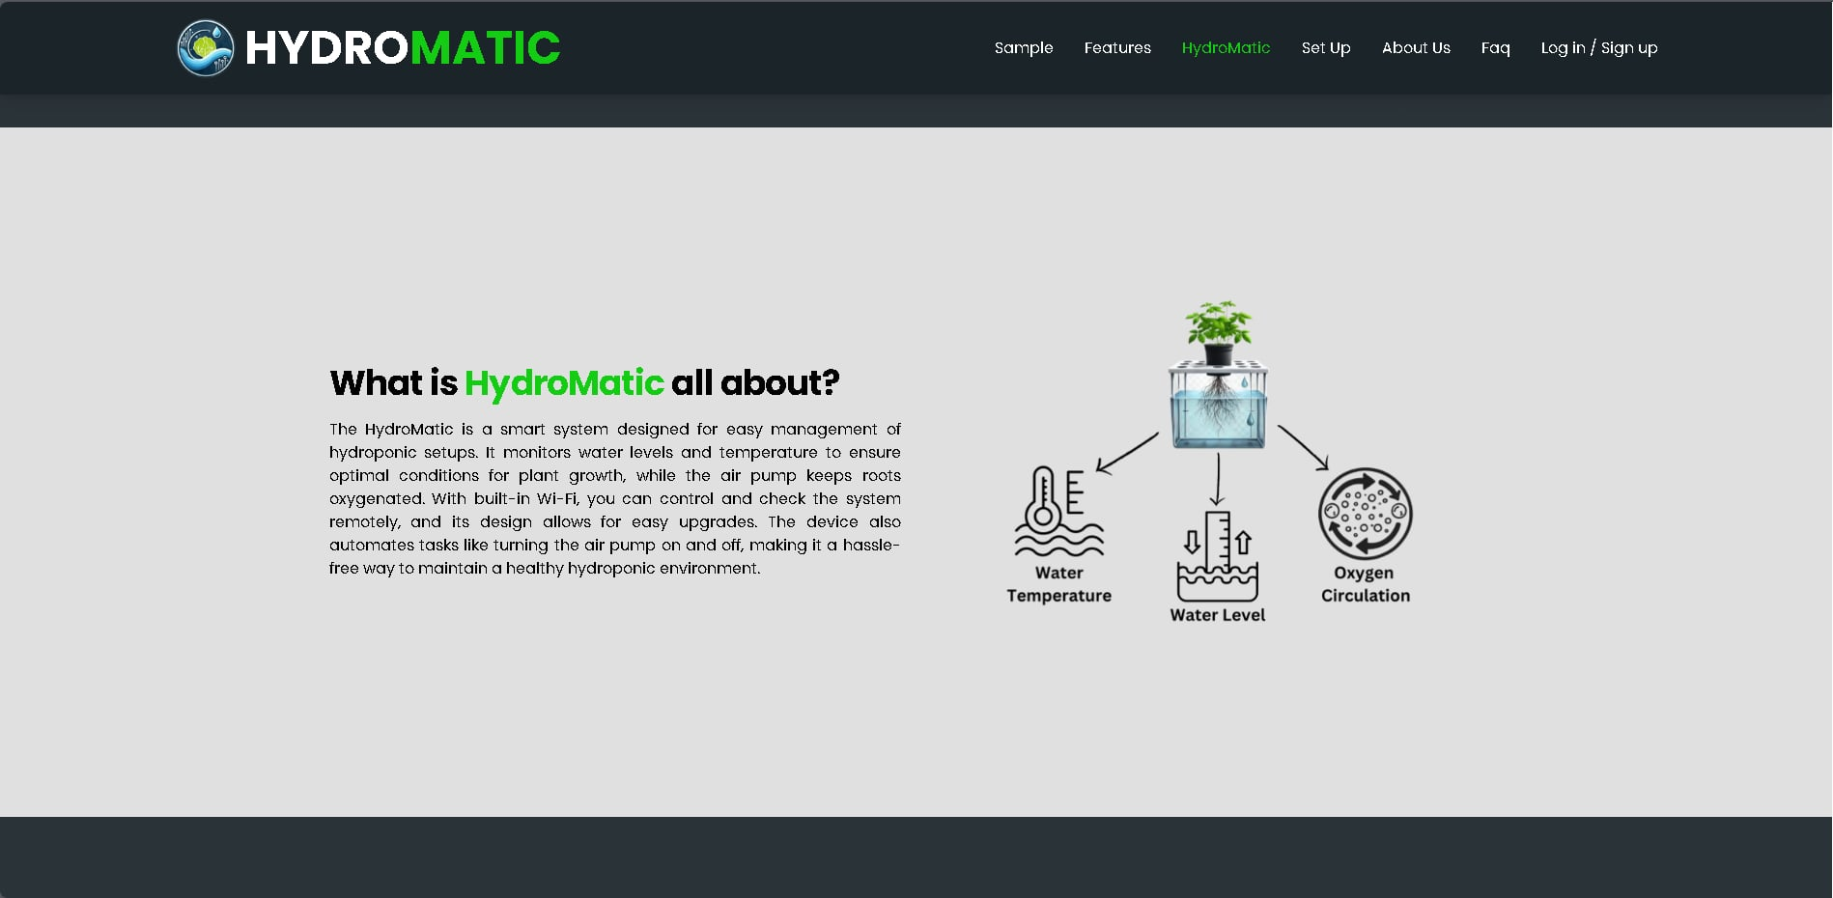 Introduces HydroMatic as a smart system for hydroponic management, specifically monitoring water levels, temperature, and oxygen circulation. It highlights remote management and automation features to maintain a healthy hydroponic environment.

Setup Section:

Guides users through configuring HydroMatic. It illustrates steps for connecting the device to Wi-Fi and finalizing setup, making it easy for new users to get started.

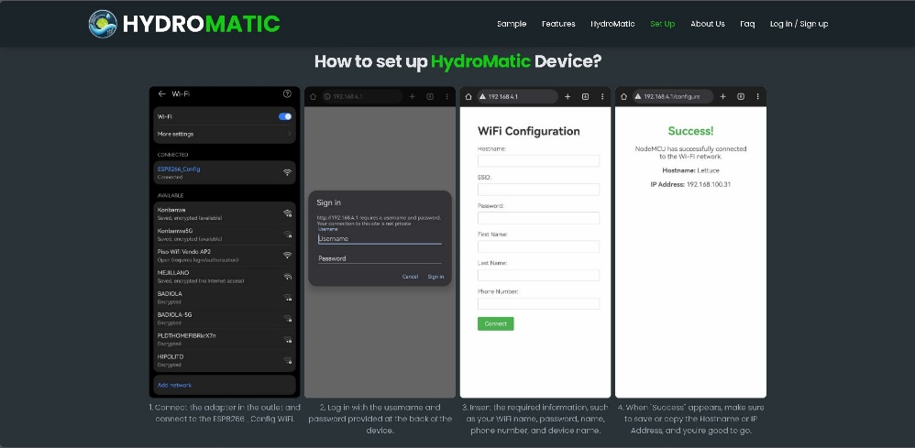

About Us Section:

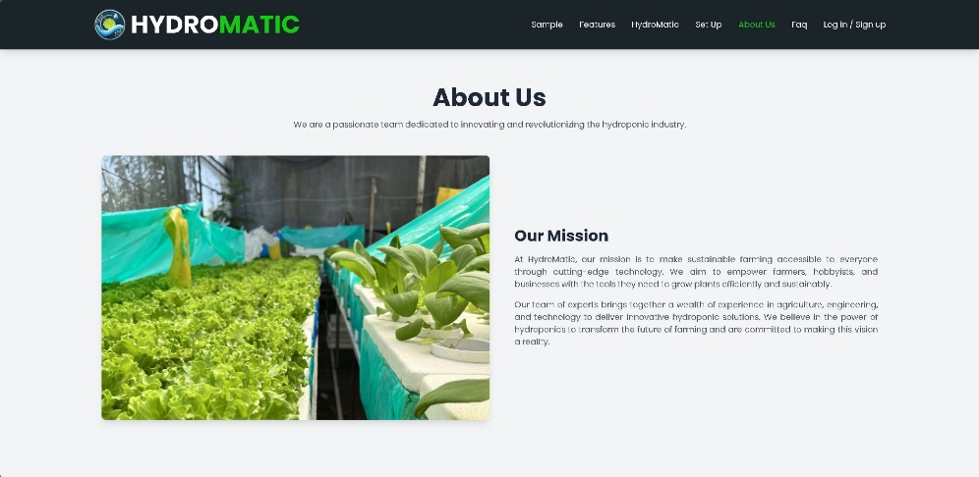 Describes HydroMatic's mission to make sustainable farming accessible through innovative technology. The team aims to empower users with tools for efficient and sustainable plant growth.

Faq Section:

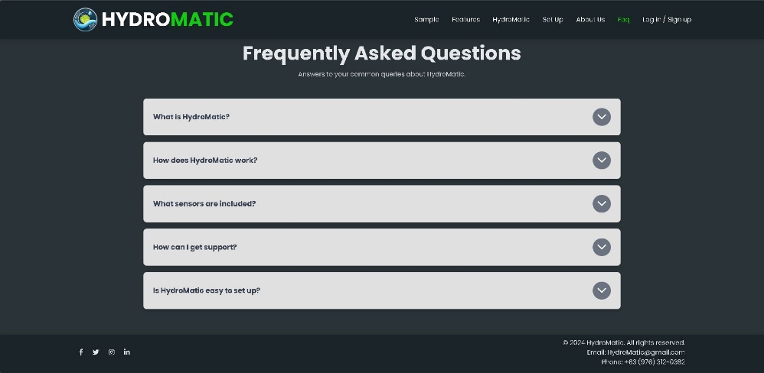Provides answers to common questions about HydroMatic, including topics like the purpose of HydroMatic, its operation, included sensors, support options, and ease of setup.

**Registration Form**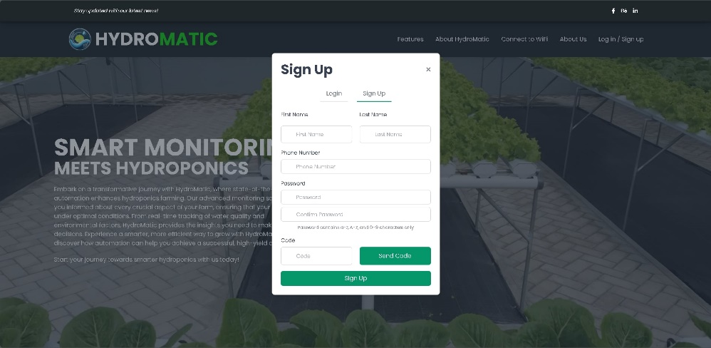

Before accessing the features of HydroMatic, you must create an account. This registration form will help you to set up your new account so you can log in to the HydroMatic website. Please ensure all required fields are completed.

Step 1 out of 4: Enter Your Personal Information

1. Enter your first name.
2. Enter your last name.
3. Enter your phone number.
4. Create a password (Password must contain 4-9 characters, including letters and numbers only).
5. Confirm your password.
6. Click “Send Code” to receive your code.
7. Enter the verification code sent to your phone.

Click “Sign Up” to proceed with the registration.

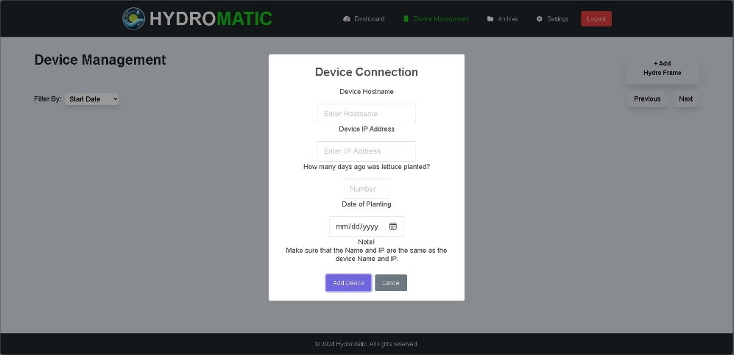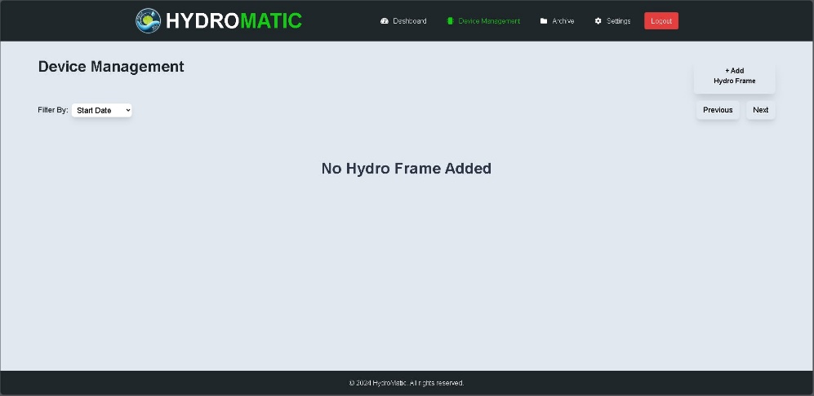After Signing up, Login with your information to Start your journey with HydroMatic.

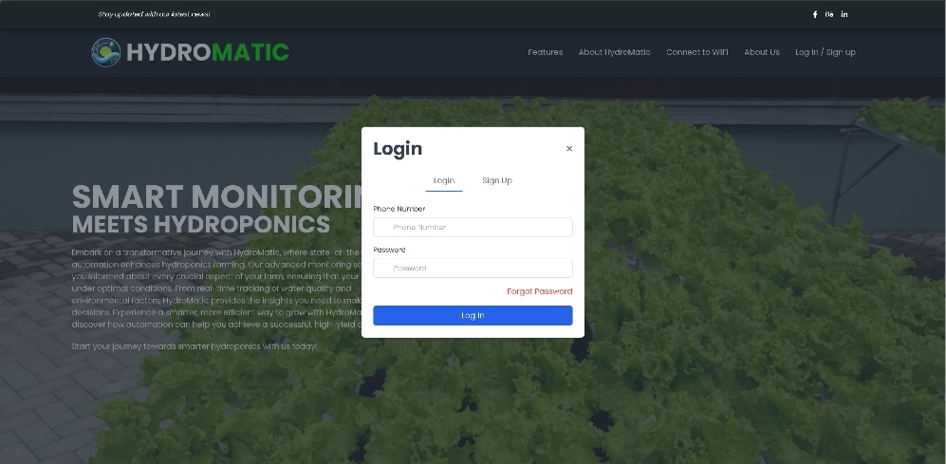

Device Connection Interface

This interface allows users to register new devices to their HydroMatic system, ensuring efficient management and tracking of each hydro frame. Here's how each section functions:

Interface Elements:

1. **Device Hostname**: Enter the hostname for the device, which uniquely identifies the device within your network.
2. **Device IP Address**: Input the IP address assigned to the device. This address should be static to avoid connection issues.
3. **How many days ago was lettuce planted?**: Enter the number of days since the lettuce (or other crops) was planted in this specific device. This information helps track growth stages.
4. **Date of Planting**: Select or enter the exact date when planting occurred. This provides a reference point for monitoring crop cycles.

Buttons:

* **Add Device**: After filling out all necessary fields, click this button to register the device onto your platform.
* **Cancel**: Dismisses the current operation and returns to the previous screen.

Navigation:

* The interface also includes "**Previous**" and "**Next**" buttons for navigating between different sections or devices, as well as the "**+Add Hydro Frame**" button, enhancing the ease of adding multiple devices.

Note:

* 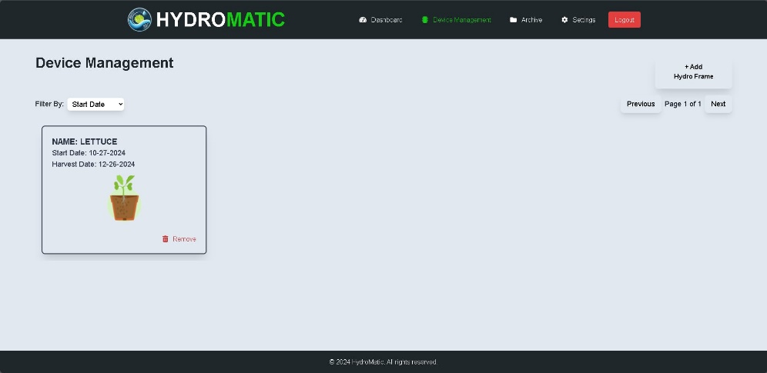A reminder ensures that users double-check the accuracy of the name and IP address, stating: "Make sure that the Name and IP are the same as the device Name and IP."

### Device Management

This section is dedicated to managing all devices associated with your HydroMatic system. Here, you can view, filter, and add devices to optimize your hydroponic farming operations.

#### Features of the Device Management Section:

1. **View Devices**: Displays all connected hydroframes. Each device entry shows relevant details such as device status, connection health, and last activity date.
2. **Filter Devices**: Enhance your search using filters to quickly find devices. You can filter devices based on:
   * **Harvest Date**: Filter devices by the expected or actual harvest date of the crops.
   * **Start Date**: Filter devices by the date they were set up and started.
3. **Add New Device**: Easily add new HydroFrames to your network.
   * Click the “Add Device” button.
   * Enter the device information, including model, installation date, and any specific configurations.
   * Submit the form to register the new device to your system.
4. 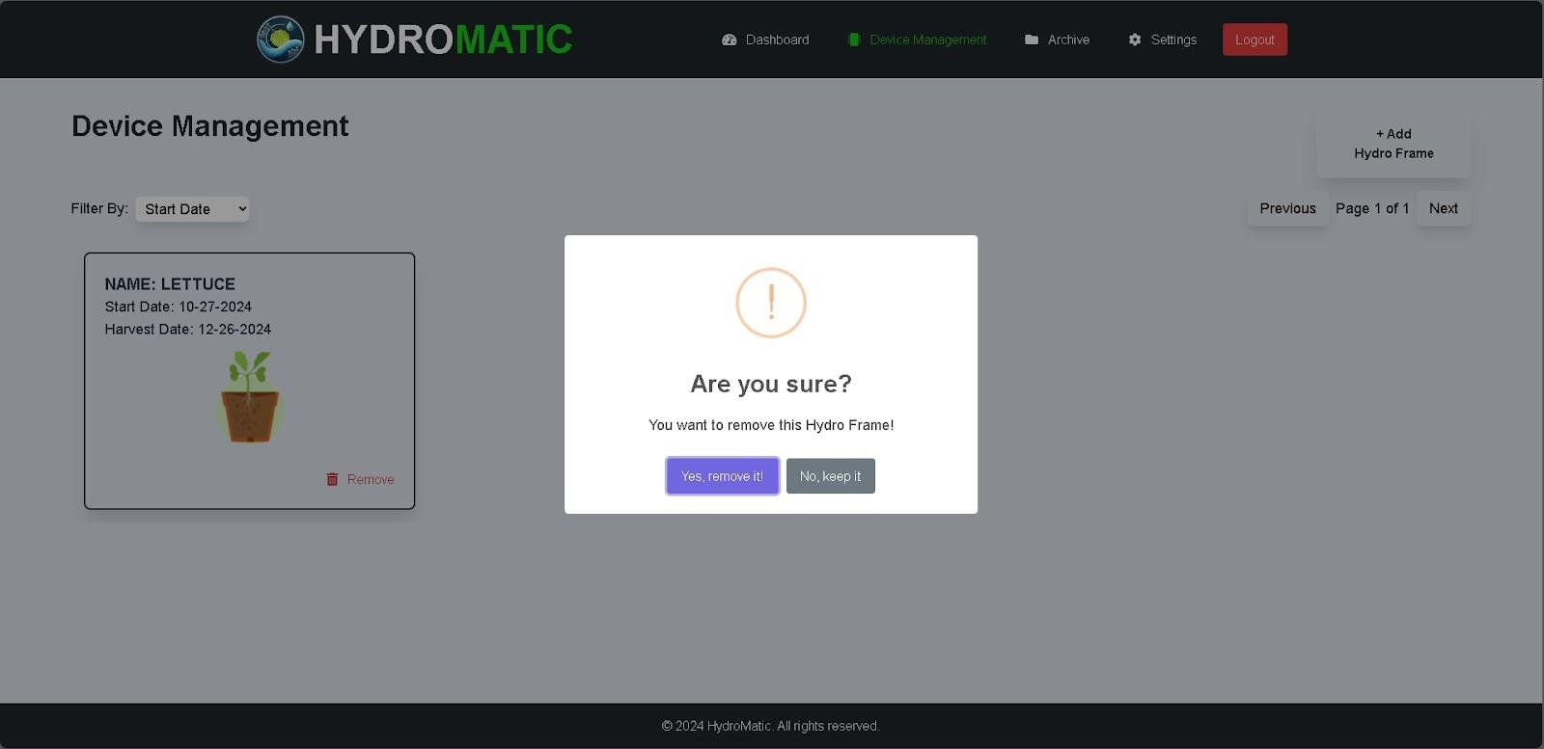**Device Configuration**: For each device, you can access settings to configure or update device parameters, schedule maintenance, or check firmware updates.

5. You can also remove an existing HydroFrame, the hydroframe will go into the archive section.

**HydroMatic Dashboard Overview**

Dashboard Features:

1. Total Hydro Frame: Shows the total number of hydroponic frames you have set up.
2. 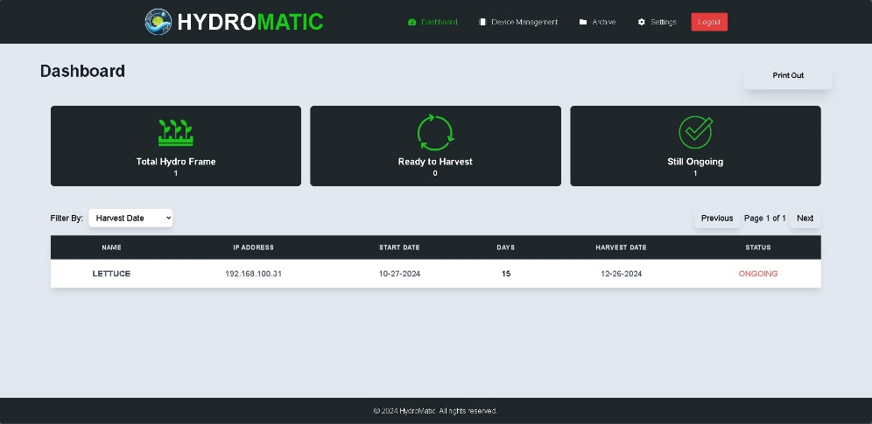Ready to Harvest: Indicates how many of your plants are at the harvest stage.
3. Still Ongoing: Displays the count of plants that are still in the growth process.

Functionality:

* Filter: You can refine the display of your hydro frames by selecting filters such as 'Harvest Date' and ‘Start date’. This will help you manage your crops based on their growth or harvest timelines.

Navigation:

* The 'Previous' and 'Next' buttons at the bottom allow for easy navigation through multiple pages of hydro frames, if applicable.
* 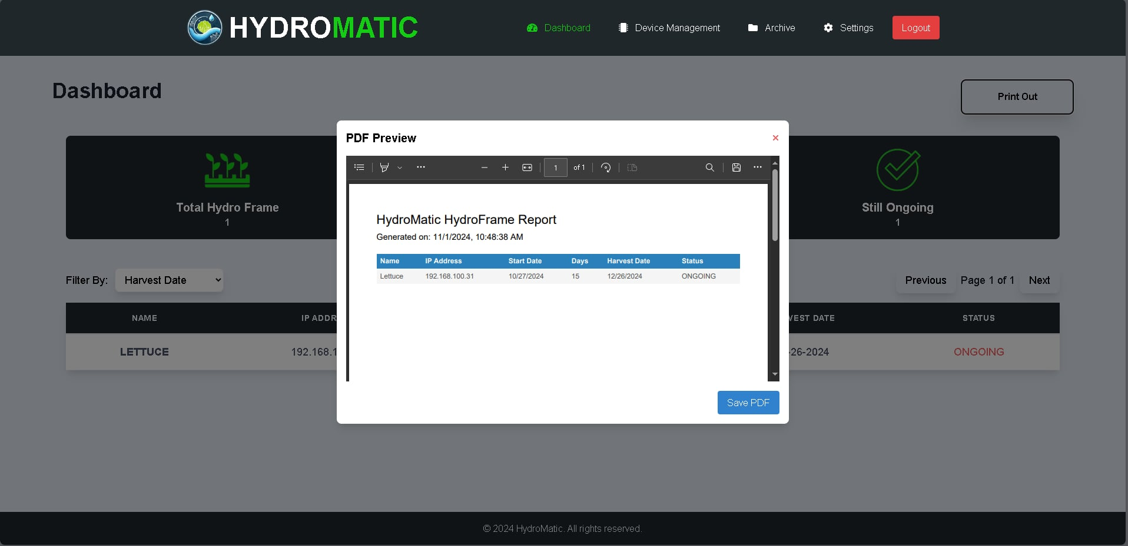The 'Print Out' button at the top right corner suggests functionality to print reports or data directly from the dashboard.

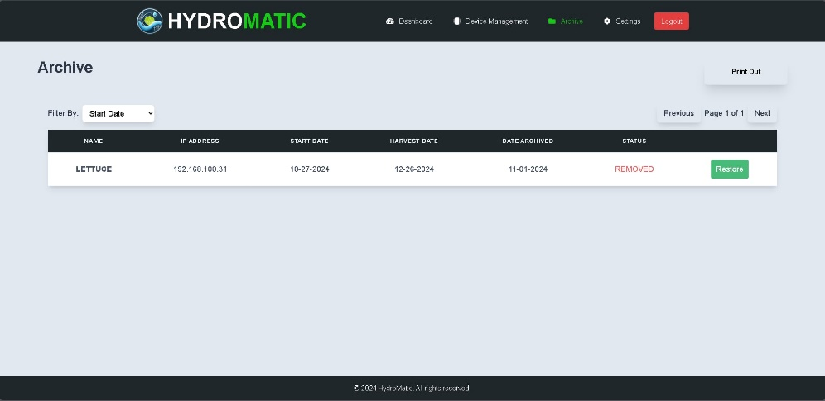Archive Page Overview

Functionality:

* Filter By: A dropdown menu to filter archived data by "Start Date," which could help users retrieve historical data based on the initiation date of specific cycles or events.
* No data available: This message is displayed indicating that there are no entries to display currently, which could either mean that no data has been archived yet or filters need adjusting.
* Print Out: A button to print out archived records, likely generating a hard copy or PDF of displayed data.
* 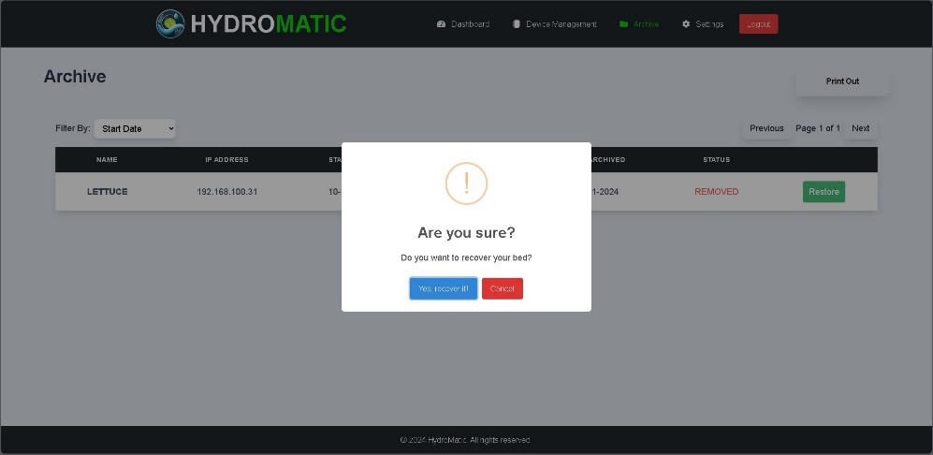Navigation Buttons: "Previous" and "Next" buttons to navigate through archived entries, should they exist beyond the current view.

You can also recover your archived hydroframe.

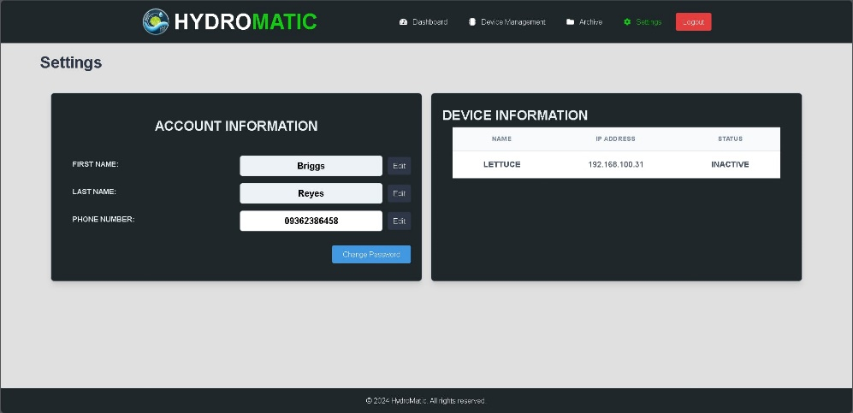

**Settings Page Overview**

Account Information Section:

* First Name: Displayed with an option to edit.
* Last Name: Displayed with an option to edit.
* Phone Number: Displayed with an option to edit.
* Change Password: A button provided to facilitate password changes for enhanced security.

Device Information Section:

* Indicates that no HydroMatic device is currently paired with the account. This section likely allows users to manage device-specific settings once devices are added.

























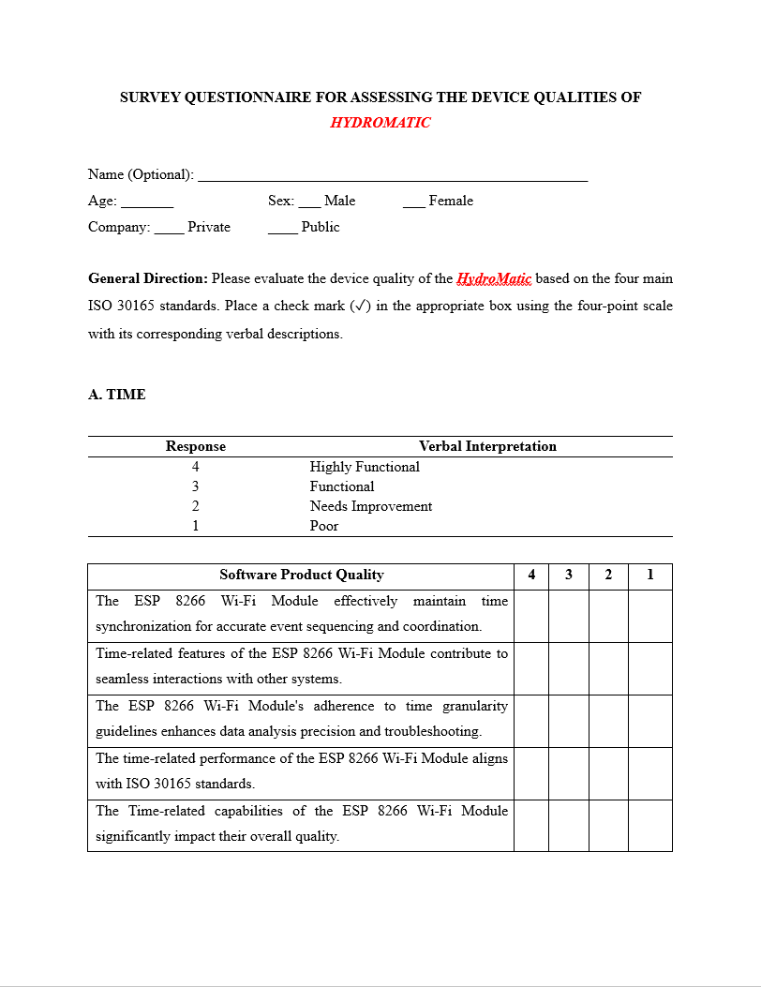

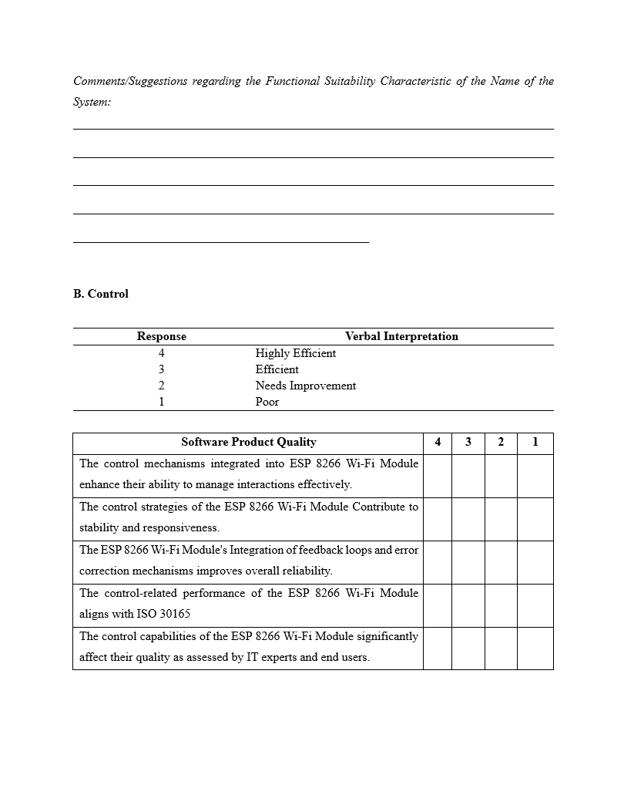

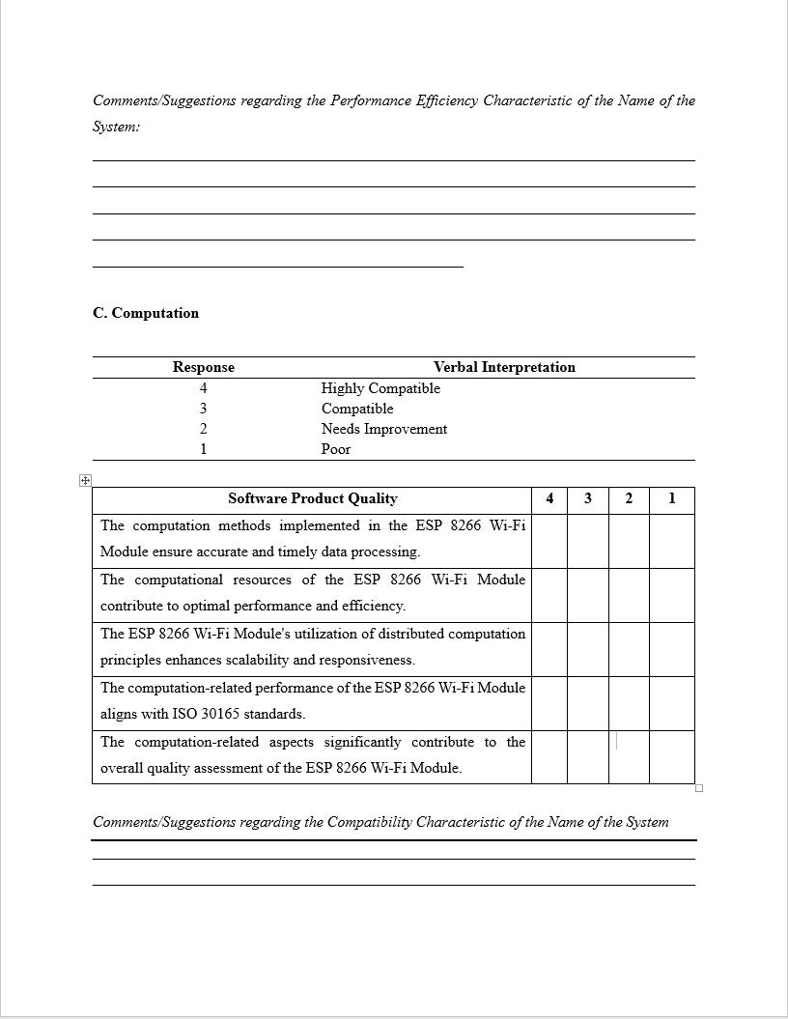



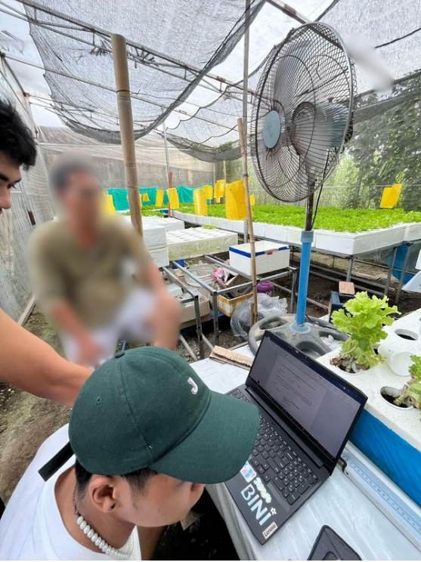

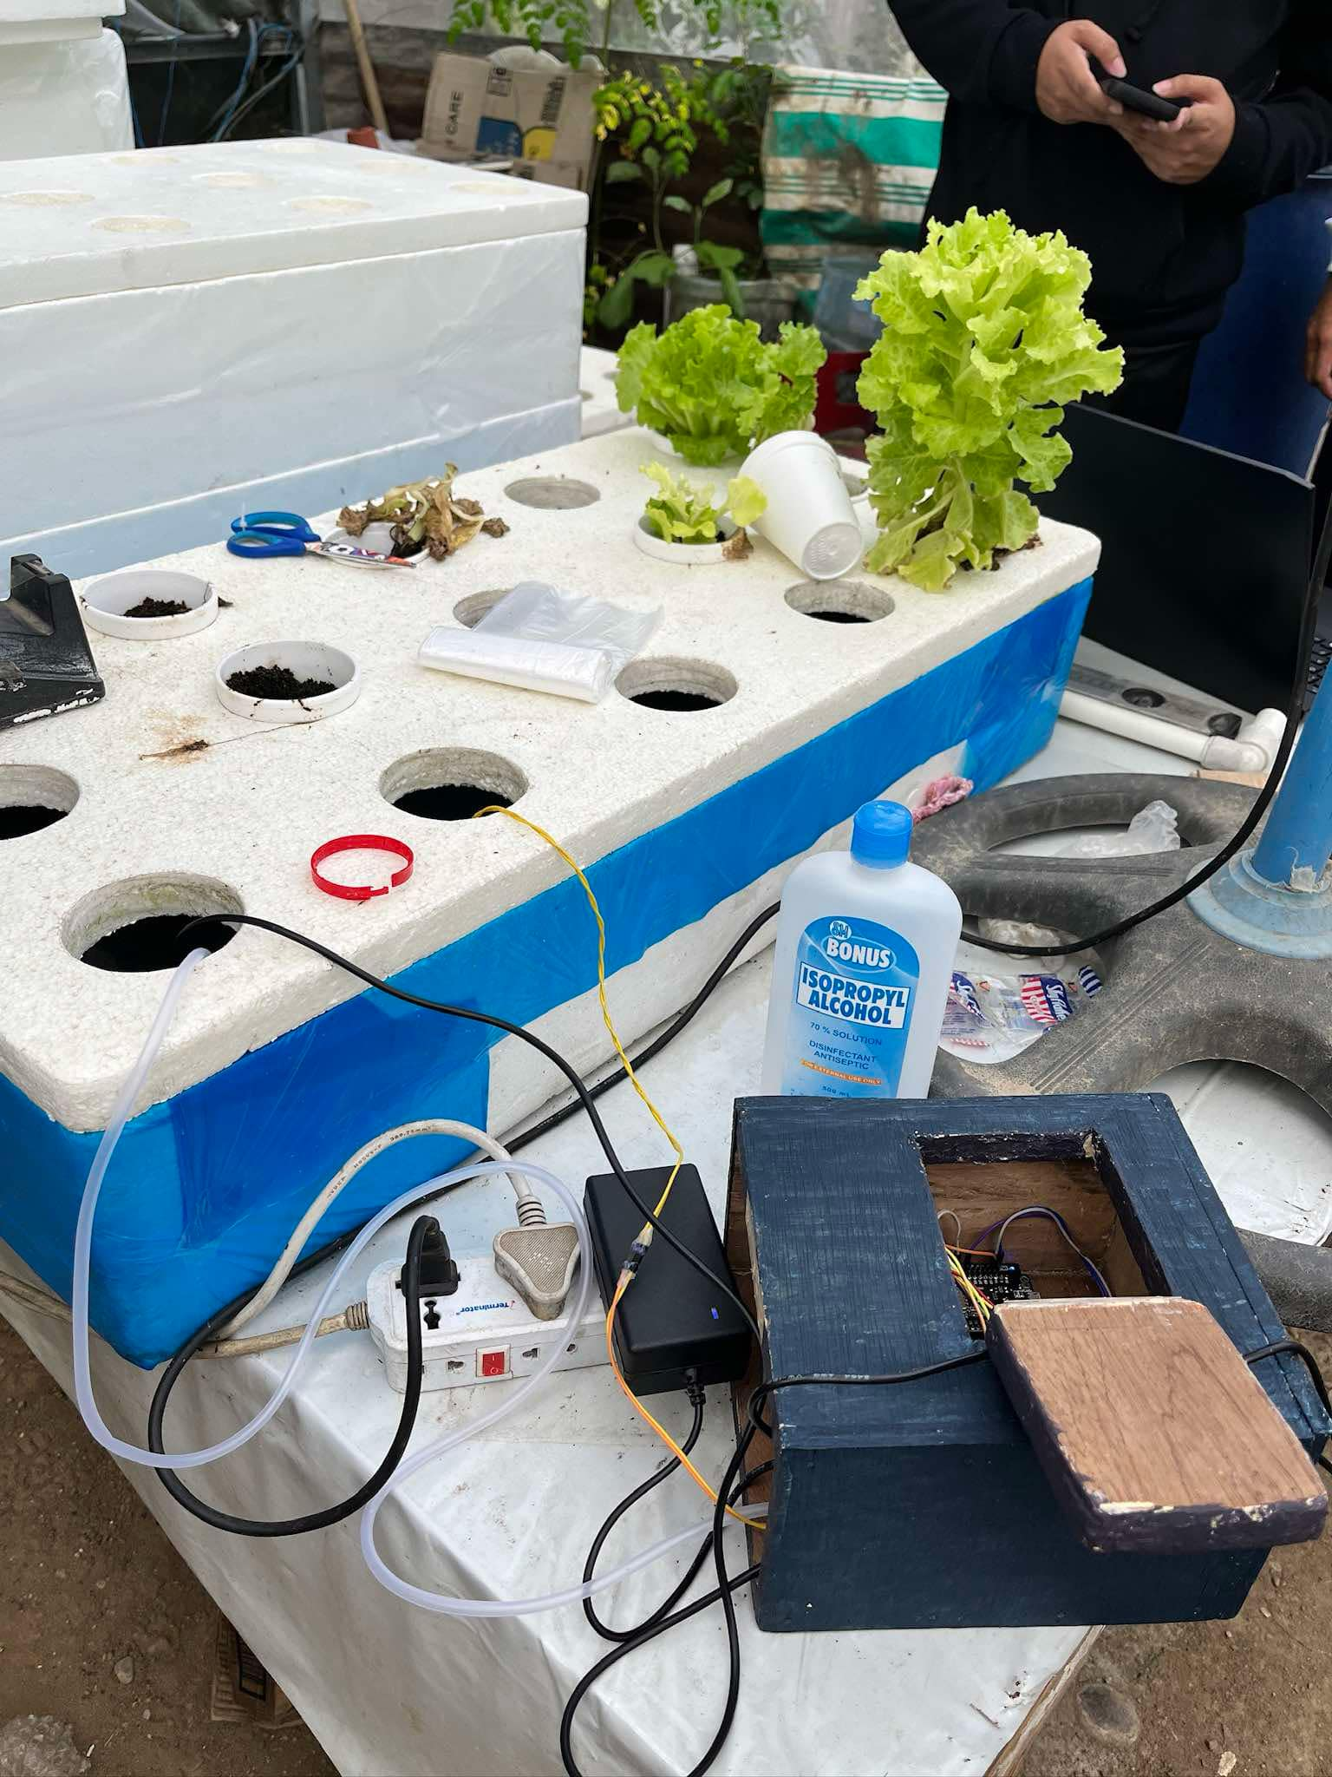

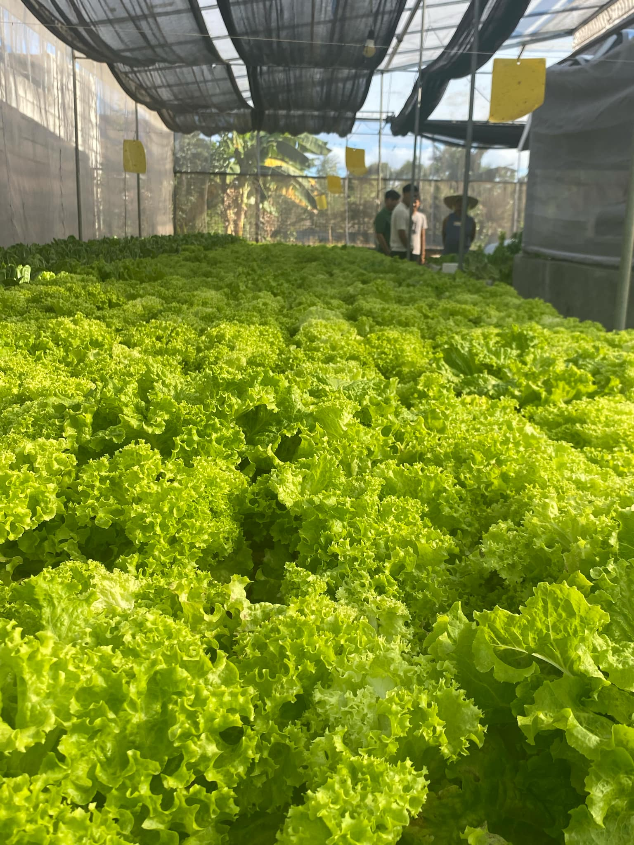

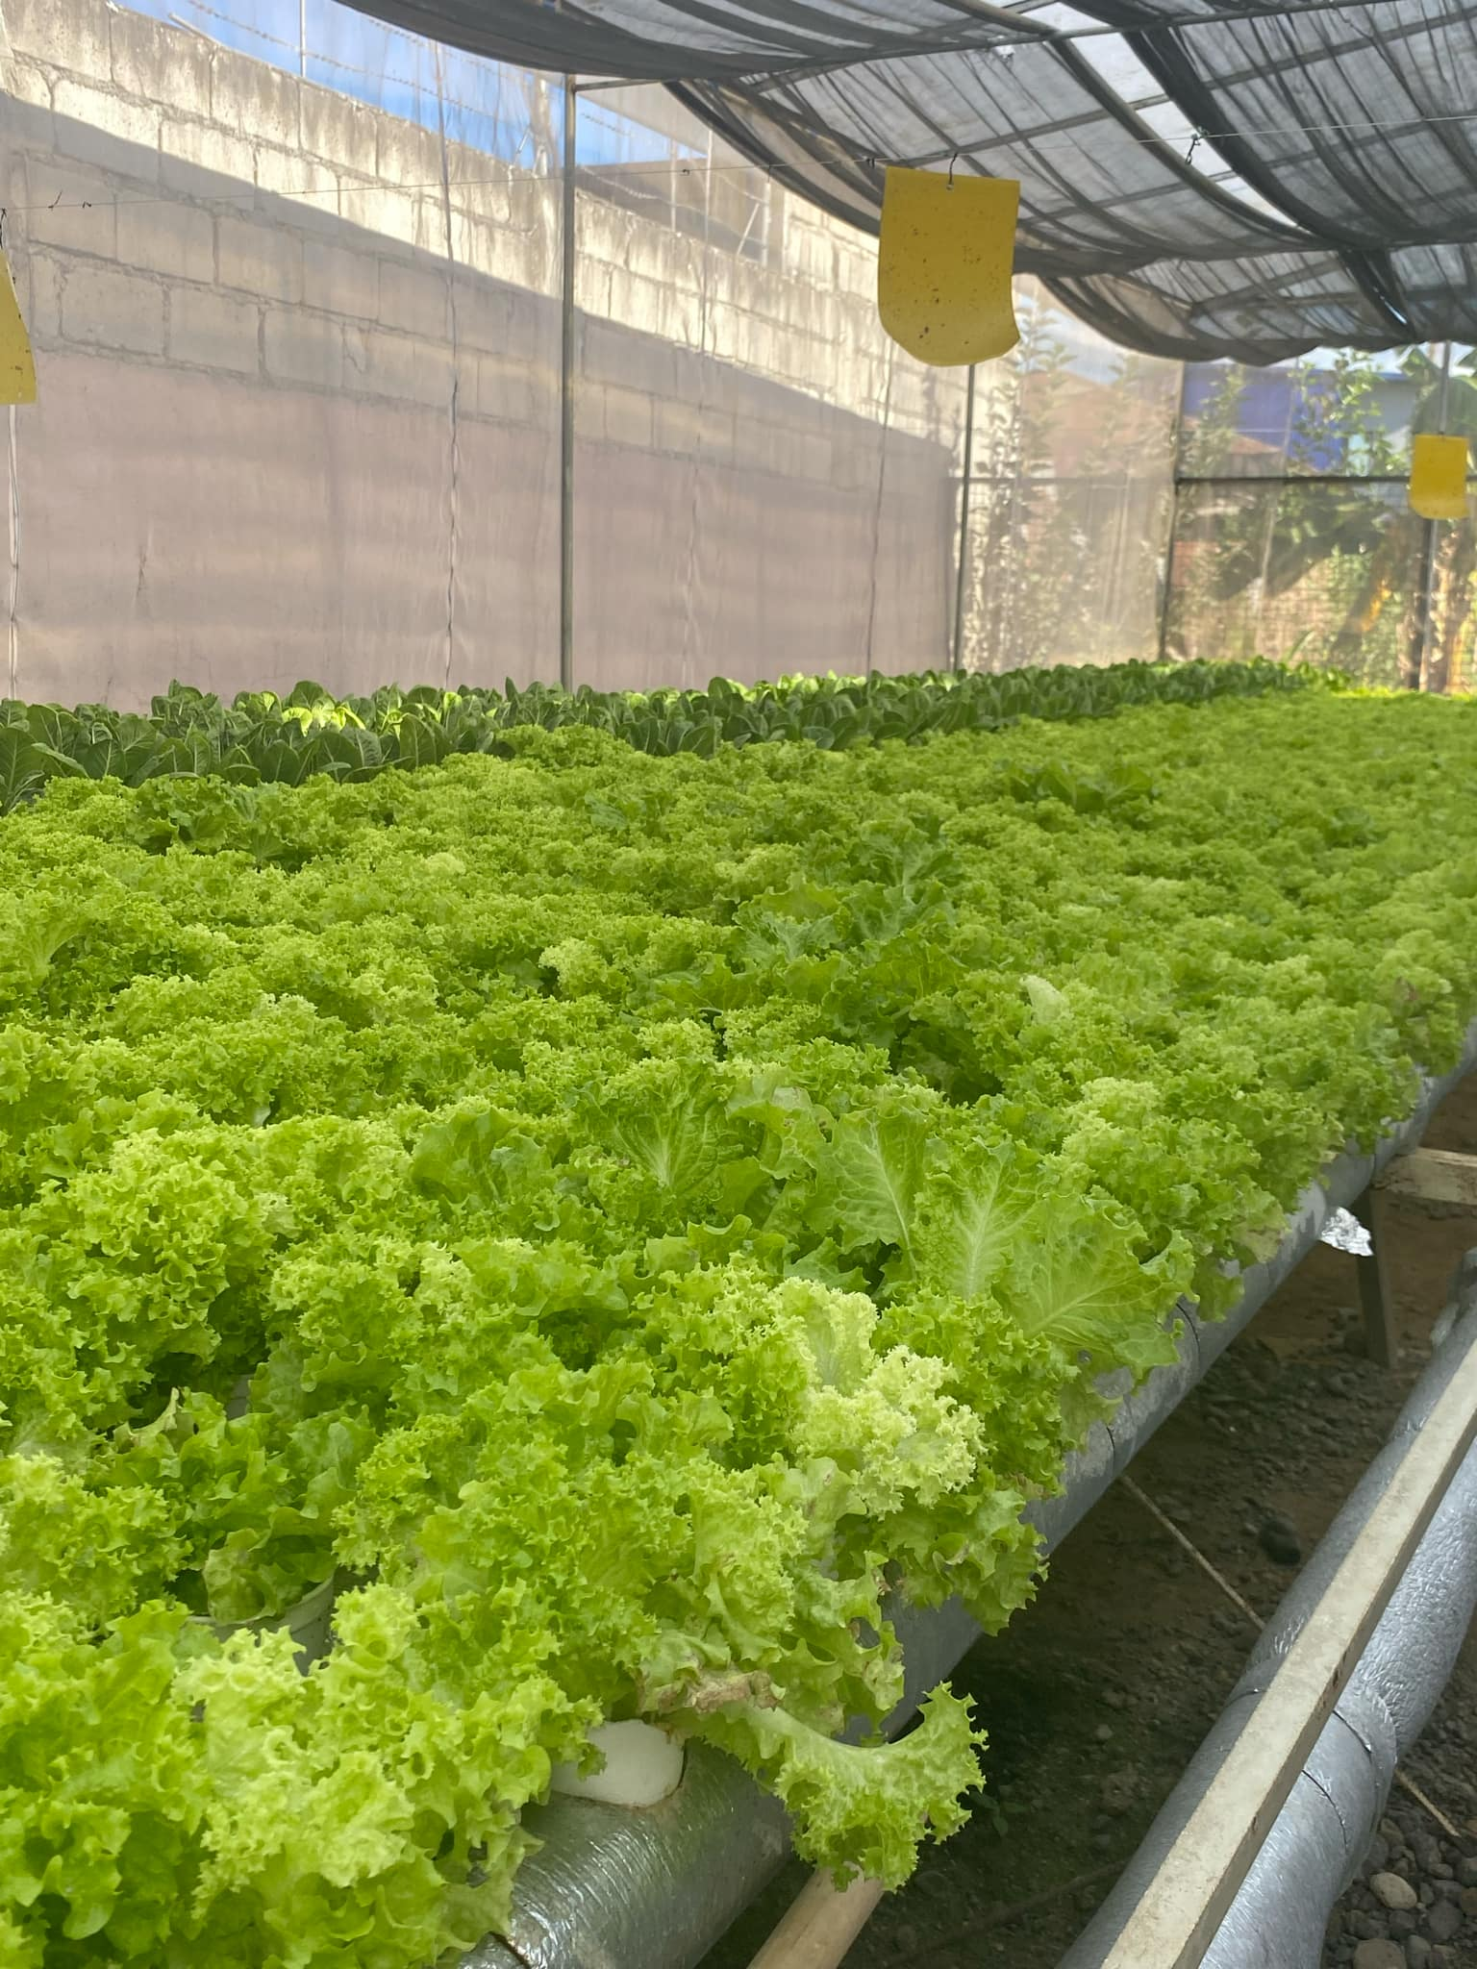

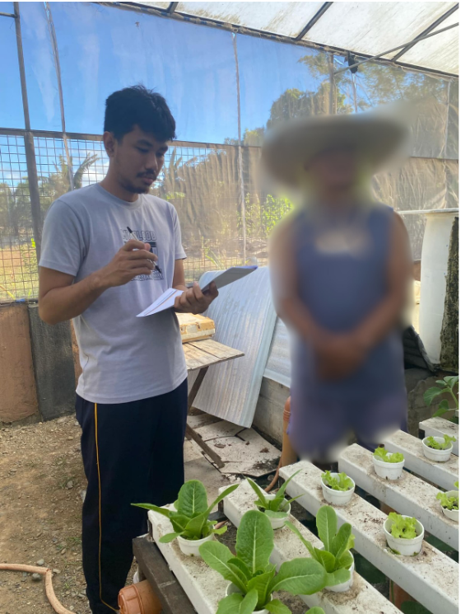



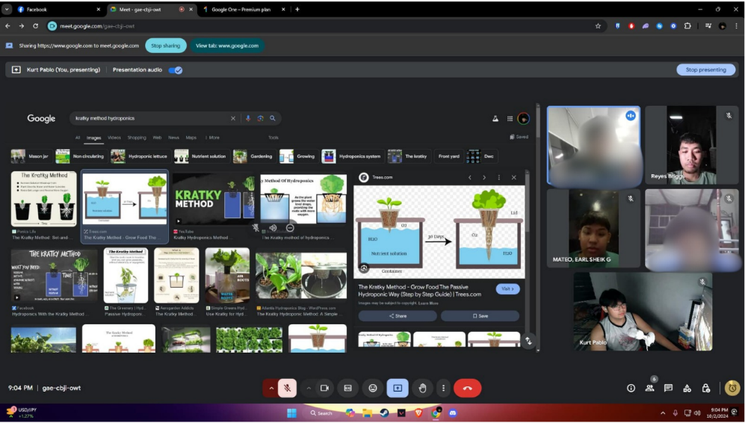

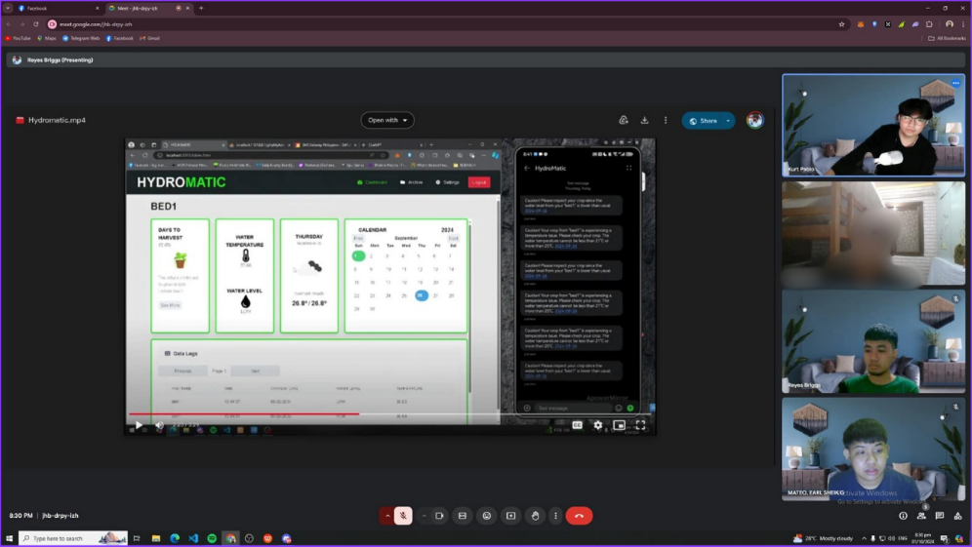

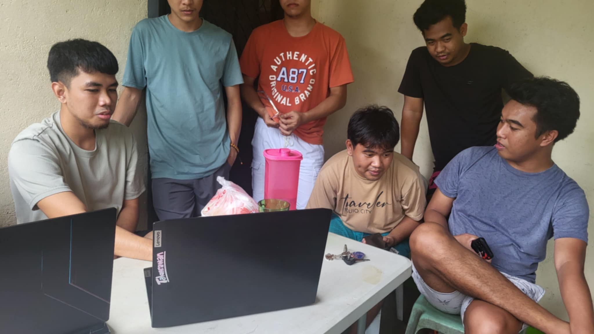

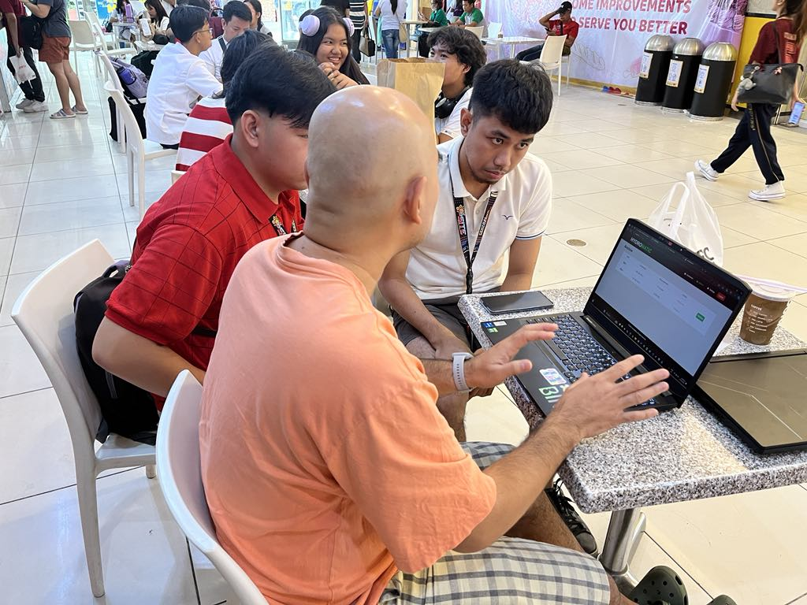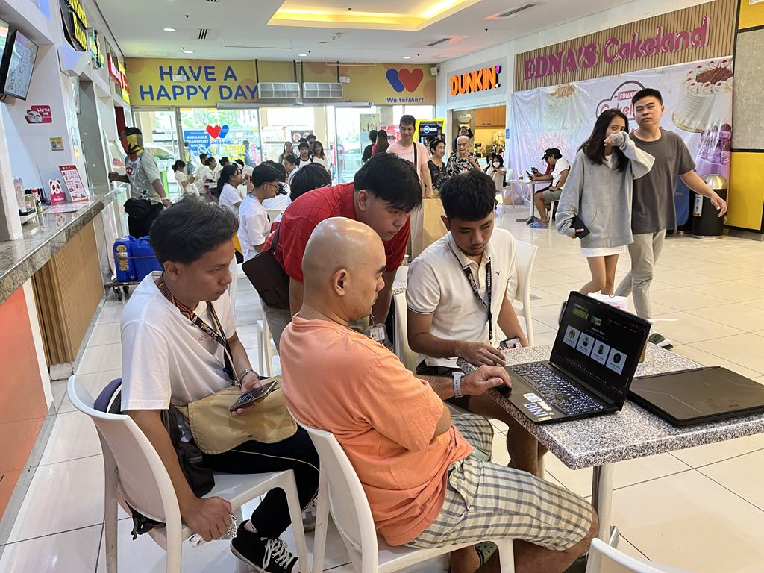

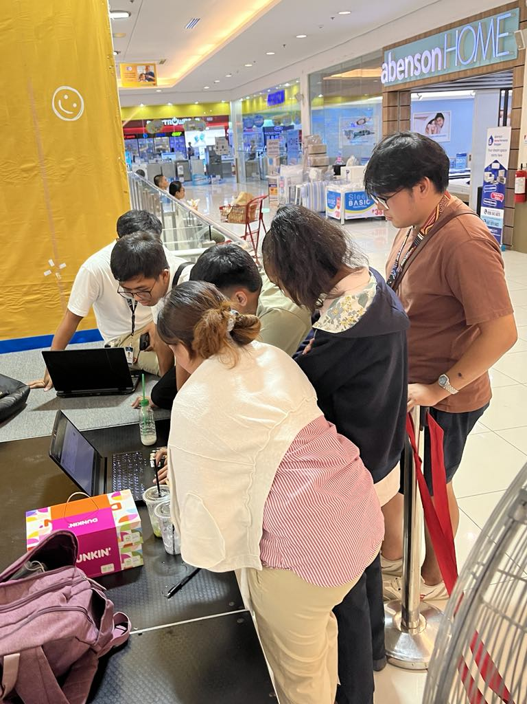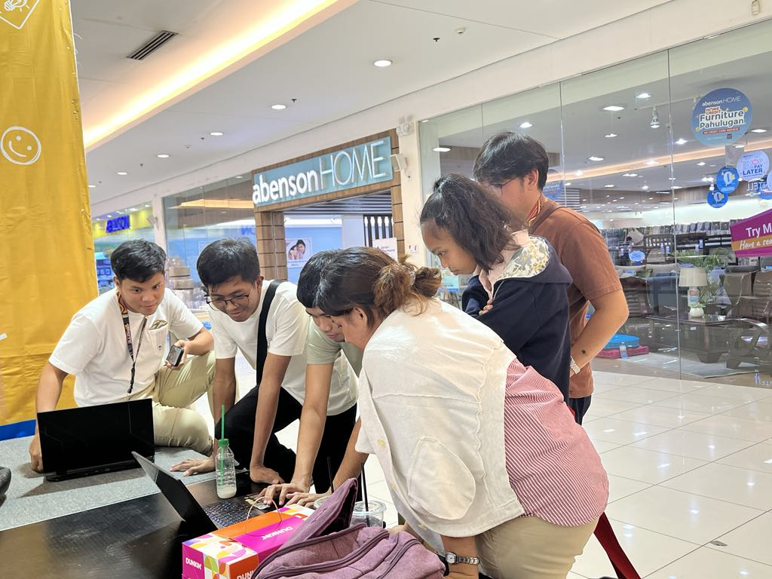



**CURRICULUM VITAE**

Name: Earl Sheik G. Mateo

Address: Brgy. San Vicente, Gapan City

Number: 09287127923

Email Address: [sheikmateo@gmail.com](mailto:sheikmateo@gmail.com)

**PERSONAL BACKGROUND**

Date of Birth: April 23, 2003

Birthplace: Gapan City

Gender: Male

Citizenship: Filipino

Religion: Roman Catholic

Civil Status: Single

Father’s Name: Nelson D. Mateo

Mother’s Name: Mary Ann G. Mateo

**Educational Background**

Tertiary: Nueva Ecija University of Science and Technology

Specialization: Web Systems Technology

Senior High School: Juan R. Liwag Memorial Highschool (SHS)

Junior High School: Juan R. Liwag Memorial Highschool

Elementary: Gapan South Central School

**CURRICULUM VITAE**

Name: Briggs V. Reyes

Address: Brgy. Tramo, Santa Rosa, Nueva Ecija

Number: 09362386458

Email Address: reyes.briggs9@gmail.com

**PERSONAL BACKGROUND**

Date of Birth: May 15, 2003

Birthplace: Cabanatuan City

Gender: Male

Citizenship: Filipino

Religion: Roman Catholic

Civil Status: Single

Father’s Name: Edwin S. Reyes

Mother’s Name: Nerissa V. Reyes

**EDUCATIONAL BACKGROUND**

Tertiary: Nueva Ecija University of Science and Technology

Specialization: Web Systems Technology

Senior High School: Saint Rose of Lima Catholic School

Junior High School: Saint Rose of Lima Catholic School

Elementary: San Gregorio Elementary School

**CURRICULUM VITAE**

Name: Kurt Russel C. Pablo

Address: Brgy. Marawa, Jaen, Nueva Ecija

Number: 0976-312-0382

Email Address: kurtpablo0606@gmail.com

**PERSONAL BACKGROUND**

Date of Birth: February 6, 2003

Birthplace: Cabanatuan City

Gender: Male

Citizenship: Filipino

Religion: Roman Catholic

Civil Status: Single

Father’s Name: Ferdinand M. Pablo

Mother’s Name: Vilma C. Pablo

**EDUCATIONAL BACKGROUND**

Tertiary: Nueva Ecija University of Science and Technology

Specialization: Web Systems Technology

Senior High School: College of the Immaculate Conception

Junior High School: College of the Immaculate Conception

Elementary: Marawa Elementary School

**CURRICULUM VITAE**

Name: Jean Micaell M. Yabot

Address: Tikiw, San Antonio, Nueva Ecija

Number: 0997-731-0709

Email Address: jeanmicaelly@gmail.com

**PERSONAL BACKGROUND**

Date of Birth: October 18, 1998

Birthplace: Tikiw, San Antonio, Nueva Ecija

Gender: Male

Citizenship: Filipino

Religion: Roman Catholic

Civil Status: Single

Father’s Name: Jommel G. Yabot

Mother’s Name: Michelle M. Yabot

**EDUCATIONAL BACKGROUND**

Tertiary: Nueva Ecija University of Science and Technology

Specialization: Web Systems Technology

High School: St. Paul School of San Antonio

Elementary: St. Paul School of San Antonio